**QVM Series Matrix Switcher**

**User Manual**

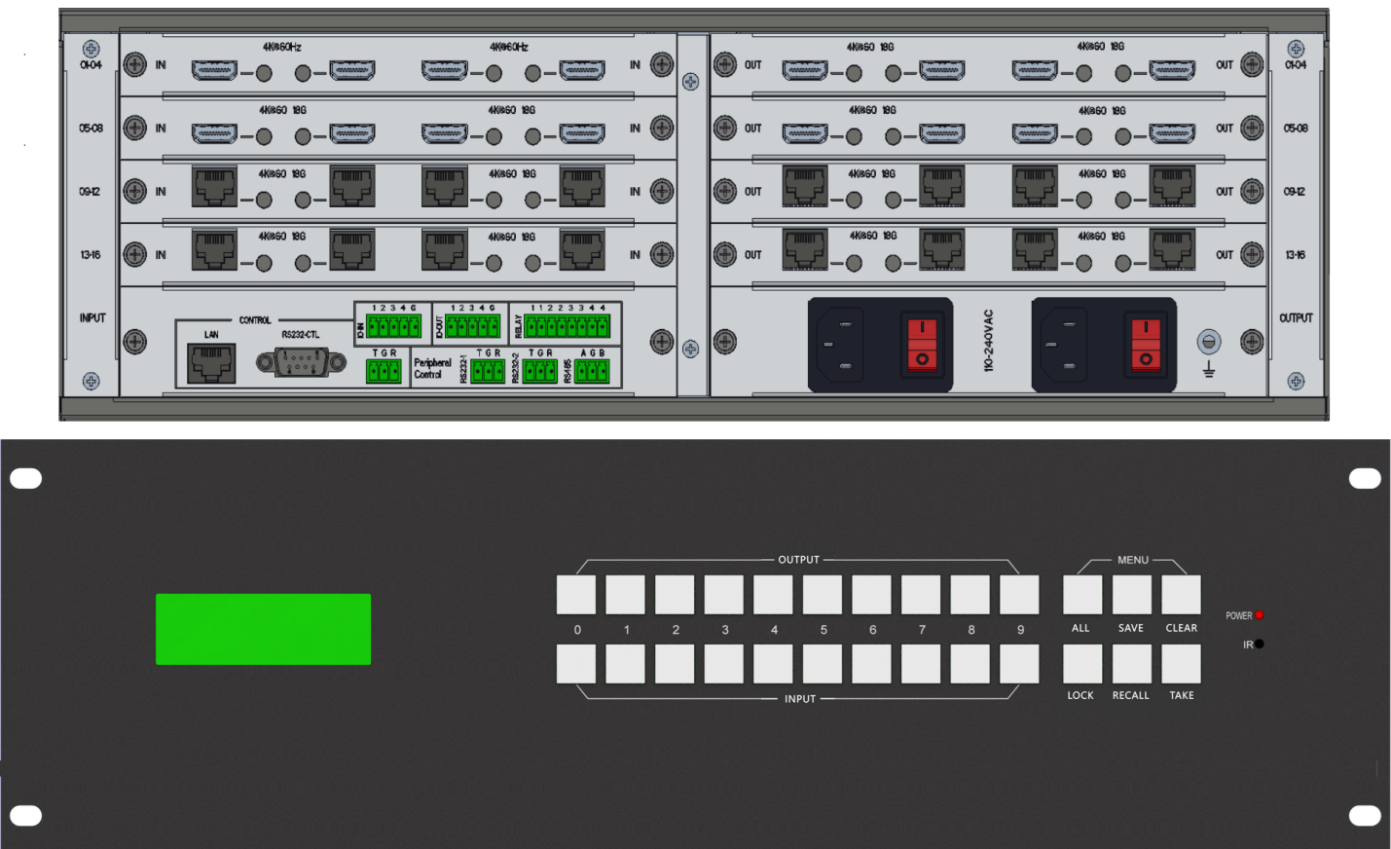

**Content**

1. System description 2

1.1. Introduction 2

1.2. Features 2

1.3. Specification-main unit 3

1.4. Specification-input card and output card 3

2. Panel introduction 4

2.1 Front panel 4

2.2 Rear view 4

3. PC Tool user guide 6

3.1 Connect tab 6

3.2 Matrix switch tab 7

3.3 Signal config tab 8

3.4 TV wall tab 8

3.5 Multiview tab 9

3.6 System tab 9

3.7 Peripheral tab 10

4. How to achieve multiview function of splicing wall 10

5. Commonly used HEX commands 11

5.1 System command 11

5.1.1 Set matrix size (inputs/outputs number) 11

5.1.2 IP config 11

5.1.3 Save Scene 12

5.1.4 Load scene 12

5.1.5 Factory reset 12

5.2 Switching, querying, and configure command 12

5.2.1 Single input and output switching 12

5.2.2 Multi input and output ports switching 12

5.2.3 Query output input correspondence 12

5.2.4 Set output resolution 13

5.2.5 Query input information 13

5.2.6 Query output information 14

5.2.7 Audio selection of input port 14

5.2.8 Output rotate 14

5.3 Display mode when no input 14

5.3.1 Display mode for output port when no input 14

5.3.2 Display mode for input port when no input 14

5.4 Wall splicing command 15

5.4.1 Splicing one output port 15

5.4.2 Set border for one output port 15

5.5 Multiview command 15

5.5.1 Enable multiview function for one output 15

5.5.2 Disable multiview function for one output 15

5.5.3 Audio selection for one multiview port 15

5.5.4 Set multiview parameters for output port 16

5.5.5 Query multiview parameters for output port 16

5.5.6 Set display position and size for one window 17

5.5.7 Set the layer level of one multiview window 17

5.5.8 Query the layer level of one multiview window 17

5.5.9 Window display and hiding 17

# System description

## Introduction

QVM series modular matrix switcher is a high-performance ultra high definition video signal switching device that supports 4K@60Hz-444 processing of input, output, switching, multiview and wall splicing

This product adopts a dual power redundancy design and a plug-in single card 4-way structure, which can support up to 8-32 signal inputs and 8-32 signal outputs

## Features

1. Support seamless switching between different input resolutions
2. Comprehensive splicing display function, four screen window multiview function and zoom function
3. Support synchronization for all output ports, eliminating tearing issue when splicing moving images
4. Supports 0°, 90°, and 180° rotation function，maybe slightly difference with different cards
5. RGB video processing, perfectly restoring true colors
6. Input cards：HDMI card，HDBaseT card，up to 3840x2160/4096x2160@60Hz input resolution

SDI card，up to 1080p60 input resolution

1. Output cards：HDMI card，HDBaseT card，up to 3840x2160/4096x2160@60Hz input resolution
2. Support audio insert on input card and audio extracting on output card
3. Provide multiple control ports: front panel buttons, remote control, RS232, network and web
4. Dual power redundancy design

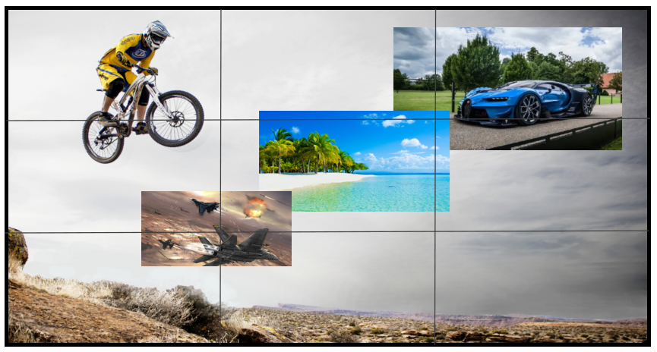

## Specification-main unit

|  |  |  |  |
| --- | --- | --- | --- |
|  | 8x8, 2U | 16x16, 3U | 32x32, 5U |
| Front view | VM88-3D渲染图-前面板 |  |  |
| Rear view |  |  |  |
| Size（W*D*H） | 483x365x89mm | 483x365x134mm | 483x365x223mm |
| Gross weight | 9Kg | 13Kg | 23Kg |
| Power module | 200W * 2（redundancy）  Or  100W * 2（redundancy） | 350W * 2（redundancy）  Or  200W * 2（redundancy） | 500W * 2（redundancy）  Or  350W * 2（redundancy） |

## Specification-input card and output card

|  |  |  |  |
| --- | --- | --- | --- |
| Input  card | Interface | Signal | Resolution |
| HDMI | HDMI,DVI | From 480p to 3840x2160@60 |
| RJ45 | HDbaseT | From 480p to 3840x2160@60  Support POC |
| BNC | SDI | 480i,576i,1080i50/60,720p50/60, 1080p24/25/29/30/50/60 |
| Output  card | Interface | Signal | Resolution |
| HDMI | HDMI,DVI | From 480p to 3840x2160@60  Different daughter cards maybe have different resolution capability |
| RJ45 | HDBaseT | From 480p to 3840x2160@60  Support POC PSE  Different daughter cards maybe have different resolution capability |
| BNC | SDI | 1080i50/60,720p50/60,1080p50/60 |

# Panel introduction

## 2.1 Front view

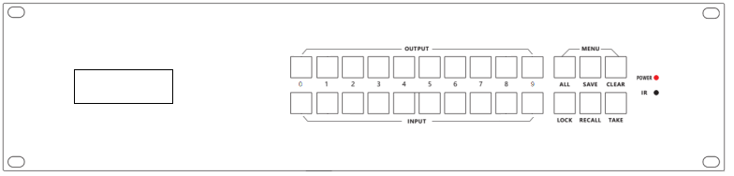

1. Installation screw: used to fix the control panel to the rack
2. LCM display screen: displays the routing status of each channel in the matrix.
3. Lock button : When activated, the inside light will be on, then all the buttons on the front panel will be locked and will not work. Press the button again, the light will turn off and unlock
4. TAKE/ENTER button：Execution action
5. OUT SELECT：Output 0, 1, 2...9, 10, 11... ,16
6. IN SELECT：Input 0, 1, 2...9, 10, 11... ,16

Press OUTPUT m +INPUT n +TAKE, switch input n to output m

1. ALL button: Press ALL + INPUT n +TAKE, switch input n to all output ports
2. SAVE button : Press SAVE+ OUTPUT n +TAKE, save current routing and screen layout to scene n
3. RECALL button: Press RECALL+ OUTPUT n +TAKE, load scene for current displaying

## 2.2 Rear view

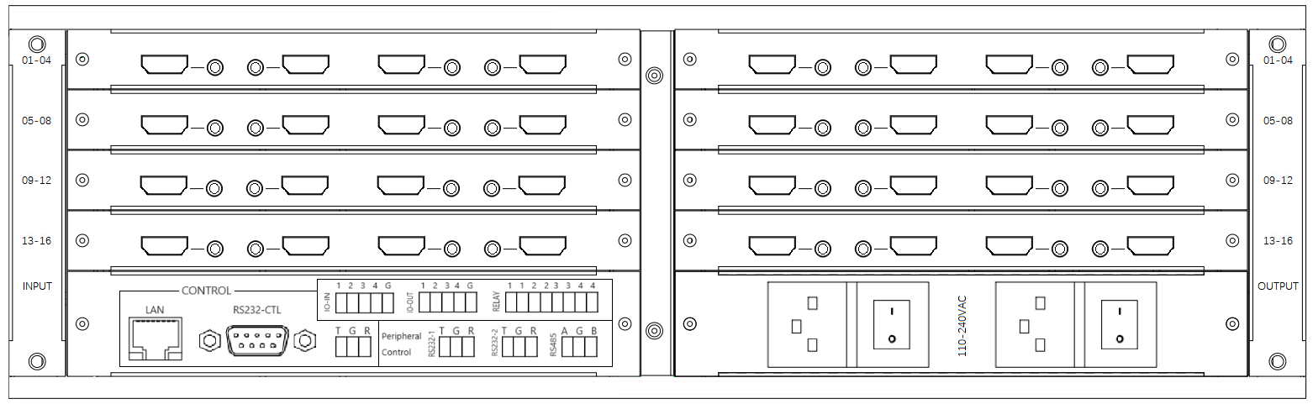

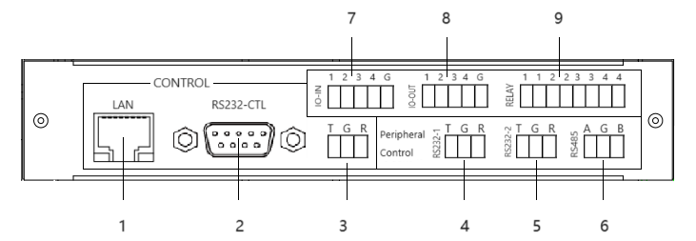

|  |  |  |  |
| --- | --- | --- | --- |
| Index | Function | Description | Details |
| 1 | **Main Control** Use PC to control this matrix switcher | TCP/IP or Web Control | IP address:192.168.0.247 Submask:255.255.255.0 Gateway:192.168.0.1 Baud Rate:9600  Web login account : admin  Web login password : admin |
| 2 | RS232 Control | Baud Rate:9600 |
| 3 | PS232-Phoenix control | T: Matrix Switcher -> PC G: Ground R: Matrix Switcher <- PC |
| 4 | **Peripheral Control** Control other peripherals through this matrix switcher | RS232-1 Peripheral Control | T: Matrix Switcher -> Peripheral G: Ground R: Matrix Switcher <- Peripheral |
| 5 | RS232-2 Peripheral Control | T: Matrix Switcher -> Peripheral G: Ground R: Matrix Switcher <- Peripheral |
| 6 | RS485 Peripheral Control | Connect to peripheral's RS455 port G: Ground |
| 7 | GPIO-Input | 4 inputs level detect,high or low G: Ground |
| 8 | GPIO-Output | 4 outputs,high or low G: Ground |
| 9 | Relay Control | 4 relays control, on or off G: Ground |

# PC Tool user guide

This PC tool is an installation free control software. It is divided into seven tabs according to different functions: Connect, Matrix, Signal, TV wall, System, Multiview and Peripheral. The initial login password is: 111111

## 3.1 Connect tab

Please note：

1. Use serial cable (straight line) or Ethernet cable
2. When using a serial port connection, the network port connection must be disconnected, and vice versa
3. When connecting through the network port, you must first search for and select the device before connecting

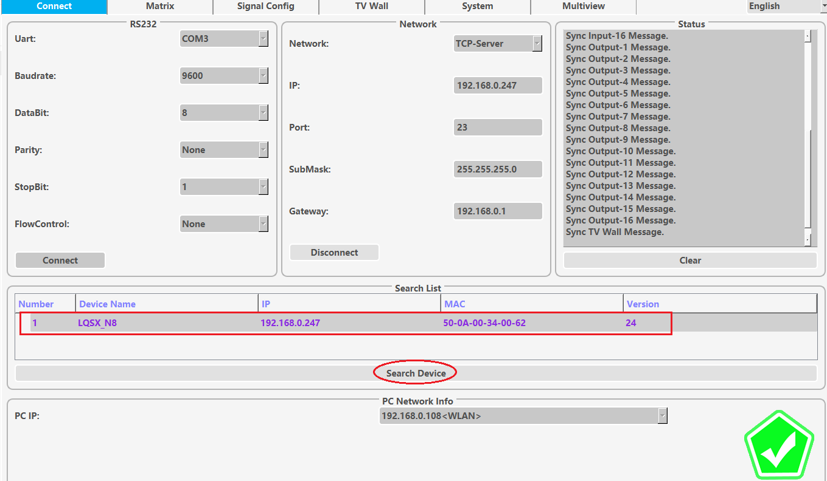

## 3.2 Matrix switch tab

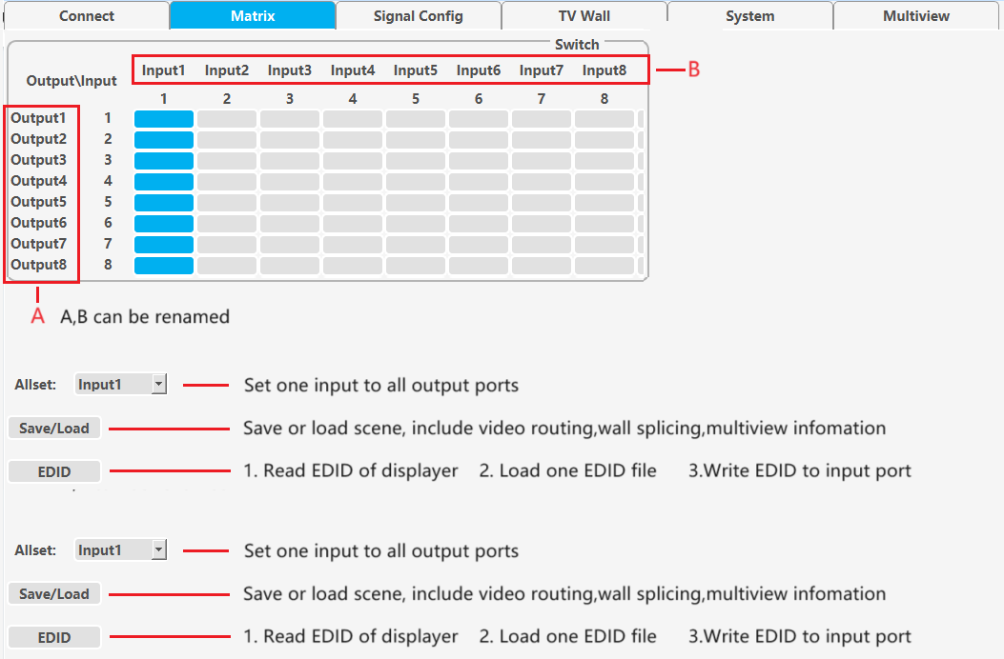

## 3.3 Signal config tab

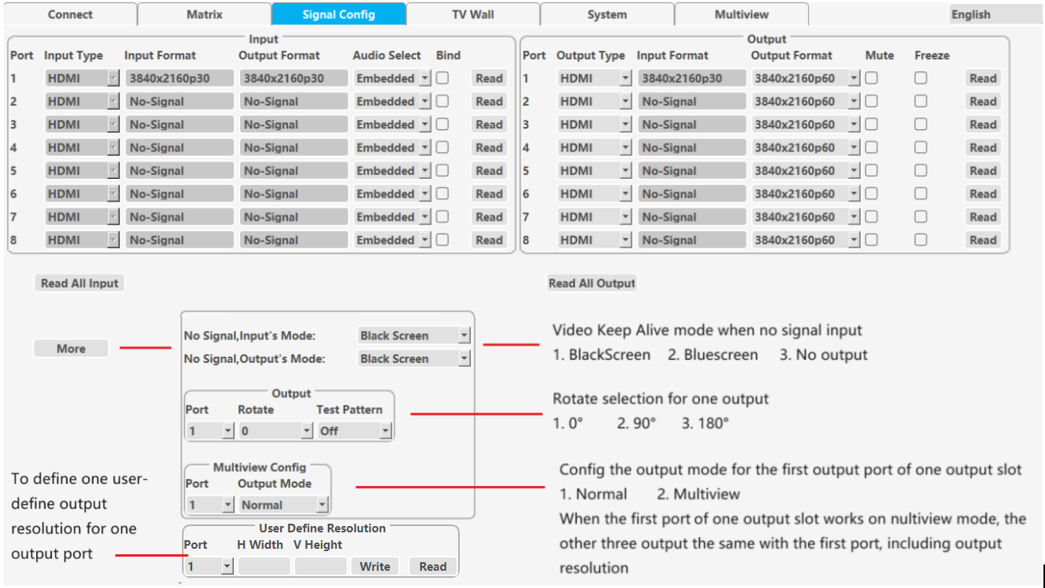

## 3.4 TV wall tab

This tab set the splicing wall parameters: layout, border , input/output settings, etc 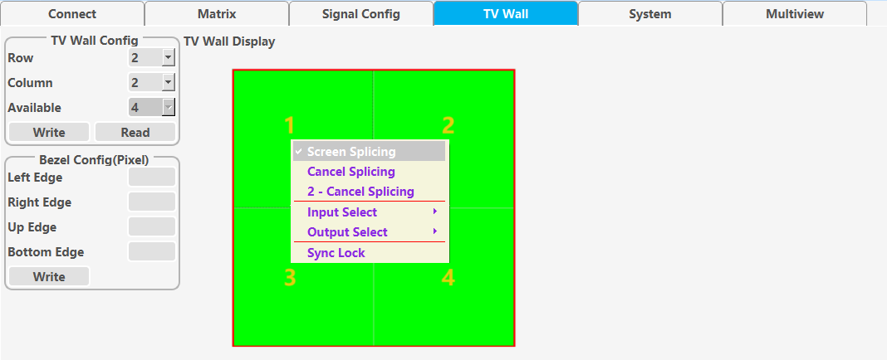

## 3.5 Multiview tab

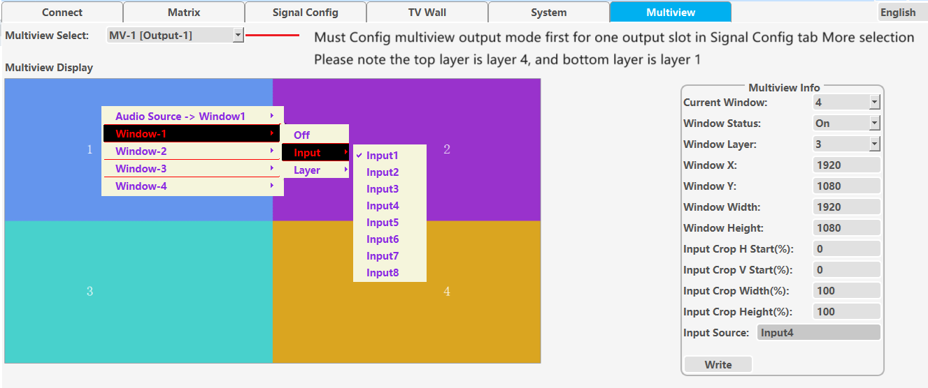

## 3.6 System tab

This tab sets network parameters, resets, reads software versions, etc

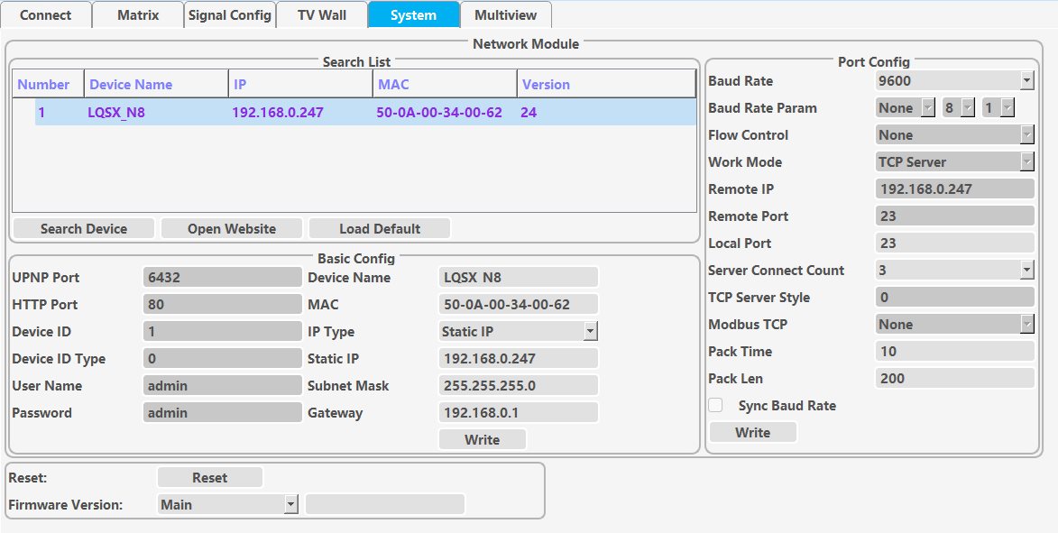

## 3.7 Peripheral tab

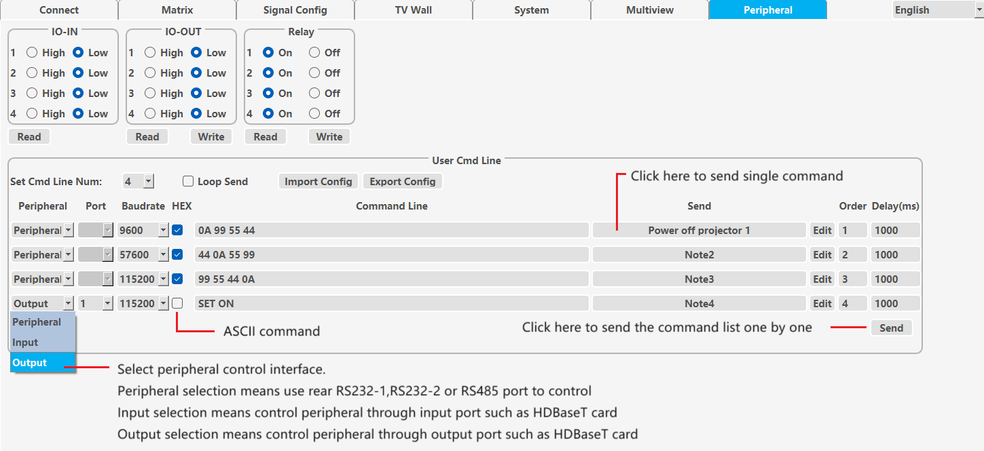

# How to achieve multiview function of splicing wall

**Step 1**, set a certain output card ( suggest to use the last output card ) to work on the multiview mode. We call one of the output ports on this card as output port M

**Step 2**, use one of the input ports of a certain input card ( suggest to use the last input port of the last input card ) as the multiview source input port, called input port N

**Step 3**, connect an external HDMI short cable between output port M and input port N

**Step 4**, set the parameters of the splicing wall and select the input source of the splicing wall as input N

# Commonly used HEX commands

Baud Rate: 9600

Data bits: 8

Parity: None

Stop bits: 1

# 5.1 System command

## 5.1.1 Set matrix size (inputs/outputs number)

Cmd: 7B 7B 95 03 01 ValidOutSum ValidInSum 99 7D 7D

ValidOutSum is output ports number; ValidInSum is input ports number

For example, for an 8x8 matrix, ValidOutSum=08, ValidInSum=08

## 5.1.2 IP config

Cmd: 7B 7B 9B DataLength content 99 7D 7D

DataLength: which is the number of bytes contained in the content

content: the data bytes after converting ASCII string “AT+WANN=IPmode,IPaddress,Subnetmask,Gateway<CR>" to HEX number

IPmode: STATIC or DHCP

IPaddress: IP address value for static IP

Subnetmask: Submask value for static IP

Gateway: Gateway value for static IP

<CR>: Carriage Return ,HEX number 0D

For example:

Set IP mode to STATIC, IP address 192.168.0.156, Subnet mask 255.255.255.0, Gateway 192.168.0.1 (please note here is a carriage return, hex number is 0D）

We need convert ASCII string AT+WANN=STATIC,192.168.0.156,255.255.255.0,192.168.0.1 to HEX number

41 54 2B 57 41 4E 4E 3D 53 54 41 54 49 43 2C 31 39 32 2E 31 36 38 2E 30 2E 31 35 36 2C 32 35 35 2E 32 35 35 2E 32 35 35 2E 30 2C 31 39 32 2E 31 36 38 2E 30 2E 31 0D

And then combined with the command header, DataLength and command tail, the overall command is

7B 7B 9B 37 41 54 2B 57 41 4E 4E 3D 53 54 41 54 49 43 2C 31 39 32 2E 31 36 38 2E 30 2E 31 35 36 2C 32 35 35 2E 32 35 35 2E 32 35 35 2E 30 2C 31 39 32 2E 31 36 38 2E 30 2E 31 0D 99 7D 7D

## 5.1.3 Save Scene

Cmd: 7B 7B 02 01 ModeIndex 99 7D 7D

ModeIndex: Scene No.

## 5.1.4 Load scene

Cmd: 7B 7B 03 01 ModeIndex 99 7D 7D

## 5.1.5 Factory reset

Cmd: 7B 7B AA 02 01 01 99 7D 7D

# 5.2 Switching, querying, and configure command

## 5.2.1 Single input and output switching

Cmd: 7B 7B 01 02 inPort outPort 99 7D 7D

inPort: Input channel, 0 represents input 1

outPort: Output channel, 0 represents output 1. If set FF,represents all output ports

## 5.2.2 Multi input and output ports switching

Cmd: 7B 7B 94 VaildLen 01 Input Output [extend data bytes，continuous Input Output port No.] 99 7D 7D

VaildLen：Add one more to the total number of input ports and output ports

For example：7B 7B 94 11 01 00 00 01 01 02 02 03 03 04 04 05 05 06 06 07 07 99 7D 7D

Switching IN1>OUT1; IN2>OUT2; ... IN8>OUT8

## 5.2.3 Query output input correspondence

Cmd：7B 7B 12 01 00 99 7D 7D

Matrix switcher will return as follows：

7B 7B 11 ValidOutNum Out1Inx Out2Inx … OutnInx 99 7D 7D

ValidOutNum：Total output port number

Out1Inx：Indicates the input port corresponding to output 1. If 0, means output 1 is switched to input 1

## 5.2.4 Set output resolution

Cmd: 7B 7B B1 03 Port 00 ResolutionIndex 99 7D 7D

Port: Ouput port No.，0 represents output 1

ResolutionIndex：Index of output resolution

1280x720p50 //- 00 1280x720p60 //- 01

1920x1080p50 //- 02 1920x1080p60 //- 03

3840x2160p25 //- 04 3840x2160p30 //- 05

3840x2160p50 //- 06 3840x2160p60 //- 07

1024x768p60 //- 08 1280x768p60" //- 09

1280x1024p60 //- 0A 1360x768p60 //- 0B

1920x1200p60 //- 0C 4096x2160p60 //- 0D

4096x2160p50 //- 0E

## 5.2.5 Query input information

Cmd: 7B 7B 7F 02 Port C0 99 7D 7D

Port: Input port No.，0 represents input 1

Matrix switcher will return as follows：

7B 7B 7F 14 Port C0 BoardType FuncFlag InType OutType AudioSelect IN_HresH IN_HresL IN_VresH IN_VresL IN_PorI IN_Frequency OUT_HresH OUT_HresL OUT_VresH OUT_VresL OUT_PorI OUT_Frequency OutRes 99 7D 7D

AudioSelect: = 1, represents external LR audio; 0, represents HDMI embedded audio

IN_HresH: The high 8 bits of the input image's horizontal resolution

IN_HresL: The low 8 bits of the input image's horizontal resolution

IN_VresH: The high 8 bits of the vertical resolution of the input image

IN_VresL: The low 8 bits of the vertical resolution of the input image

IN_PorI:= 1, progressive; 0, interlaced

IN_Frequency: Input frame rate

Attention, OUT_HresH and other OUT_ xx parameter here, mean the output parameters of the input channel

## 5.2.6 Query output information

Cmd: 7B 7B 7F 02 Port 80 99 7D 7D

Port: Output port No.，0 represents output 1

Matrix switcher will return as follows：

7B 7B 7F 0D Port 80 BoardType FuncFlag InType OutType IN_HresH IN_HresL IN_VresH IN_VresL IN_PorI IN_Frequency OutRes 99 7D 7D

OutRes: the index of output resolution

Attention, IN_HresHand other IN_ xx parameter here, mean the input parameters of the output channel

## 5.2.7 Audio selection of input port

Cmd: 7B 7B C4 03 Port 40 AudioSelect 99 7D 7D

Port: Input port No.，0 represents input 1

AudioSelect:= 1, means external LR audio ；0, means embedded audio

## 5.2.8 Output rotate

Cmd: 7B 7B BA 03 OutPort 00 RotateIndex 99 7D 7D

RotateIndex: 0: 0°；1: 90°；2: 180°

# 5.3 Display mode when no input

## 5.3.1 Display mode for output port when no input

Cmd: 7B 7B D7 03 OutPort 00 OutMode 99 7D 7D

OutPort: 0 represents output 1; FF means all the output ports

OutMode = 0, Black screen；1, Blue screen；2, No output

## 5.3.2 Display mode for input port when no input

Cmd: 7B 7B D7 03 InPort 40 OutMode 99 7D 7D

InPort: 0 represents input 1; FF means all the input ports

OutMode: = 0, Black screen；1, Blue screen；2, No output

# 5.4 Wall splicing command

There are two ways to build a video wall

1. Each command is individually set for a specific output port. After setting up each output port required for splicing, a splicing wall naturally forms. The disadvantage is that the entire splicing wall information cannot be read.
2. Set the splicing parameters for all output ports used for splicing with one command. The advantage is that it can read all the parameters of this spliced wall

## 5.4.1 Splicing one output port

Cmd: 7B 7B 90 06 OutPort 00 Line Column P Q 99 7D 7D

Line: total lines of screens

Column: total columns of screens

P: What line of the splicing screen is the current output port on

Q: What column of the splicing screen is the current output port on

## 5.4.2 Set border for one output port

Cmd: 7B 7B 91 06 OutPort 00 LeftBezel RightBezel TopBezel BottomBezel 99 7D 7D

# 5.5 Multiview command

## 5.5.1 Enable multiview function for one output

Cmd: 7B 7B A1 03 Port 00 01 99 7D 7D

## 5.5.2 Disable multiview function for one output

Cmd: 7B 7B A1 03 Port 00 00 99 7D 7D

## 5.5.3 Audio selection for one multiview port

Cmd: 7B 7B A2 03 OutPort 00 AudioSrc 99 7D 7D

AudioSrc：0：Mute；1：Window 1 ；2：Window 2; 3：Window 3 ；4：Window 4

## 5.5.4 Set multiview parameters for output port

Cmd: 7B 7B 9C 12 OutPort 00 WinCount WinID WinStatus LayerRank ViewXH ViewXL ViewYH ViewYL ViewWH ViewWL ViewHH ViewHL CropXRatio CropYRatio CropWRatio CropHRatio 99 7D 7D

WinCount: total window numbers, 4（We can open or close a certain window, but the total number remains 4)

ValidData: Composed of 4 consecutive data bytes

(WinID + WinStatus + LayerRank + ViewXH + ViewXL + ViewYH + ViewYL + ViewWH + ViewWL + ViewHH + ViewHL + CropXRatio + CropYRatio + CropWRatio + CropHRatio)

WinID: Window ID (0~3 respectively represent window 1~4)

WinStatus: 1,Open； 0,Close

LayerRank: The layer of the window (0~3 represents the first to fourth layers, 3 represents the top layer, and 0 represents the bottom layer)

ViewXH: Window horizontal position, high bits

ViewXL: Window horizontal position, low bits

ViewYH: Window vertical position, high bits

ViewYL: Window vertical position, low bits

ViewWH: Window width, high bits

ViewWL: Window width, low bits

ViewHH: Window height, high bits

ViewHL: Window height, low bits

CropXRatio: Input crop，horizontal start, %，default 00

CropYRatio: Input crop，vertical start, %，default 00

CropWRatio: Input crop，width, %，default 64 (Hex digital）, means 100%

CropHRatio: Input crop，height, %，default 64 (Hex digital）, means 100%

## 5.5.5 Query multiview parameters for output port

Cmd: 7B 7B 9C 02 OutPort 80 99 7D 7D

Matrix switcher will return as follows：

7B 7B 9C 43 Port 80 ResWH ResWL ResHH ResHL 04 ValidData 99 7D 7D

ResWH OutResWL: Output resolution, width（High 8 bits and low 8 bits)

ResHH ResHL: Output resolution, height（High 8 bits and low 8 bits)

ValidData: Composed of 4 consecutive data bytes

(WinID + WinStatus + LayerRank + ViewXH + ViewXL + ViewYH + ViewYL + ViewWH + ViewWL + ViewHH + ViewHL + CropXRatio + CropYRatio + CropWRatio + CropHRatio)

## 5.5.6 Set display position and size for one window

Cmd: 7B 7B 9E 08 OutPort 00 04 WinID CropXRatio CropYRatio CropWRatio CropHRatio 99 7D 7D

## 5.5.7 Set the layer level of one multiview window

Cmd: 7B 7B A0 05 Port 00 04 WinID LayerRank 99 7D 7D

## 5.5.8 Query the layer level of one multiview window

Cmd: 7B 7B A0 05 Port 80 04 WinID LayerRank 99 7D 7D

## 5.5.9 Window display and hiding

Cmd: 7B 7B A0 05 OutPort 00 04 WinID WinStatus 99 7D 7D

WinStatus：1: Open, 0: Close