Seamless UHD Video Switcher

With Multiview and KVM Control

Version 1.5

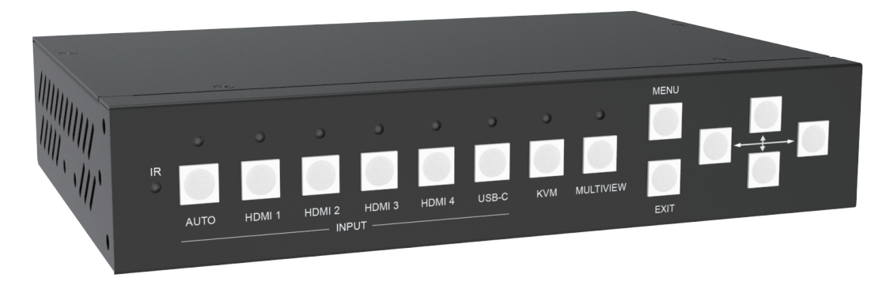

**warningWarning**

* Do not expose this device to Rain, Moisture, and

Dripping

* Only use accessories specified by the manufacture
* Unplug this device during Lightning Storms
* The manual is for reference only, maybe updated

without further notice

Content

1. Features 3

2. Panel Layout 4

3. Remoter 6

4. EDID and HDCP handle 6

5. Video and Audio 7

6. Multiview 7

7. USB Roaming and hotkey control 8

8. OSD Menu Navigation 8

9. Specification 10

10. Package Contents 11

11. RS232 command 11

System and IP command 11

Switching command, only available on SINGLE mode 12

Output command 13

Multiview command 14

Audio command 18

KVM command 19

EDID command 19

**Introduction**

The 5x Inputs and 2x Outputs seamless multiview video switcher with USB-KVM control was developed for the purpose of multiple sources displayed on a single screen and supporting high input and output resolutions.

The switcher can combine up to four video signals onto a single UHD or HD displayer.

The switcher support 4x USB-Type A input which connected to PC and 2x USB output which connected to Mouse and Keyboard

User can easily manage it via the front buttons, remoter, RS232 or TCP/IP commands.

The HDMI B mirror output port can be used for audio amplifier, video capture (with HDMI to USB dongle), or remote display (with HDBaseT convert box)

Application Field:

Home Theatre; Video Conference; Security Monitoring; Presentation and Broadcasting; Teaching System; Financial Stock Analysis; Game E-Sports; Medical Display.

# Features

* 4x HDMI, 1x USB-C(video only) inputs and 2x HDMI mirror outputs
* Support HDMI 2.0,HDCP 2.2, support video resolution up to 3840x2160@60
* Support 5 categories of multiview modes, SINGLE, PIP, PBP, 3xWIN, 4xWIN
* Seamless switching on single window display mode

Fast switching on non-single window display modes

* Support 4x USB Host devices and Mouse/Keyboard for USB-KVM control

Support Mouse/Keyboard control with Windows, Linux and Mac platform

* Support volume control and independently audio selection

Support LPCM, AC3, DD+, DTS, DTS-HD, up to 7.1 audio channel

* Support OSD navigation for advanced setting
* Support USB Roaming for USB-Mouse KVM control
* Extensive EDID and HDCP control

# Panel Layout

Front

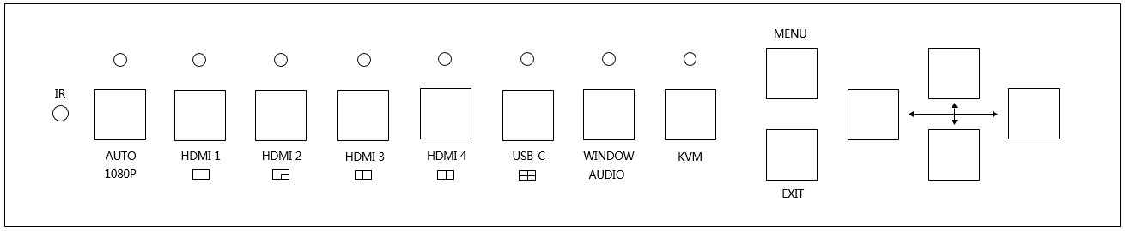

| **Name** | **Description** |
| --- | --- |
| **AUTO** | Press **AUTO** button to enable or disable auto switching function when single window display mode  Long press this button for 3 seconds will change the output resolution to 1080p60 |
| **HDMI 1, HDMI 2**  **HDMI 3, HDMI 4**  **USB-C** | Press these buttons to direct select HDMI 1, 2, 3, 4 or USB-C (video only) as the input source for WIN 1 display  Long press these buttons for 3 seconds to select SINGLE,PIP,  PBP,3xWIN or 4xWIN Multiview mode |
| **WINDOW,**  **AUDIO** | Continue press this button there will be a border shown on window 1 or 2…,then press one input button such as HDMI 1**,** and then HDMI 1 will displayed on the current selected window.  Long press this button for 3 seconds, there will be an Audio selection list on the screen, use and Enter (Menu) to select.  Note, when work on non-SINGLE mode, the LED is always lit. |
| **KVM** | Continue Press this button, the screen will show up one border on window 1, 2, 3 or 4, then user can select one display window as KVM source.  For example if select WIN 2 as KVM source, then rear USB-Keyboard / Mouse will switched to the USB-Host device which displayed on WIN 2. |
| **MENU,EXIT,** | OSD Menu Navigation buttons |

Rear

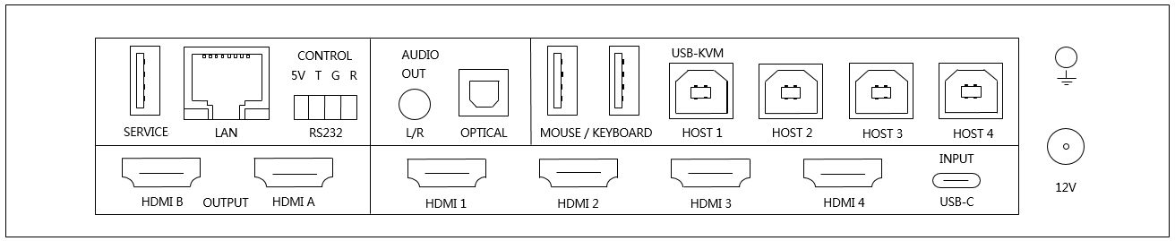

|  |  |
| --- | --- |
| **Name** | **Description** |
| **HDMI A, B** out | HDMI scaling output up to 3840x2160@60  **HDMI A** is the main output |
| **INPUT**s | HDMI 1, HDMI 2, HDMI 3, HDMI 4, USB-C(Video only) |
| **USB-Service** | Used for firmware update |
| **LAN** | TCP/IP control. Default parameters as following  IP address: 192.168.0.247; Sub Mask: 255.255.255.0  GATEWAY: 192.168.0.1; NETPORT: 2000  All the parameters can be changed by RS232 command |
| **RS232** control | 4 way male phoenix connector  Default baud rate 9600, 8 data bits, 1 stop bit, no parity  Baud rate can be changed via OSD menu  **5V** means 5V output;  **T** means Switcher PC  **R** means Switcher PC  **G** means Ground |
| **AUDIO OUTPUT** | 3.5mm L+R output and Toslink-optical digital output |
| **KVM** | USB Connectors which connected to PC or Mouse/Keyboard  4x USB Type B ports connected to PC  2x USB Type A ports to be plugged in mouse or keyboard  The binding relationship between video inputs and USB Host devices as following  HDMI 1<> Host 1, HDMI 2<> Host 2,  HDMI 3<> Host 3, HDMI 4<> Host 4, USB-C <> Host 4  HDMI 4 and USB-C can’t be used as KVM source meanwhile |
| **12V** | 12V power adapter to plug in |

# Remoter

|  |  |
| --- | --- |
| **Number** | **Description** |
| **1** | Return/Exit |
| **2** | Video input selection |
| **3** | OSD menu navigation  Menu (Enter),UP, DOWN,  LEFT,RIGHT |
| **4** | Multiview mode selection |
| **5** | Audio input selection |
| **6** | USB-KVM selection.  The same with the front KVM button function |

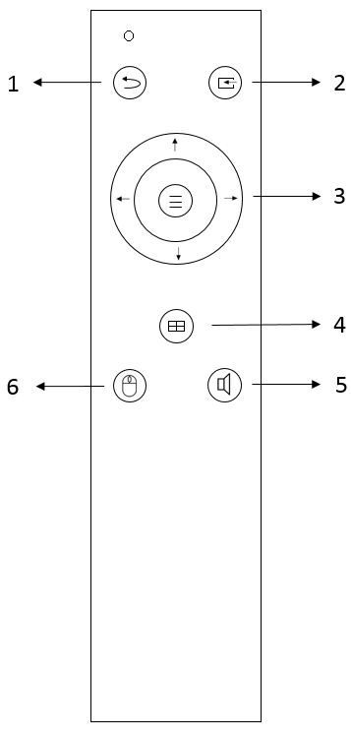

# EDID and HDCP handle

User can select following EDID modes by RS232 command or OSD menu navigation

|  |  |  |  |
| --- | --- | --- | --- |
| **Number** | **EDID mode** | **Number** | **EDID mode** |
| **1** | 4K60-2.0CH | 10 | 1600x1200 |
| **2** | 4K60-5.1CH | 11 | 1440x900 |
| **3** | 4K30-2.0CH | 12 | 1360x768 |
| **4** | 4K30-5.1CH | 13 | 1280x1024 |
| **5** | 1080P-2.0CH | 14 | 1024x768 |
| **6** | 1080P-5.1CH | 15 | AUTO |
| **7** | 720P | 16 | 4K60-7.1CH |
| **8** | 1920x1200 | 17 | 4K30-7.1CH |
| **9** | 1680x1050 | 18 | 1080P-7.1CH |
|  |  | 19 | USER |

The HDMI output support 3 HDCP options: FORCE-1.4, FORCE-2.2, FORCE-OFF

User can select it by RS232 command

# Video and Audio

The switcher support multiple resolution video input up to 3840x2160@60, and support multiple audio format such as LPCM, AC3, DD+, DTS, DTS-HD, up to 7.1 channel pass through function via HDMI cable

User can control the audio volume when the audio input is LPCM format

Please note, USB-C input port can only accept LPCM 2.0 audio

The switcher support following video output resolution by a powerful scaling engine

|  |  |  |  |
| --- | --- | --- | --- |
| **Number** | **Output Resolution** | **Number** | **Output Resolution** |
| **1** | 4096x2160p 60Hz | 8 | 1920x1080p 60Hz |
| **2** | 4096x2160p 50Hz | 9 | 1920x1080p 50Hz |
| **3** | 3840x2160p 60Hz | 10 | 1360x768p 60Hz |
| **4** | 3840x2160p 50Hz | 11 | 1280x800p 60Hz |
| **5** | 3840x2160p 30Hz | 12 | 1280x720p 60Hz |
| **6** | 3840x2160p 25Hz | 13 | 1280x720p 50Hz |
| **7** | 1920x1200p60Hz RB | 14 | 1024x768 60Hz |

# Multiview

The Switcher support 5 categories of multiview display modes

SINGLE, PIP, PBP, 3xWIN, 4xWIN

Users can select different operations for different Multiview modes as following:

SINGLE: Inputs selection

PIP: Inputs selection, Display Ratio selection, Sub window size and position selection

PBP, 3xWIN, 4xWIN: Inputs selection, Window Ratio selection, Display aspect

Multiview window distribution as following

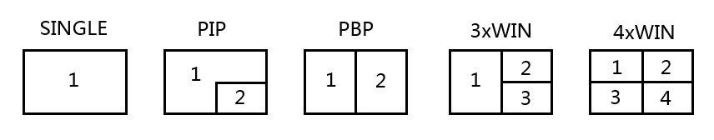

User can do more layouts via RS232 commands or OSD menu navigation

# USB Roaming and hotkey control

The KVM button on front panel can direct select KVM window

USB Roaming can be enabled when works on PBP, 3xWIN or 4xWIN mode

The following sketch map shows USB Roaming when moving mouse cursor from left (WIN1) to right for 4xWIN display mode

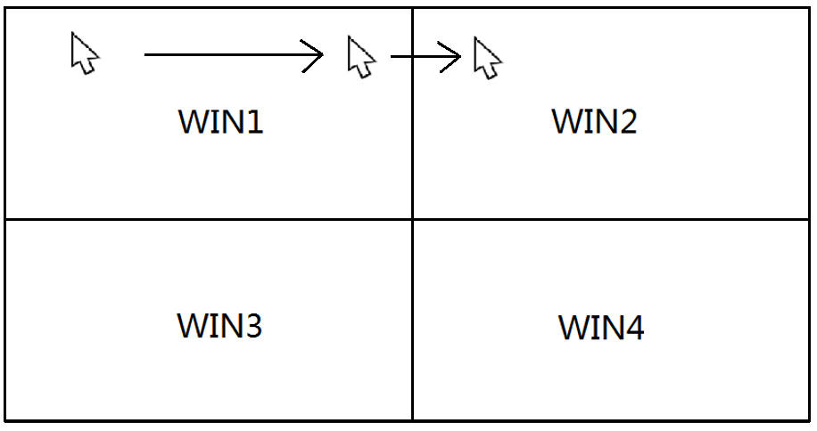

There are some hotkeys of keyboard for KVM control:

1. Ctrl + Ctrl + 1,2,3 or 4, select keyboard/mouse window
2. Ctrl + Ctrl + R + N, disable USB Roaming
3. Ctrl + Ctrl + R + Y, Enable USB Roaming
4. Ctrl + Ctrl + M + 1,2,3,4 or 5 switching multiview mode to SINGLE, PIP, PBP, 3xWIN, or 4xWIN mode
5. Ctrl + Ctrl + W + m + S + n, display source n on window m. m means window number, n is input port number ( 1 means HDMI 1 input,…, 5 means USB-C input).
6. Ctrl + Ctrl + A + n, n is 1, 2, …5, or A, switch audio source,

1 means HDMI 1, A means WIN 1 (the source of window 1)

1. Ctrl + Ctrl + A + N, audio mute
2. Ctrl + Ctrl + A + Y, audio unmute

Please note:

1. The “+” here represents a sequence, not an actual symbol or letter
2. After press Ctrl + Ctrl, system will enter Hotkey waiting, if the left

Keys pressing not finished in 5 seconds， hotkeys will be time out

1. After press Ctrl + Ctrl, system will enter Hotkey waiting, if then press

Ctrl or ESC,hotkeys operation will be terminated

# OSD Menu Navigation

Total 6 buttons used for OSD navigation, MENU, EXIT, UP, DOWN, LEFT, RIGHT

Menu contents as following:

|  |  |  |  |
| --- | --- | --- | --- |
| Output | Resolution | 3840x2160p60 | 3840x2160p60,… |
| VKA | BLACKSCREEN, | BLACKSCREEN, BLUESCREEN |
| 4K-Auto | ON | ON,OFF |
| ITC | OFF | ON,OFF |
| Multiview | Single | Input select | HDMI1, … |
| PIP | Win1 Select | HDMI1,… |
| Win2 Select | HDMI1,… |
| PIP Position | RightBottom,… |
| PIP Size | SMALL,… |
| PBP | Win1 Select | HDMI1,… |
| Win2 Select | HDMI1,… |
| MODE | 1, 2 |
| Aspect | Full, 16:9 |
| 3xWIN | Win1 Select | HDMI1,… |
| Win2 Select | HDMI1,… |
| Win3 Select | HDMI1,… |
| MODE | 1, 2 |
| Aspect | Full, 16:9 |
| 4xWIN | Win1 Select | HDMI1,… |
| Win2 Select | HDMI1,… |
| Win3 Select | HDMI1,… |
| Win4 Select | HDMI1,… |
| MODE | 1, 2 |
| Aspect | Full,16:9 |
| AUDIO | Audio Select | WIN1 | WIN1,HDMI1,… |
| Volume | 100 | 0..100 |
| AUDIO-MUTE | OFF | ON, OFF |
| System | Language/语言 | English | English, 中文 |
| EDID | 4K60-2.0 | 4K60-2.0,… |
| USB Roaming | OFF | ON, OFF |
| Baud rate | 9600 | 9600, 19200, 38400,57600, 115200 |
| Reset |  |  |
| FW Version |  | Read only |
| IP Address |  | Read only |

Please note

For **ITC** setting, suggest **OFF** for video display and **ON** for PC especially desktop display, default setting is **OFF**

# Specification

|  |  |
| --- | --- |
| Band Width | 594MHz (18Gbps), HDMI 2.0, HDCP2,2 |
| Audio Format | LPCM, AC3, DD+, DTS, DTS-HD  Up to 7.1 channel |
| Input ports | 4x HDMI, 1x USB-C, 4x USB-B (Host) |
| Output ports | 2x HDMI, 2x USB-A (Device),  1x 3.5mm LR audio,  1x Toslink digital audio |
| Power Supply | 12V/3A ,15W max |
| Operating Temperature | 0 to +40°C (+32 to +104 °F) |
| Operating Humidity | 10 to 70 % RH (non-condensing) |
| ESD | Air: ± 8KV, Contact: ± 4KV, |
| Dimensions | L219 x W146 x H44 mm |
| Mass (Main Unit) | 1.2kg |

# Package Contents

|  |  |
| --- | --- |
| **Item** | **Quantity** |
| Switcher Unit | 1 |
| 12V/3A power adapter | 1 |
| 4-way male captive screw connector | 1 |
| User Manual | 1 |
| Remoter | 1 |
| Bracket | 2 |

# RS232 command

**Note:** All the commands begin with SET or GET, end with Carriage Return (CR).

⮠ Represents Carriage Return (CR). All return messages are always end with CR.

## System and IP command

|  |  |
| --- | --- |
| Command | Details |
| GET HELP⮠ | Get the Commands list |
| SET RESET⮠ | Recover to default setting |
| GET VERSION⮠ | Get firmware version  Return: VERSION w (w is version number) |
| SET BAUDRATE w⮠ | w is 9600, 19200, 38400,57600 or 115200  Return: BAUDRATE w |
| GET BAUDRATE w⮠ | Return: BAUDRATE w |
| SET IP ADDRESS w⮠ | For example: SET IP ADDRESS 192.168.0.247  Return: IP ADDRESS w |
| GET IP ADDRESS⮠ | Return: IP ADDRESS w |
| SET SUBMASK w⮠ | For example: SET SUBMASK 255.255.255.0  Return: SUBMASK w |
| GET SUBMASK⮠ | Return: SUBMASK w |
| SET GATEWAY w⮠ | For example: SET GATEWAY 192.168.0.1  Return: GATEWAY w |
| GET GATEWAY⮠ | Return: GATEWAY w |
| SET NETPORT w⮠ | For example: SET NETPORT 2000  Return: NETPORT w |
| GET NETPORT⮠ | Return: NETPORT w |
| SET NETWORK-INFO IP PORT SUBMASK GATEWAY⮠ | For Example:  SET NETWORK-INFO 192.168.0.247 2000 255.255.255.0 192.168.0.1  Return: NETWORK-INFO 192.168.0.247 2000 255.255.255.0 192.168.0.1 |
| GET NETWORK-INFO⮠ | Return: NETWORK-INFO IP PORT SUBMASK GATEWAY |

## Switching command, only available on SINGLE mode

|  |  |
| --- | --- |
| Commands | Details |
| SET AUTO SWITCH w⮠ | w is ON or OFF, default OFF  Return: AUTO SWITCH w |
| GET AUTO SWITCH⮠ | Return: AUTO SWITCH w |
| SET IN SOURCE w⮠ | w is one of the following:  HDMI1, HDMI2, HDMI3, HDMI4, USB-C  Return: IN SOURCE w |
| GET IN SOURCE⮠ | Get current input channel selection information  Return: IN SOURCE w |
| GET IN RESOLUTION⮠ | Get current input resolution  Return: IN RESOLUTION w (w is input resolution) |
| GET IN STATUS⮠ | Get status of all input ports  x is HDMI1…HMDI4,USB-C  Return: IN STATUS x VALID(or INVALID)  If input port is vaild,  Return: IN STATUS x InputRes ColorSpace ColorDepth |

## Output command

|  |  |
| --- | --- |
| Commands | Details |
| SET OUT RESOLUTION w⮠ | w is one of the following, default: 3840x2160p60  4096x2160p60, 4096x2160p50,  3840x2160p60, 3840x2160p50,  3840x2160p30, 3840x2160p25,  1920x1200p60RB, 1920x1080p60,  1920x1080p50, 1360x768p60,  1280x800p60, 1280x720p60,  1280x720p50, 1024x768p60，  AUTO, USER  Return: OUT RESOLUTION w |
| GET OUT RESOLUTION⮠ | Get current output resolution setting  Return: OUT RESOLUTION w |
| SET RESO-USER Width Height⮠ | Set user define output resolution  Width is horizontal active pixels  Height is vertical active lines  For user define output resolution,the frame rate is always 60Hz  Return: RESO-USER Width Height⮠ |
| GET RESO-USER⮠ | Return: RESO-USER Width Height⮠ |
| SET OUT 4K-AUTO w⮠ | w is ON or OFF, default ON  If we set 4K output to a displayer which can’t support 4K, then the ON setting can change the resolution to 1080p or 4K-4:2:0  Return: OUT 4K-AUTO w |
| GET OUT 4K-AUTO⮠ | Get current OUT 4K-AUTO mode  Return: OUT 4K-AUTO w |
| SET OUT HDCP w⮠ | w is one of the following, default OFF  FORCE-1.4,FORCE-2.2,FORCE-OFF  Return: OUT HDCP w |
| GET OUT HDCP⮠ | Return: OUT HDCP w |
| SET OUT VKA w⮠ | w is BLUESCREEN or BLACKSCREEN.  Default BLACKSCREEN. It is for no signal display  Return: OUT VKA w |
| GET OUT VKA⮠ | Return: OUT VKA w |
| SET OUT ITC w⮠ | w is ON or OFF, default OFF  Return: OUT ITC w |
| GET OUT ITC⮠ | Return: OUT ITC w |

## Multiview command

|  |  |
| --- | --- |
| Commands | Details |
| SET MULTIVIEW w⮠ | Select one Multiview mode for current display  w is one of the following, default SINGLE  SINGLE C:\Users\windows7\AppData\Local\Temp\1629080528(1).png, PIP , PBPC:\Users\windows7\AppData\Local\Temp\1629081546(1).png, 3xWIN C:\Users\windows7\AppData\Local\Temp\1629082712(1).png, 4xWIN C:\Users\windows7\AppData\Local\Temp\1629082974(1).png  Return: MULTIVIEW w |
| GET MULTIVIEW⮠ | Get the current Multiview mode  Return: MULTIVIEW w |
| SET WINDOWx IN y⮠ | Select one input for one display window for the current Multiview mode. x is one of 1, 2, 3 or 4  y is one of HDMI1, HDMI2, HDMI3, HDMI4, USB-C  Return: WINDOWx IN y |
| GET WINDOWx IN⮠ | This command to get which is the input source for one display window for the current Multiview mode  Return: WINDOWx IN y |
| SET FREEZE-WINx w | Freeze the display window,x is one of 1, 2, 3 ,4 or ALL, w is ON or OFF  Return: FREEZE-WINx w |
| GET FREEZE-WINx | x is one of 1, 2, 3 ,4.  Return: FREEZE-WINx w (w is ON or OFF) |
| SET PIP POS w⮠ | This command to select the PIP sub window position.  w is one of the following, default RightBottom  LeftTop, LeftBottom, RightTop, RightBottom, USER  Return: PIP POS w |
| GET PIP POS⮠ | This command to get the PIP sub window position  Return: PIP POS w |
| SET PIP SIZE w⮠ | This command to select the PIP sub window size.  w is one of the following, default LARGE  SMALL,MIDDLE, LARGE, USER  Return: PIP SIZE w |
| GET PIP SIZE⮠ | Return: PIP SIZE w |
| SET PIP USER HStart VStart HSize VSize⮠ | Return: PIP USER HStart VStart HSize VSize  This command allows users to customize a PIP layout include sub window position and size.  This customized PIP layout will replace other pre-defined PIP modes (such as LeftTop,LARGE) and display on the screen  After the user enters SET PIP POS or SET PIP SIZE command,the PIP USER will become invalid    Please note  HStart plus HSize less than or equal to 101  VStart plus VSize less than or equal to 101 |
| GET PIP USER⮠ | Return: PIP USER HStart VStart HSize VSize |
| SET PBP MODE w⮠ | Set the PBP display mode  w is one of 1,2 or 3, default 1    Return: PBP MODE w  Please note for PBP mode 3, the window 2 can capture part of the input image area. It is main used for presenter show when work with conference camera situations  The capture area can be defined by SET PBP-PRESENTER command |
| GET PBP MODE⮠ | Return: PBP MODE w |
| SET PBP ASPECT w⮠ | Set the PBP window display aspect  w is FULL or 16:9, default FULL    Return: PBP ASPECT w |
| GET PBP ASPECT⮠ | Return: PBP ASPECT w |
| SET PBP-PRESENTER HStart VStart HSize VSize⮠ | Set window 1 capture area for PBP mode 3  This command only valid when the switcher already work on PBP mode 3  Return: PBP-PRESENTER HStart VStart HSize VSize    Default HStart 38, VStart 13, HSize 25, VSize 75  Please note  HStart plus HSize less than or equal to 101  VStart plus VSize less than or equal to 101 |
| GET PBP-PRESENTER⮠ | Return: PBP-PRESENTER HStart VStart HSize VSize |
| SET 3xWIN MODE w⮠ | Set the 3xWIN display mode  w is one of 1,2,3 or 4, default 1  C:\Users\windows7\AppData\Local\Temp\1658982390(1).png  Return: 3xWIN MODE w |
| GET 3xWIN MODE⮠ | Return: 3xWIN MODE w |
| SET 3xWIN ASPECT w⮠ | Set the 3xWIN window display aspect  w is FULL or 16:9, default FULL  C:\Users\windows7\AppData\Local\Temp\1658982480(1).png  Return: 3xWIN ASPECT w |
| GET 3xWIN ASPECT⮠ | Return: 3xWIN ASPECT w |
| SET 4xWIN MODE w⮠ | Set the 4xWIN display mode  w is 1 or 2 ,default 1    Return: 4xWIN MODE w |
| GET 4xWIN MODE⮠ | Return: 4xWIN MODE w |
| SET 4xWIN ASPECT w⮠ | Set the 4xWIN window display aspect  w is FULL or 16:9, default FULL  C:\Users\windows7\AppData\Local\Temp\1637116792(1).png  Return: 4xWIN ASPECT w |
| GET 4xWIN ASPECT⮠ | Return: 4xWIN ASPECT w |
| GET MULTIVIEW-SYNC⮠ | Return Multiview layout information |
| SET SAVE SCENE w⮠ | Save current display scene  w is 1, 2,…20  Return: SAVE SCENE w |
| SET LOAD SCENE w⮠ | Load display scene  w is 1, 2,…20  Return: LOAD SCENE w |

## Audio command

|  |  |
| --- | --- |
| Commands | Details |
| SET AUDIO SOURCEw⮠ | w is one of the following:  WIN1, HDMI1, HDMI2, HDMI3, HDMI4, USB-C  Return: AUDIO SOURCE w |
| GET AUDIO SOURCE⮠ | Return: AUDIO SOURCE w |
| SET AUDIO VOL+⮠ | Increase audio out volume  Return: AUDIO VOL w (w is the volume value) |
| SET AUDIO VOL-⮠ | Decrease audio out volume  Return: AUDIO VOL w (w is the volume value) |
| SET AUDIO VOL w⮠ | Set audio volume value  w is 0,1…,or 100, default 100  For example: SET AUDIO VOL 100  Return: AUDIO VOL w |
| GET AUDIO VOL⮠ | Return: AUDIO VOL w |
| SET AUDIO-MUTE w⮠ | Mute or unmute audio output  Here w is ON or OFF, default OFF  Return: AUDIO-MUTE w |
| GET AUDIO-MUTE⮠ | Return: AUDIO-MUTE w |

## KVM command

|  |  |
| --- | --- |
| Commands | Details |
| SET KVMw⮠ | w is one of WIN1, WIN2, WIN3, WIN4  Return: KVM w |
| SET USB ROAMINGw⮠ | w is ON or OFF, default OFF  Return: USB ROAMING w |
| GET USB ROAMING ⮠ | Return: USB ROAMING w |

Please note when work on SINGLE display mode, the KVM function of current selected source is always activated

## EDID command

The following commands are used to set EDID mode for the inputs

|  |  |
| --- | --- |
| Commands | Details |
| SET IN EDIDMODE w⮠ | w is one of the following:  4K60-2.0, 4K60-5.1, 4K60-7.1, 4K30-2.0,  4K30-5.1, 4K30-7.1, 1080p60-2.0,1080p60-5.1,  1080p60-7.1,1920x1200, 1680x1050, 1600x1200, 1440x900, 1360x768, 1280x1024, 1024x768, 720p, AUTO,USER  Default: 4K60-2.0  Return: IN EDIDMODE w |
| SET EDID-USER w⮠ | Switcher can only support 256 bytes EDID-USER data.  w is 256 bytes EDID data.  Return: EDID-USER OK |
| GET IN EDIDMODE⮠ | Return: IN EDIDMODE w |