Seamless UHD Presentation Switcher

With Multiview Control

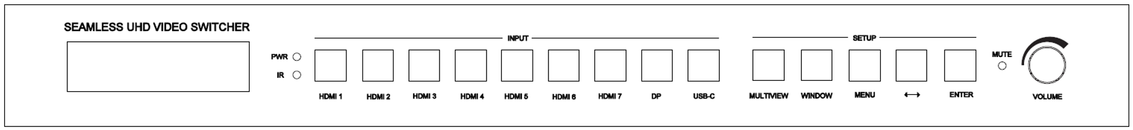

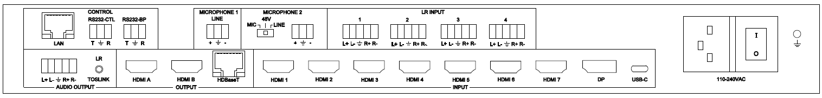

**warningWarning**

* Do not expose this device to Rain, Moisture, and Dripping
* Only use accessories specified by the manufacture
* Unplug this device during Lightning Storms
* The manual is for reference only, maybe updated

without further notice

Content

1. Features 3

2. Panel Layout 4

3. EDID and HDCP handle 5

4. Video and Audio 6

5. Multiview 7

6. Remoter 7

7. OSD Menu 8

8. Specification 10

9. Package Contents 10

10. RS232 command 10

System command 10

Switching command, only available on SINGLE mode 11

Output command 12

Multiview command 14

Audio command 17

EDID command 18

**Introduction**

This device is a seamless multi-format presentation switcher with 7 HDMI 2.0 inputs, 1 Display Port input and 1 USB-C (Video and Audio only) input. It provides three mirrored outputs – HDMI A, HDMI B for local display and HDBaseT output for a remote HDBaseT receiver and display.

It provide 4 balanced LR audio inputs and 2 microphone inputs

This device support display multiple sources on a single screen up to 4 display window

User can easily manage it via the front buttons,Remoter,RS232, TCP/IP commands.

# Features

* 7 HDMI inputs, 1 DP input, 1 USB-C (Video and Audio only) input
* 3 mirrored outputs – HDMI A, HDMI B and HDBaseT
* HDBaseT transmission distance：70m@4K; 100m@1080p60
* Support HDMI 2.0,HDCP 2.2, video resolution up to 3840x2160@60
* Support SINGLE,PIP,PBP,3xWIN,4xWIN display mode

Provide up to 20 display scene to save or load

* Seamless switching on single window display mode
* Fast switching on non-single window display modes
* Support independently audio selection (break away selection)
* Support audio LPCM,AC3,DD+,DTS for Input HDMI1/2/3
* Support 2 microphone inputs, both can be mixed with main audio
* Independently microphones volume control and overall volume control
* Support balanced LR audio output and Toslink digital audio output
* Support external LR input
* Support multiple Test Pattern output
* Support 24V iPOC power supply to remote HDBaseT receiver
* Support OSD Menu navigation

# Panel Layout

Front



| **Name** | **Description** |
| --- | --- |
| **Power LED** | Lit when the switcher is powered |
| **IR sensor** | Remoter receiver |
| **HDMI 1, 2…,7,**  **DP, USB-C** | Total 9 inputs to be selected  Press one of these buttons to direct select input source for single window display  When display on PIP,PBP,3xWIN,4xWIN mode, one of the inside LED for the 9 input buttons will still be lit, it represents the input source of the window 1 |
| **MULTIVIEW** | Press this button to loop select PIP, PBP, 3xWIN, 4xWIN display mode. When switcher work on single mode, then press Multiview button to select the last Multiview mode (PIP,PBP, 3xWIN or 4xWIN).  The inside LED on Multiview button will be lit when work on PIP,PBP, 3xWIN or 4xWIN mode, and will be off when work on single window mode |
| **WINDOW** | Press this button, then the screen will show up one yellow border on window 1. Continue press this button the border will be shown on window 2 or 3… then press one button such as HDMI 1**,** and then HDMI 1 will displayed on the current selected window |
| **MENU, ↔** ,  **ENTER** | Three buttons to setup the system with front panel OSD navigation:   1. Microphone 1 ON or OFF 2. Microphone 1 volume, control it with audio knob 3. Microphone 2 ON or OFF 4. Microphone 2 volume, control it with audio knob 5. Main audio ON or OFF 6. Main audio selection 7. 4K AUTO output ON or OFF 8. COMP Mode: CSC,DSC.   HDBT compression mode when output resolution is 4K60   1. Test Pattern ON or OFF 2. Output resolution selection 3. EDID selection 4. Auto Switch ON or OFF 5. Long Reach Mode ON or OFF 6. RS232 baud rate 7. IP address info 8. Firmware version info |
| **MUTE LED** | Lit when audio muted |
| **Audio Knob** | Left or right rotation to control overall audio volume (main audio and two microphones audio)  Directly press it to mute or unmute overall audio output |

Rear



|  |  |
| --- | --- |
| **Name** | **Description** |
| **Audio outputs** | Balanced L+R output,  3.5mm L+R output and Toslink-optical output compatible |
| **Outputs** | HDMI A, HDMI B, HDBaseT |
| **INPUT**s | HDMI 1, …, HDMI 7, DP, USB-C |
| **LAN** | TCP/IP control. Default parameters as following  IP address: 192.168.0.247; Sub Mask: 255.255.255.0  GATEWAY: 192.168.0.1; NETPORT: 2000  All the parameters can be changed by RS232 command |
| **RS232** control | Default baud rate 9600, 8 data bits, 1 stop bit, no parity  T, Switcher → PC  R, Switcher **←**PC  G, Ground  Baud rate options as following, can be selected by front panel  9600,19200,38400,57600,115200 |
| **RS232-BP** | Pass through RS232-CTL commands |
| **Microphone 1** | Microphone-Line input |
| **Microphone 2** | Microphone input, there are three options with slide switch to select: 48V Phantom, MIC, LINE |

# EDID and HDCP handle

User can select following EDID modes by RS232 command or front panel

|  |  |  |  |
| --- | --- | --- | --- |
| **Number** | **EDID mode** | **Number** | **EDID mode** |
| **1** | 4K60-2.0CH | 11 | 1440x900 |
| **2** | 4K60-5.1CH | 12 | 1360x768 |
| **3** | 4K30-2.0CH | 13 | 1280x1024 |
| **4** | 4K30-5.1CH | 14 | 1024x768 |
| **5** | 1080P-2.0CH | 15 | AUTO |
| **6** | 1080P-5.1CH | 16 | 4K60-7.1CH |
| **7** | 720P | 17 | 4K30-7.1CH |
| **8** | 1920x1200 | 18 | 1080P-7.1CH |
| **9** | 1680x1050 | 19 | USER |
| **10** | 1600x1200 |  |  |

The HDMI output support 3 HDCP options: FORCE-1.4, FORCE-2.2, FORCE-OFF

User can select it by RS232 command

# Video and Audio

Support compressed audio such as AC3, DD+, DTS to pass through via HDMI cable with INPUT 1/2/3.

Beside HDMI(DP,USB-C) inner audio,there are 4 balanced LR audio inputs and one mute-NONE for main audio selection and this main audio selection is broken away from video selection.

So there are total 14 options for main audio selection:

WIN1, HDMI1, HDMI2,…HDMI7,DP,USB-C,LR1,LR2,LR3,LR4

WIN1 means the main audio is always taken from the source of window 1.

Both microphones (one is Microphone-Line only) can be mixed together with main audio.

Microphone and overall volume can be controlled by RS232 command or front buttons and knob.

Please note when main audio is compressed format such as AC3 or DTS, the switcher can’t do microphone mixer. And will pass through main audio to downstream.

The switcher support multiple resolution video input up to 3840x2160@60, and support following video output resolution:

|  |  |  |  |
| --- | --- | --- | --- |
| **Number** | **Output Resolution** | **Number** | **Output Resolution** |
| **1** | 4096x2160p 60Hz | 8 | 1920x1080p 60Hz |
| **2** | 4096x2160p 50Hz | 9 | 1920x1080p 50Hz |
| **3** | 3840x2160p 60Hz | 10 | 1360x768p 60Hz |
| **4** | 3840x2160p 50Hz | 11 | 1280x800p 60Hz |
| **5** | 3840x2160p 30Hz | 12 | 1280x720p 60Hz |
| **6** | 3840x2160p 25Hz | 13 | 1280x720p 50Hz |
| **7** | 1920x1200p60Hz RB | 14 | 1024x768 60Hz |

# Multiview

The Switcher support 5 categories of multiview display modes

SINGLE, PIP, PBP, 3xWIN, 4xWIN

Users can select different operations for different Multiview modes as following:

SINGLE, PIP, PBP, 3xWIN, 4xWIN

Multiview window distribution as following

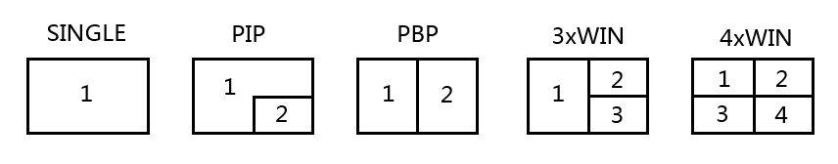

User can do more layouts via RS232 commands and provide user defined multiview up to 10 scenes. The scene includes following points

Multiview Mode: SINGLE, PIP, PBP, 3xWIN, 4xWIN

SINGLE: Input selection

PIP: Inputs selection, Sub window size and position selection

PBP, 3xWIN, 4xWIN: Inputs selection, Layout Mode, Display aspect

# Remoter

|  |  |
| --- | --- |
| **Number** | **Description** |
| **1** | Return/Exit |
| **2** | Video input selection |
| **3** | OSD menu navigation  Menu (Enter),UP, DOWN,  LEFT,RIGHT  Press Left or Right key alone can decrease or increase audio volume |
| **4** | Multiview mode selection |
| **5** | Audio input selection |
| **6** | Reserve |

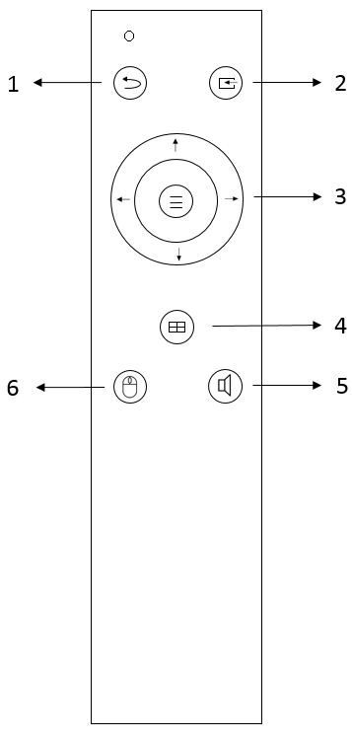

# OSD Menu

Total 4 categories of OSD content: Output Config, Multiview, Audio, System

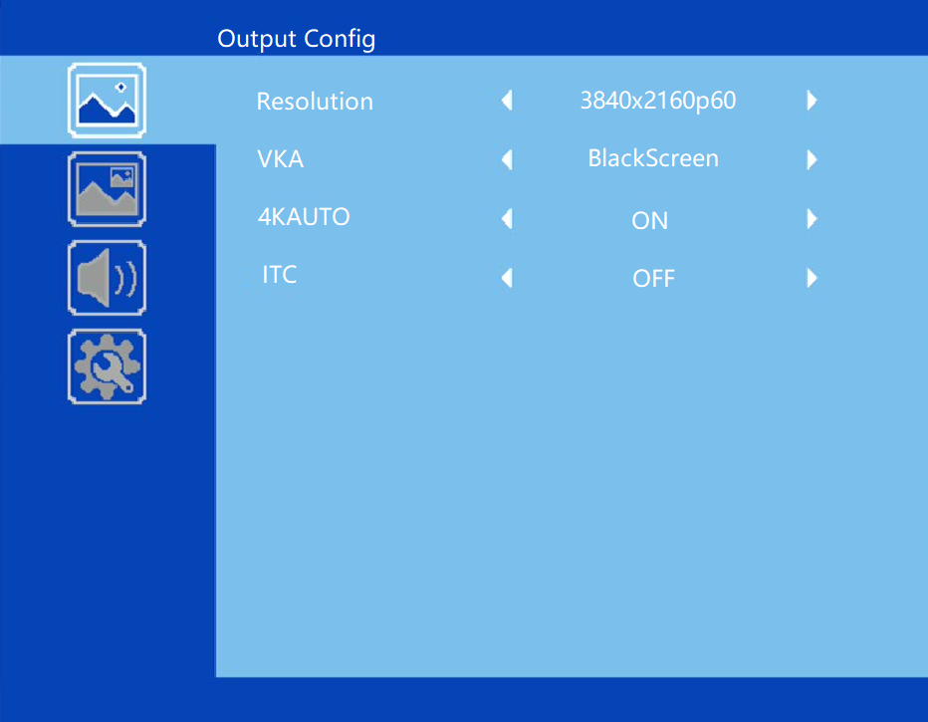

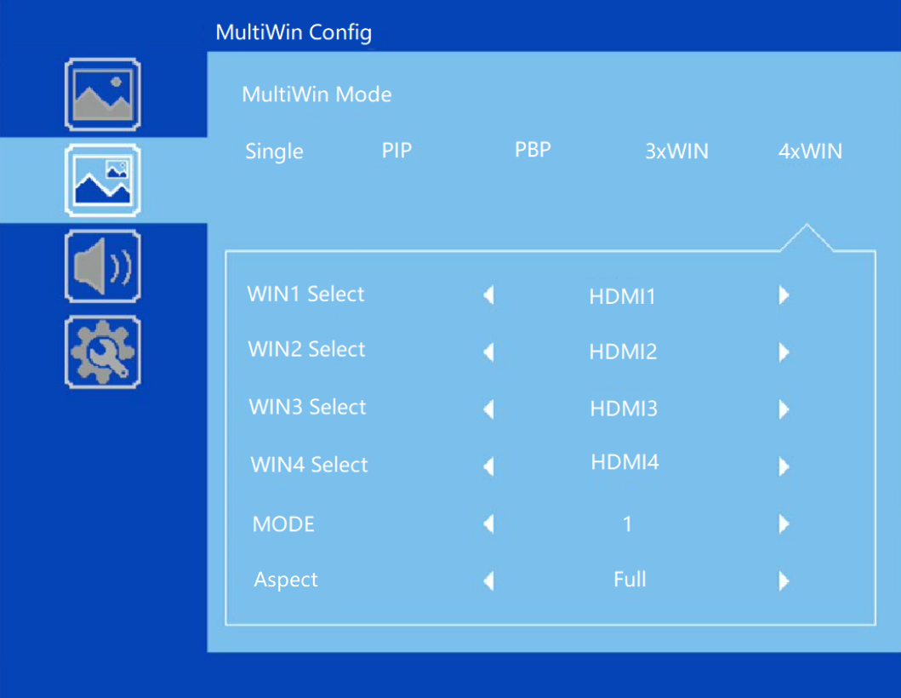

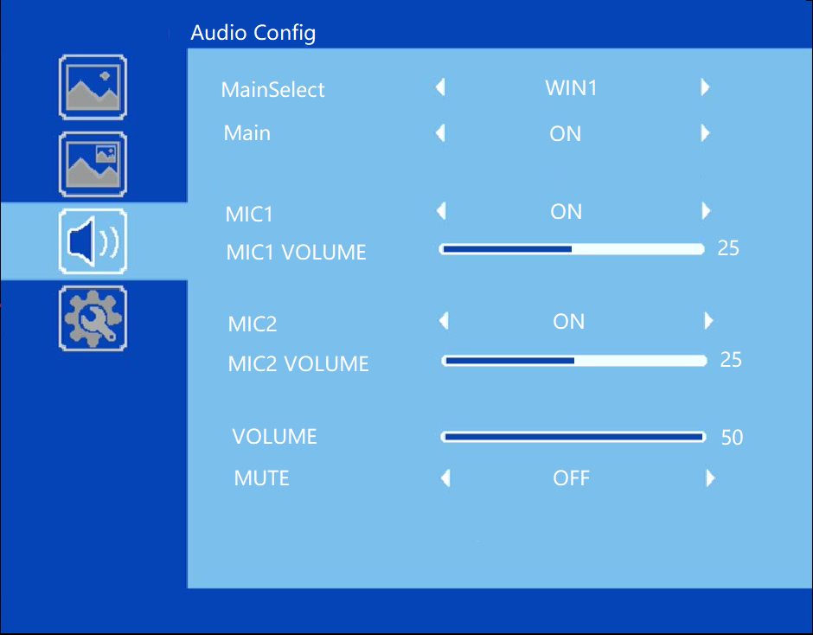

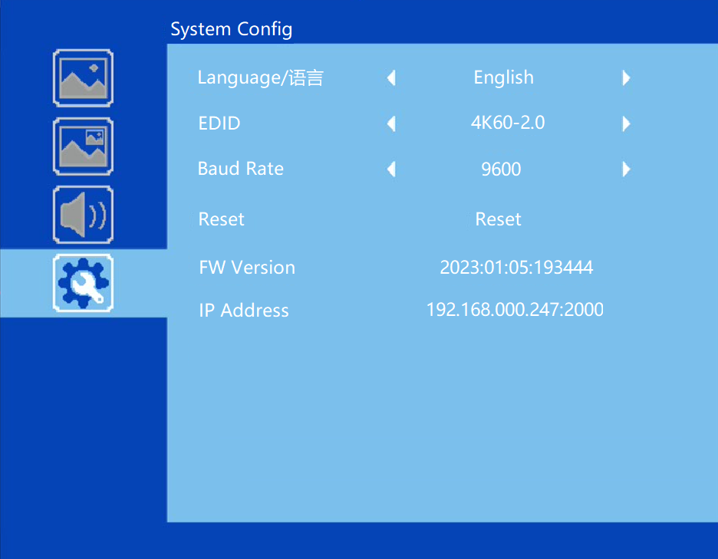

# Specification

|  |  |
| --- | --- |
| Band Width | 594MHz (18Gbps), HDMI 2.0, HDCP2,2 |
| Audio Format | LPCM |
| Input ports | 7 HDMI, 1 DP, 1 USB-C |
| Output ports | 2 HDMI, 1 HDBaseT  1 5-way captive female screw connector  1 Mini Toslink connector |
| Power Supply | 110-220VAC |
| Operating Temperature | 0 to +40°C (+32 to +104 °F) |
| Operating Humidity | 10 to 70 % RH (non-condensing) |
| ESD | Air: ± 8KV, Contact: ± 4KV, |
| Dimensions | L430 x W220 x H44 mm |
| Mass (Main Unit) | 5kg |

# Package Contents

|  |  |
| --- | --- |
| **Item** | **Quantity** |
| Switcher Unit | 1 |
| Remoter | 1 |
| AC Power Cord | 1 |
| User Manual | 1 |
| 3 way male captive screw connector | 3 |
| 5 way male captive screw connector | 5 |

# RS232 command

**Note:** All the commands begin with SET or GET, end with Carriage Return (CR).

⮠ Represents Carriage Return (CR).

All return messages are always end with CR.

## System command

|  |  |
| --- | --- |
| Command | Details |
| GET HELP⮠ | Get the Commands list |
| SET RESET⮠ | Recover to default setting |
| GET VERSION⮠ | Get main firmware version  Return: VERSION w (w is version number) |
| GET SUB-VERSION⮠ | Get ARM firmware version  Return: SUB-VERSION w (w is version number) |
| GET KEYBOARD-VERSION⮠ | Get Keyboard firmware version  Return: KEYBOARD-VERSION w (w is version number) |
| SET BAUDRATE w⮠ | w is 9600, 19200, 38400,57600 or 115200  Return: BAUDRATE w |
| GET BAUDRATE⮠ | Return: BAUDRATE w |
| SET IP ADDRESS w⮠ | For example: SET IP ADDRESS 192.168.0.247  Return: IP ADDRESS w |
| GET IP ADDRESS⮠ | Return: IP ADDRESS w |
| SET SUBMASK w⮠ | For example: SET SUBMASK 255.255.255.0  Return: SUBMASK w |
| GET SUBMASK⮠ | Return: SUBMASK w |
| SET GATEWAY w⮠ | For example: SET GATEWAY 192.168.0.1  Return: GATEWAY w |
| GET GATEWAY⮠ | Return: GATEWAY w |
| SET NETPORT w⮠ | For example: SET NETPORT 2000  Return: NETPORT w |
| GET NETPORT⮠ | Return: NETPORT w |
| SET NETWORK-INFO IP PORT SUBMASK GATEWAY⮠ | For Example:  SET NETWORK-INFO 192.168.0.247 2000 255.255.255.0 192.168.0.1  Return: NETWORK-INFO 192.168.0.247 2000 255.255.255.0 192.168.0.1 |
| GET NETWORK-INFO⮠ | Return: NETWORK-INFO IP PORT SUBMASK GATEWAY |
| SET LONG-REACH w⮠ | w is ON or OFF |
| GET LONG-REACH⮠ | Return: LONG-REACH w |
| SET FREEZE-WINx w | Freeze the display window,x is one of 1, 2, 3 ,4 or ALL, w is ON or OFF  Return: FREEZE-WINx w |
| GETFREEZE-WINx | x is one of 1, 2, 3 ,4.  Return: FREEZE-WINx w (w is ON or OFF) |

## Switching command, only available on SINGLE mode

|  |  |
| --- | --- |
| Commands | Details |
| SET AUTO SWITCH w⮠ | w is ON or OFF, default OFF  Return: AUTO SWITCH w |
| GET AUTO SWITCH⮠ | Return: AUTO SWITCH w |
| SET IN SOURCE w⮠ | w is one of the following:  HDMI1, HDMI2,…,HDMI7,DP,USB-C  Return: IN SOURCE w |
| GET IN SOURCE⮠ | Get current input channel selection information  Return: IN SOURCE w |
| GET IN RESOLUTION⮠ | Get current input resolution  Return: IN RESOLUTION w (w is input resolution) |
| GET IN STATUS⮠ | Get status of all input ports  x is HDMI1…..HMDI7,DP,USB-C  Return: IN STATUS x VALID(or INVALID)  If input port is vaild,  Return: IN STATUS x InputRes ColorSpace ColorDepth |

## Output command

|  |  |
| --- | --- |
| Commands | Details |
| SET OUT RESOLUTION w⮠ | w is one of the following, default: 3840x2160p60  4096x2160p60, 4096x2160p50,  3840x2160p60, 3840x2160p50,  3840x2160p30, 3840x2160p25,  1920x1200p60RB, 1920x1080p60,  1920x1080p50, 1360x768p60,  1280x800p60, 1280x720p60,  1280x720p50, 1024x768p60，  AUTO, USER  Return: OUT RESOLUTION w |
| GET OUT RESOLUTION⮠ | Get current output resolution setting  Return: OUT RESOLUTION w |
| SET RESO-USER Width Height⮠ | Set user define output resolution,  Width is horizontal active pixels  Height is vertical active lines  For user define output resolution,the frame rate is always 60Hz  Return: RESO-USER Width Height⮠ |
| GET RESO-USER⮠ | Return: RESO-USER Width Height⮠ |
| SET OUT HDCP w⮠ | w is one of following, default FORCE-1.4  FORCE-1.4,FORCE-2.2,FORCE-OFF  Return: OUT HDCP w |
| SET OUT COMP w⮠ | w is CSC or DSC, default CSC  Compression mode when HDBT output resolution is 4K60  Return: OUT COMP w |
| GET OUT COMP⮠ | Return: OUT COMP w |
| GET OUT HDCP⮠ | Return: OUT HDCP w |
| SET OUT VKA w⮠ | Set video keep alive mode  w is BLUESCREEN or BLACKSCREEN.  Default BLACKSCREEN. It is for no signal display  Return: OUT VKA w |
| GET OUT VKA⮠ | Return: OUT VKA w |
| SET OUT ITC w⮠ | w is ON or OFF, default OFF  Return: OUT ITC w  Suggest **OFF** for video display and **ON** for PC especially desktop display, default setting is **OFF** |
| GET OUT ITC⮠ | Return: OUT ITC w |
| SET OUT TSP w⮠ | Set Test Pattern on or off, w is ON or OFF  Return: OUT TSP w |
| GET OUT TSP⮠ | Return: OUT TSP w |
| SET OUT TSP-COLOR w⮠ | Set Test Pattern Colour , w is one of the following:  BLACK, BLUE, GREEN, RED, WHITE, PRBS,RAMP, CHECKER_BOARD, STRIPE, RED_RAMP, GREEN_RAMP, BLUE_RAMP  Default: CHECKER_BOARD  Return: OUT TSP-COLOR w |
| GET OUT TSP-COLOR⮠ | Return: OUT TSP-COLOR w |
| SET OUT TSP-TIMING w⮠ | Set output timing for Test Pattern display  w is one of the following:  4K30,1080p60, 720p60  default 1080p60  Return: OUT TSP-TIMING w |
| GET OUT TSP-TIMING⮠ | Return: OUT TSP-TIMING w |

## Multiview command

|  |  |
| --- | --- |
| Commands | Details |
| SET MULTIVIEW w⮠ | Select one multiview mode for current display  w is one of the following, default SINGLE  SINGLE C:\Users\windows7\AppData\Local\Temp\1629080528(1).png, PIP , PBPC:\Users\windows7\AppData\Local\Temp\1629081546(1).png, 3xWIN C:\Users\windows7\AppData\Local\Temp\1629082712(1).png, 4xWIN C:\Users\windows7\AppData\Local\Temp\1629082974(1).png  Return: MULTIVIEW w |
| GET MULTIVIEW⮠ | Get the current Multiview mode  Return: MULTIVIEW w |
| SET WINDOWx IN y⮠ | Select one input for one display window for the current Multiview mode. x is one of 1, 2, 3 or 4  y is one of HDMI1, HDMI2, …, HDMI7, DP,USB-C  Return: WINDOWx IN y |
| GET WINDOWx IN⮠ | This command to get which is the input source for one display window for the current Multiview mode  Return: WINDOWx IN y |
| SET PIP POS w⮠ | This command to select the PIP sub window position.  w is one of the following, default RightBottom  LeftTop, LeftBottom, RightTop, RightBottom,USER  Return: PIP POS w |
| GET PIP POS⮠ | This command to get the PIP sub window position  Return: PIP POS w |
| SET PIP SIZE w⮠ | This command to select the PIP sub window size.  w is one of the following, default LARGE  SMALL,MIDDLE, LARGE,USER  Return: PIP SIZE w |
| GET PIP SIZE⮠ | Return: PIP SIZE w |
| SET PIP USER HStart VStart HSize VSize⮠ | Return: PIP USER HStart VStart HSize VSize  This command allows users to customize a PIP layout include sub window position and size.  This customized PIP layout will replace other pre-defined PIP modes (such as LeftTop,LARGE) and display on the screen    Please note  HStart plus HSize less than or equal to 101  VStart plus VSize less than or equal to 101 |
| GET PIP USER⮠ | Return: PIP USER HStart VStart HSize VSize |
| SET PBP MODE w⮠ | Set the PBP display mode  w is one of 1,2 or 3, default 1    Return: PBP MODE w  Please note for PBP mode 3, window2 can capture part of the input image area. It is main used for presenter show when work with conference camera situations  The capture area can be defined by SET PBP-PRESENTER command |
| GET PBP MODE⮠ | Return: PBP MODE w |
| SET PBP ASPECT w⮠ | Set the PBP window display aspect  w is FULL or 16:9, default FULL    Return: PBP ASPECT w |
| GET PBP ASPECT⮠ | Return: PBP ASPECT w |
| SET PBP-PRESENTER HStart VStart HSize VSize⮠ | Set window 1 capture area for PBP mode 3  This command only valid when the switcher already work on PBP mode 3  Return: PBP-PRESENTER HStart VStart HSize VSize    Default HStart 38, VStart 13, HSize 25, VSize 75  Please note  HStart plus HSize less than or equal to 101  VStart plus VSize less than or equal to 101 |
| GET PBP-PRESENTER⮠ | Return: PBP-PRESENTER HStart VStart HSize VSize |
| SET 3xWIN MODE w⮠ | Set the 3xWIN display mode  w is one of 1,2,3 or 4; default 1  C:\Users\windows7\AppData\Local\Temp\1658982390(1).png  Return: 3xWIN MODE w |
| GET 3xWIN MODE⮠ | Return: 3xWIN MODE w |
| SET 3xWIN ASPECT w⮠ | Set the 3xWIN window display aspect  w is FULL or 16:9, default FULL  C:\Users\windows7\AppData\Local\Temp\1658982480(1).png  Return: 3xWIN ASPECT w |
| GET 3xWIN ASPECT⮠ | Return: 3xWIN ASPECT w |
| SET 4xWIN MODE w⮠ | Set the 4xWIN display mode  w is 1 or 2 ,default 1    Return: 4xWIN MODE w |
| GET 4xWIN MODE⮠ | Return: 4xWIN MODE w |
| SET 4xWIN ASPECT w⮠ | Set the 4xWIN window display aspect  w is FULL or 16:9, default FULL  C:\Users\windows7\AppData\Local\Temp\1637116792(1).png  Return: 4xWIN ASPECT w |
| GET 4xWIN ASPECT⮠ | Return: 4xWIN ASPECT w |
| GET MULTIVIEW-SYNC⮠ | Return Multiview layout information |
| SET SAVE SCENE w⮠ | Save current display scene  w is 1, 2,…20  Return: SAVE SCENE w |
| SET LOAD SCENE w⮠ | Load display scene  w is 1, 2,…20  Return: LOAD SCENE w |

## Audio command

|  |  |
| --- | --- |
| Commands | Details |
| SET MAIN-AUDIO ONOFFw⮠ | Mute or unmute main audio  Here w is ON or OFF, default ON  Return:MAIN-AUDIO ONOFFw |
| GET MAIN-AUDIO ONOFF⮠ | Return:MAIN-AUDIO ONOFFw |
| SET AUDIO SOURCEw⮠ | Main audio selection, w is one of the following:  WIN1,HDMI1,…,HDMI7,DP,USB-C,LR1,…,LR4  Return: AUDIO SOURCE w |
| GET AUDIO SOURCE⮠ | Return: AUDIO SOURCE w |
| SET AUDIO VOL+⮠ | Increase overall audio out volume  Return: AUDIO VOL w (w is the volume value) |
| SET AUDIO VOL-⮠ | Decrease overall audio out volume  Return: AUDIO VOL w (w is the volume value) |
| SET AUDIO VOL w⮠ | Set audio volume value  w is 0,1…,50, default 50  For example: SET AUDIO VOL 50  Return: AUDIO VOL w |
| GET AUDIO VOL⮠ | Return: AUDIO VOL w |
| SET AUDIO-MUTE w⮠ | Mute or unmute overall audio output  Here w is ON or OFF, default OFF  Return: AUDIO-MUTE w |
| GET AUDIO-MUTE⮠ | Return: AUDIO-MUTE w |
| SET MIC1 ONOFF w⮠ | w is ON or OFF |
| GET MIC1 ONOFF⮠ | Return :MIC1 ONOFF w |
| SET MIC1 VOL+⮠ | Increase microphone 1 pre-volume  Return: MIC1 VOL w ( w is one of 0,1,...,50) |
| SET MIC1 VOL-⮠ | Decrease microphone 1 pre-volume  Return: MIC1 VOL w |
| SET MIC1 VOL w⮠ | Set microphone 1 pre-volume value, default 25 |
| GET MIC1 VOL w⮠ | Get microphone 1 pre-volume value |
| SET MIC2 ONOFF w⮠ | w is ON or OFF |
| GET MIC2 ONOFF⮠ | Return :MIC1 ONOFF w |
| SET MIC2 VOL+⮠ | Increase microphone 2 pre-volume  Return: MIC2 VOL w ( w is one of 0,1,...50) |
| SET MIC2 VOL-⮠ | Decrease microphone 2 pre-volume  Return: MIC2 VOL w |
| SET MIC2 VOL w⮠ | Set microphone 2 pre-volume value, default 25 |
| GET MIC2 VOL w⮠ | Get microphone 2 pre-volume value |

## EDID command

The following commands are used to set EDID mode for the inputs

|  |  |
| --- | --- |
| Commands | Details |
| SET IN EDIDMODE w⮠ | w is one of the following:  4K60-2.0, 4K60-5.1, 4K60-7.1, 4K30-2.0,  4K30-5.1, 4K30-7.1, 1080p60-2.0,1080p60-5.1,  1080p60-7.1,1920x1200, 1680x1050, 1600x1200, 1440x900, 1360x768, 1280x1024, 1024x768, 720p, AUTO,USER Default: 4K60-2.0  Return: IN EDIDMODE w |
| SET EDID-USER w⮠ | Switcher can only support 256 bytes EDID-USER data.  w is 256 bytes EDID data.  Return: EDID-USER OK |
| GET IN EDIDMODE⮠ | Return: IN EDIDMODE w |