Seamless UHD Video Switcher

With Multiview

**Version 1.2**

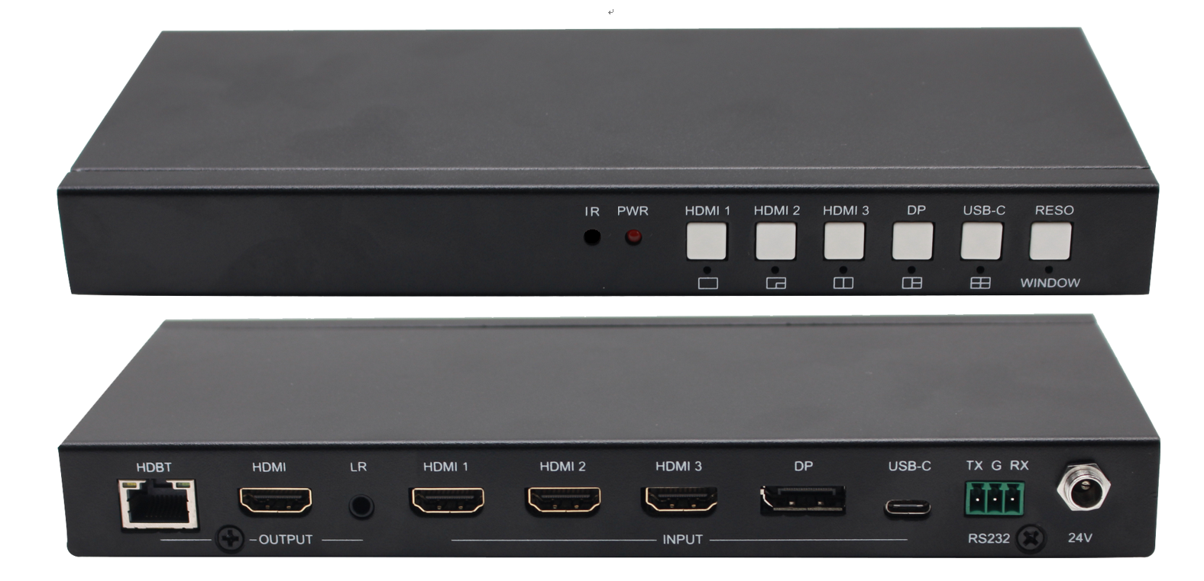

**warningWarning**

* Do not expose this device to Rain, Moisture, and Dripping
* Only use accessories specified by the manufacture
* Unplug this device during Lightning Storms
* The manual is for reference only, maybe updated without

further notice

Content

1. Features 3

2. Panel Layout 4

3. Remoter 6

4. EDID and HDCP handle 6

5. Video and Audio 7

6. Multiview 7

7. OSD Menu Navigation 8

8. Specification 9

9. Package Contents 10

10. RS232 command 10

System command 10

Switching command, only available on SINGLE mode 10

Output command 11

Multiview command 12

Audio command 16

EDID command 17

**Introduction**

The 5x Inputs and 2x Outputs seamless multiview video switcher was developed for the purpose of multiple sources displayed on a single screen, supporting high input and output resolutions.

HDBaseT mirrored output port can be used for long distance video transmission

User can easily manage it via the front buttons, IR remoter or RS232 commands.

Application Field:

Home Theatre; Video Conference; Security Monitoring; Presentation and Broadcasting; Teaching System; Financial Stock Analysis; Game E-Sports; Medical Display.

# Features

* Inputs: 3x HDMI inputs, 1x DP, 1x USB-C ( video only)

Outputs: 1x HDMI, 1x HDBaseT，1x 3.5mm L/R output

* Support HDMI 2.0,HDCP 2.2, support video resolution up to 3840x2160@60
* Support 5 categories of multiview modes, SINGLE, PIP, PBP, 3xWIN, 4xWIN
* Seamless switching on single window display mode

Fast switching on non-single window display modes

* Extensive EDID and HDCP handle
* Support volume control and independently audio selection

Support LPCM, AC3, DD+, DTS, DTS-HD, up to 7.1 audio channel

* Support OSD navigation for advanced setting
* Provide 24V/10watt PSE ( POC ) for remote HDBaseT receiver power supply
* HDBaseT transmission length up to 70m @1080p, or 40m @4K

# Panel Layout

Front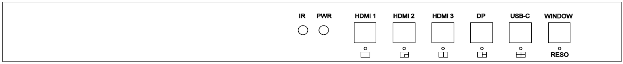

| **Name** | **Description** |
| --- | --- |
| **HDMI 1** | Press HDMI 1 button to select HDMI 1 as the input source.  Long press it for 3 seconds to enter **SINGLE** mode, C:\Users\windows7\AppData\Local\Temp\1629080528(1).png.  **SINGLE** mode means only one display window on the screen  Note, when works on non-SINGLE mode, directly short press input buttons will be invalid. |
| **HDMI 2** | Press HDMI 2 button to select HDMI 2 as the input source.  Long press it for 3 seconds to enter PIP Multiview mode, . |
| **HDMI 3** | Press HDMI 3 button to select HDMI 3 as the input source.  Long press it for 3 seconds to enter PBP Multiview mode, C:\Users\windows7\AppData\Local\Temp\1629081546(1).png. |
| **DP** | Press DP button to select DP as the input source.  Long press it for 3 seconds to enter **3xWIN** mode, C:\Users\windows7\AppData\Local\Temp\1629082712(1).png.  **3xWIN** mode is Three Windows Multiview mode. |
| **USB-C** | Press USB-C button to select USB-C (video only) as the input  Long press it for 3 seconds to enter **4xWIN** mode, C:\Users\windows7\AppData\Local\Temp\1629082974(1).png.  **4xWIN** mode is Four Windows Multiview mode. |
| **WINDOW** | Press this button, the screen will show up one yellow border on window 1. Continue press this button the border will be shown on window 2 or 3… then press one input button such as HDMI 1**,** and then HDMI 1 will displayed on the current selected window.  Long press this button for 3 seconds can select different output resolution with OSD information. |

Please note: Press HDMI 3 and DP at the same time can enable/disable AUTO SWITCH function when SINGLE window display mode

Rear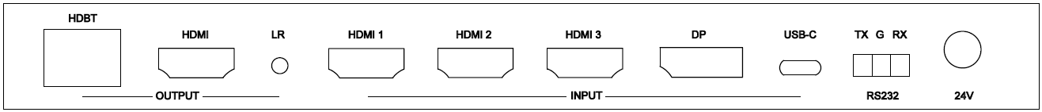

|  |  |
| --- | --- |
| **Name** | **Description** |
| **HDBT** out | HDBaseT Scaling output up to 3840x2160@60 |
| **HDMI** out | HDMI scaling output up to 3840x2160@60 |
| **LR** out | 3.5mm LR stereo audio output, 20Hz ~ 20kHz, 1.5Vrms max |
| **INPUT**s | **HDMI 1**, **HDMI 2**, **HDMI 3**, **DP,** **USB-C** |
| **RS232** | External RS232 control  Default Baud Rate: 9600, Data Bits:8, Parity: None Stop Bits:1  3 way 3.5mm phoenix connector  **TX** means Switcher PC; **RX** means Switcher PC  **G** means Ground  Baud Rate can be changed by OSD menu |
| **24V** | 24V power adapter to plug in |

Side

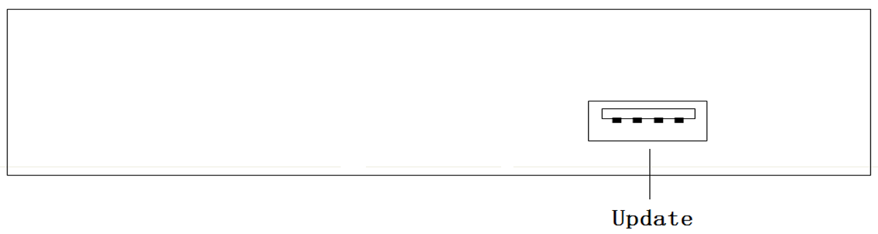

USB-A port is here is only for firmware upgrade

# Remoter

|  |  |
| --- | --- |
| **Number** | **Description** |
| **1** | Return/Exit |
| **2** | Video input selection |
| **3** | OSD menu navigation  Menu (Enter),UP, DOWN,  LEFT,RIGHT |
| **4** | Multiview mode selection |
| **5** | Audio input selection |
| **6** | Reserved |

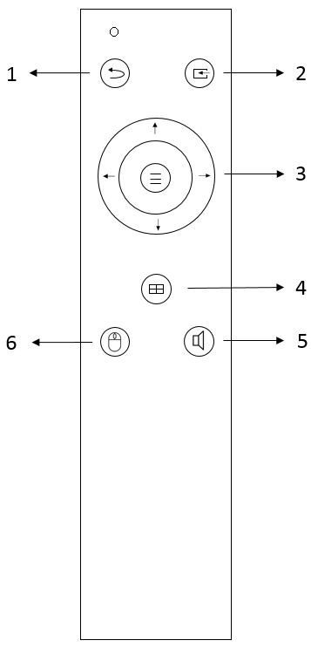

# EDID and HDCP handle

User can select following EDID modes by RS232 command or OSD menu navigation

|  |  |  |  |
| --- | --- | --- | --- |
| **Number** | **EDID mode** | **Number** | **EDID mode** |
| **1** | 4K60-2.0CH | 10 | 1600x1200 |
| **2** | 4K60-5.1CH | 11 | 1440x900 |
| **3** | 4K30-2.0CH | 12 | 1360x768 |
| **4** | 4K30-5.1CH | 13 | 1280x1024 |
| **5** | 1080P-2.0CH | 14 | 1024x768 |
| **6** | 1080P-5.1CH | 15 | AUTO |
| **7** | 720P | 16 | 4K60-7.1CH |
| **8** | 1920x1200 | 17 | 4K30-7.1CH |
| **9** | 1680x1050 | 18 | 1080P-7.1CH |
|  |  | 19 | USER |

The HDMI output support 3 HDCP options: FORCE-1.4, FORCE-2.2, FORCE-OFF

User can select it by RS232 command

# Video and Audio

The switcher support multiple resolution video input up to 3840x2160@60, and support multiple audio format such as LPCM, AC3, DD+, DTS, DTS-HD, up to 7.1 channel pass through function via HDMI cable

User can control the audio volume when the audio input is LPCM format

The switcher support following video output resolution by a powerful scaling engine

|  |  |  |  |
| --- | --- | --- | --- |
| **Number** | **Output Resolution** | **Number** | **Output Resolution** |
| **1** | 4096x2160p 60Hz | 8 | 1920x1080p 60Hz |
| **2** | 4096x2160p 50Hz | 9 | 1920x1080p 50Hz |
| **3** | 3840x2160p 60Hz | 10 | 1360x768p 60Hz |
| **4** | 3840x2160p 50Hz | 11 | 1280x800p 60Hz |
| **5** | 3840x2160p 30Hz | 12 | 1280x720p 60Hz |
| **6** | 3840x2160p 25Hz | 13 | 1280x720p 50Hz |
| **7** | 1920x1200p60Hz RB | 14 | 1024x768 60Hz |

# Multiview

The Switcher support 5 categories of multiview display modes

SINGLE, PIP, PBP, 3xWIN, 4xWIN

Users can select different operations for different Multiview modes as following:

SINGLE: Inputs selection

PIP: Inputs selection, Sub window size and position selection

PBP, 3xWIN, 4xWIN: Inputs selection, Layout Mode, Display aspect

Multiview window distribution as following

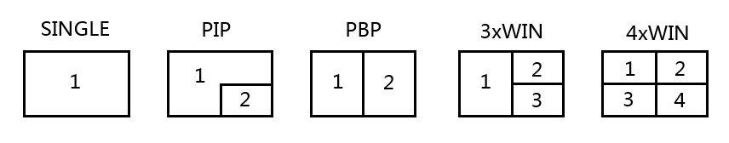

User can do more layouts via RS232 commands or OSD menu navigation，and support up to 20 scenes saving and loading function by command

# OSD Menu Navigation

Total 6 buttons used for OSD navigation, MENU, EXIT, UP, DOWN, LEFT, RIGHT

Menu contents as following:

|  |  |  |  |
| --- | --- | --- | --- |
| Output | Resolution | 3840x2160p60 | 3840x2160p60,… |
| VKA | BLACKSCREEN, | BLACKSCREEN, BLUESCREEN |
| 4K-Auto | ON | ON,OFF |
| ITC | OFF | ON,OFF |
| Multiview | Single | Input select | HDMI1, … |
| PIP | Win1 Select | HDMI1,… |
| Win2 Select | HDMI1,… |
| PIP Position | RightBottom,… |
| PIP Size | SMALL,… |
| PBP | Win1 Select | HDMI1,… |
| Win2 Select | HDMI1,… |
| MODE | 1, 2 |
| Aspect | Full, 16:9 |
| 3xWIN | Win1 Select | HDMI1,… |
| Win2 Select | HDMI1,… |
| Win3 Select | HDMI1,… |
| MODE | 1, 2 |
| Aspect | Full, 16:9 |
| 4xWIN | Win1 Select | HDMI1,… |
| Win2 Select | HDMI1,… |
| Win3 Select | HDMI1,… |
| Win4 Select | HDMI1,… |
| MODE | 1, 2 |
| Aspect | Full,16:9 |
| AUDIO | Audio Select | WIN1 | WIN1,HDMI1,… |
| Volume | 100 | 0..100 |
| AUDIO-MUTE | OFF | ON, OFF |
| System | Language/语言 | English | English, 中文 |
| EDID | 4K60-2.0 | 4K60-2.0,… |
| Baud rate | 9600 | 9600, 19200, 38400,57600, 115200 |
| Reset |  |  |
| FW Version |  | Read only |

Please note, for **ITC** setting, suggest **OFF** for video display and **ON** for PC especially desktop display, default setting is **OFF**

# Specification

|  |  |
| --- | --- |
| Band Width | 594MHz (18Gbps), HDMI 2.0, HDCP2,2 |
| Audio Format | LPCM, AC3, DD+, DTS, DTS-HD  Up to 7.1 channel |
| Input ports | 3x HDMI, 1x DP, 1x USB-C (video only) |
| Output ports | 1x HDMI, 1x HDBaseT  1x 3.5mm LR audio |
| Power Supply | 24V/1A ,14W max |
| Operating Temperature | 0 to +40°C (+32 to +104 °F) |
| Operating Humidity | 10 to 70 % RH (non-condensing) |
| ESD | Air: ± 8KV, Contact: ± 4KV, |
| Dimensions | L225 x W100 x H25 mm |
| Mass (Main Unit) | 0.75kg |

# Package Contents

|  |  |
| --- | --- |
| **Item** | **Quantity** |
| Switcher Unit | 1 |
| 24V/1A power adapter | 1 |
| User Manual | 1 |
| Remoter | 1 |
| 3-way male captive screw connector |  |

# RS232 command

**Note:** All the commands begin with SET or GET, end with Carriage Return (CR).

⮠ Represents Carriage Return (CR).

All return messages are always end with CR.

## System command

|  |  |
| --- | --- |
| Command | Details |
| GET HELP⮠ | Get the Commands list |
| SET RESET⮠ | Recover to default setting |
| GET VERSION⮠ | Get firmware version  Return: VERSION w (w is version number) |
| SET BAUDRATE w⮠ | w is 9600, 19200, 38400,57600 or 115200  Return: BAUDRATE w |
| GET BAUDRATE⮠ | Return: BAUDRATE w |

## Switching command, only available on SINGLE mode

|  |  |
| --- | --- |
| Commands | Details |
| SET AUTO SWITCH w⮠ | w is ON or OFF, default OFF  Return: AUTO SWITCH w |
| GET AUTO SWITCH⮠ | Return: AUTO SWITCH w |
| SET IN SOURCE w⮠ | w is one of the following:  HDMI1, HDMI2, HDMI3, DP, USB-C  Return: IN SOURCE w |
| GET IN SOURCE⮠ | Get current input channel selection information  Return: IN SOURCE w |
| GET IN RESOLUTION⮠ | Get current input resolution  Return: IN RESOLUTION w (w is input resolution) |
| GET IN STATUS⮠ | Get status of all input ports  x is HDMI1…HMDI4,USB-C  Return: IN STATUS x VALID(or INVALID)  If input port is vaild,  Return: IN STATUS x InputRes ColorSpace ColorDepth |

## Output command

|  |  |
| --- | --- |
| Commands | Details |
| SET OUT RESOLUTION w⮠ | w is one of the following, default: 3840x2160p60  4096x2160p60, 4096x2160p50,  3840x2160p60, 3840x2160p50,  3840x2160p30, 3840x2160p25,  1920x1200p60RB, 1920x1080p60,  1920x1080p50, 1360x768p60,  1280x800p60, 1280x720p60,  1280x720p50, 1024x768p60，  AUTO, USER  Return: OUT RESOLUTION w |
| GET OUT RESOLUTION⮠ | Get current output resolution setting  Return: OUT RESOLUTION w |
| SET RESO-USER Width Height⮠ | Set user define output resolution,  Width is horizontal active pixels  Height is vertical active lines  For user define output resolution,the frame rate is always 60Hz  Return: RESO-USER Width Height⮠ |
| GET RESO-USER⮠ | Return: RESO-USER Width Height⮠ |
| SET OUT HDCP w⮠ | w is one of following, default FORCE-OFF  FORCE-1.4,FORCE-2.2,FORCE-OFF  Return: OUT HDCP w |
| GET OUT HDCP⮠ | Return: OUT HDCP w |
| SET OUT VKA w⮠ | w is BLUESCREEN or BLACKSCREEN.  Default BLACKSCREEN. It is for no signal display  Return: OUT VKA w |
| GET OUT VKA⮠ | Return: OUT VKA w |
| SET OUT ITC w⮠ | w is ON or OFF, default OFF  Return: OUT ITC w |
| GET OUT ITC⮠ | Return: OUT ITC w |

## Multiview command

|  |  |
| --- | --- |
| Commands | Details |
| SET MULTIVIEW w⮠ | Select one Multiview mode for current display  w is one of the following, default SINGLE  SINGLE C:\Users\windows7\AppData\Local\Temp\1629080528(1).png, PIP , PBPC:\Users\windows7\AppData\Local\Temp\1629081546(1).png, 3xWIN C:\Users\windows7\AppData\Local\Temp\1629082712(1).png, 4xWIN C:\Users\windows7\AppData\Local\Temp\1629082974(1).png  Return: MULTIVIEW w |
| GET MULTIVIEW⮠ | Get the current Multiview mode  Return: MULTIVIEW w |
| SET WINDOWx IN y⮠ | Select one input for one display window for the current Multiview mode. x is one of 1, 2, 3 or 4  y is one of HDMI1, HDMI2, HDMI3, DP, USB-C  Return: WINDOWx IN y |
| GET WINDOWx IN⮠ | This command to get which is the input source for one display window for the current Multiview mode  Return: WINDOWx IN y |
| SET FREEZE-WINx w | Freeze the display window,x is one of 1, 2, 3 ,4 or ALL, w is ON or OFF  Return: FREEZE-WINx w |
| GET FREEZE-WINx | x is one of 1, 2, 3 ,4.  Return: FREEZE-WINx w (w is ON or OFF) |
| SET PIP POS w⮠ | This command to select the PIP sub window position.  w is one of the following, default RightBottom  LeftTop, LeftBottom, RightTop, RightBottom, USER  Return: PIP POS w |
| GET PIP POS⮠ | This command to get the PIP sub window position  Return: PIP POS w |
| SET PIP SIZE w⮠ | This command to select the PIP sub window size.  w is one of the following, default LARGE  SMALL,MIDDLE, LARGE, USER  Return: PIP SIZE w |
| GET PIP SIZE⮠ | Return: PIP SIZE w |
| SET PIP USER HStart VStart HSize VSize⮠ | Return: PIP USER HStart VStart HSize VSize  This command allows users to customize a PIP layout include sub window position and size.  This customized PIP layout will replace other pre-defined PIP modes (such as LeftTop,LARGE) and display on the screen  After the user enters SET PIP POS or SET PIP SIZE command,the PIP USER will become invalid    Please note  HStart plus HSize less than or equal to 101  VStart plus VSize less than or equal to 101 |
| GET PIP USER⮠ | Return: PIP USER HStart VStart HSize VSize |
| SET PBP MODE w⮠ | Set the PBP display mode  w is one of 1,2 or 3, default 1    Return: PBP MODE w  Please note for PBP mode 3, window2 can capture part of the input image area. It is main used for presenter show when work with conference camera situations  The capture area can be defined by SET PBP-PRESENTER command |
| GET PBP MODE⮠ | Return: PBP MODE w |
| SET PBP ASPECT w⮠ | Set the PBP window display aspect  w is FULL or 16:9, default FULL    Return: PBP ASPECT w |
| GET PBP ASPECT⮠ | Return: PBP ASPECT w |
| SET PBP-PRESENTER HStart VStart HSize VSize⮠ | Set window 1 capture area for PBP mode 3  This command only valid when the switcher already work on PBP mode 3  Return: PBP-PRESENTER HStart VStart HSize VSize    Default HStart 38, VStart 13, HSize 25, VSize 75  Please note  HStart plus HSize less than or equal to 101  VStart plus VSize less than or equal to 101 |
| GET PBP-PRESENTER⮠ | Return: PBP-PRESENTER HStart VStart HSize VSize |
| SET 3xWIN MODE w⮠ | Set the 3xWIN display mode  w is one of 1,2,3 or 4, default 1  C:\Users\windows7\AppData\Local\Temp\1658982390(1).png  Return: 3xWIN MODE w |
| GET 3xWIN MODE⮠ | Return: 3xWIN MODE w |
| SET 3xWIN ASPECT w⮠ | Set the 3xWIN window display aspect  w is FULL or 16:9, default FULL  C:\Users\windows7\AppData\Local\Temp\1658982480(1).png  Return: 3xWIN ASPECT w |
| GET 3xWIN ASPECT⮠ | Return: 3xWIN ASPECT w |
| SET 4xWIN MODE w⮠ | Set the 4xWIN display mode  w is 1 or 2 ,default 1    Return: 4xWIN MODE w |
| GET 4xWIN MODE⮠ | Return: 4xWIN MODE w |
| SET 4xWIN ASPECT w⮠ | Set the 4xWIN window display aspect  w is FULL or 16:9, default FULL  C:\Users\windows7\AppData\Local\Temp\1637116792(1).png  Return: 4xWIN ASPECT w |
| GET 4xWIN ASPECT⮠ | Return: 4xWIN ASPECT w |
| GET MULTIVIEW-SYNC⮠ | Return Multiview layout information |
| SET SAVE SCENE w⮠ | Save current display scene  w is 1, 2,…20  Return: SAVE SCENE w |
| SET LOAD SCENE w⮠ | Load display scene  w is 1, 2,…20  Return: LOAD SCENE w |

## Audio command

|  |  |
| --- | --- |
| Commands | Details |
| SET AUDIO SOURCEw⮠ | w is one of the following:  WIN1, HDMI1, HDMI2, HDMI3, DP, USB-C  Return: AUDIO SOURCE w |
| GET AUDIO SOURCE⮠ | Return: AUDIO SOURCE w |
| SET AUDIO VOL+⮠ | Increase audio out volume  Return: AUDIO VOL w (w is the volume value) |
| SET AUDIO VOL-⮠ | Decrease audio out volume  Return: AUDIO VOL w (w is the volume value) |
| SET AUDIO VOL w⮠ | Set audio volume value  w is 0,1…,or 100, default 100  For example: SET AUDIO VOL 100  Return: AUDIO VOL w |
| GET AUDIO VOL⮠ | Return: AUDIO VOL w |
| SET AUDIO-MUTE w⮠ | Mute or unmute audio output  Here w is ON or OFF, default OFF  Return: AUDIO-MUTE w |
| GET AUDIO-MUTE⮠ | Return: AUDIO-MUTE w |

## EDID command

The following commands are used to set EDID mode for the inputs

|  |  |
| --- | --- |
| Commands | Details |
| SET IN EDIDMODE w⮠ | w is one of the following:  4K60-2.0, 4K60-5.1, 4K60-7.1, 4K30-2.0,  4K30-5.1, 4K30-7.1, 1080p60-2.0,1080p60-5.1,  1080p60-7.1,1920x1200, 1680x1050, 1600x1200, 1440x900, 1360x768, 1280x1024, 1024x768, 720p, AUTO,USER  Default: 4K60-2.0  Return: IN EDIDMODE w |
| SET EDID-USER w⮠ | Switcher can only support 256 bytes EDID-USER data.  w is 256 bytes EDID data.  Return: EDID-USER OK |
| GET IN EDIDMODE⮠ | Return: IN EDIDMODE w |