Seamless UHD KVM Switcher

With Multiview Control

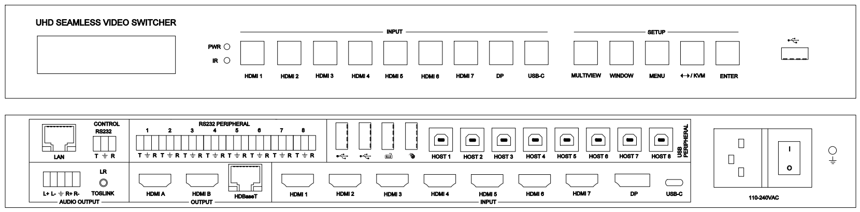

**warningWarning**

* Do not expose this device to Rain, Moisture, and

Dripping

* Only use accessories specified by the manufacture
* Unplug this device during Lightning Storms
* The manual is for reference only, maybe updated

without further notice

Content

1. Features 3

2. Panel Layout 4

3. EDID and HDCP handle 5

4. Video and Audio 6

5. Multiview 6

6. USB Roaming and hotkey control 7

7. Remoter 8

8. OSD Menu 9

9. Specification 11

10. Package Contents 11

11. RS232 command 11

System command 11

Switching command, only available on SINGLE mode 13

Output command 13

Multiview command 15

Audio command 18

KVM command 19

EDID command 19

RS232-peripheral command 20

**Introduction**

This device is a seamless multi-format scaling switcher with 7 HDMI 2.0 inputs, 1 Display Port input and 1 USB-C input. It provides three mirrored outputs-HDMI A,HDMI B for local display and HDBaseT output for a remote HDBaseT receiver and display.

It integrates 8 USB Host input ports and three USB 2.0 output ports, and there are two more USB-A ports only for Keyboard or Mouse KVM control.

It provide 8 RS232-peripheral ports, make it conveniently for users to use or control different devices

This device support display multiple sources on a single screen up to 4 display window

User can easily manage it via the front buttons, Remoter,RS232 and TCP/IP commands.

# Features

* 7 HDMI 2.0/HDCP2.2 inputs, 1 DP input, 1 USB-C input
* 3 mirrored outputs – HDMI A, HDMI B and HDBaseT
* HDBaseT transmission distance：70m@4K; 100m@1080p60
* 8 USB-Host inputs, five USB device outputs (two for Keyboard and Mouse, other three for other USB device)
* Support SINGLE, PIP, PBP, 3xWIN, 4xWIN display mode
* Provide up to 20 scenes save or load
* Seamless switching on single window display mode;

Fast switching on non-single window display modes

* Support USB mouse roaming function for KVM control
* Support independently audio selection (break away selection)
* Support AC3, DD+, DTS on input HDMI 1,2,3
* Support audio volume control (only LPCM format)
* Balanced stereo audio output and Toslink audio output
* Provides 8 RS232-peripheral ports
* Support multiple Test Pattern output
* Support 24V iPOC power supply to remote HDBaseT receiver
* Support OSD Menu navigation

# Panel Layout

Front

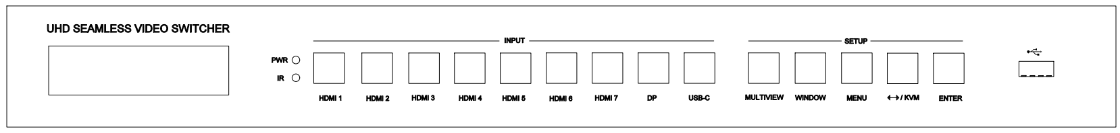

| **Name** | **Description** |
| --- | --- |
| **Power LED** | Lit when the switcher is powered |
| **IR sensor** | Remoter receiver |
| **HDMI 1, 2…,7,**  **DP, USB-C** | Total 9 inputs to be selected.  Press one of these buttons to direct select one input source for single window display,  When display on PIP,PBP,3xWIN,4xWIN mode, one of the inside LED for the 9 input buttons will still be lit, it represents the selected WIN-KVM input source |
| **MULTIVIEW** | Press this button to loop select PIP, PBP, 3xWIN, 4xWIN display mode. When switcher work on single mode, then press MULTIVIEW button to select the last Multiview mode (PIP,PBP, 3xWIN or 4xWIN), include WIN-KVM information  The inside LED on MULTIVIEW button will be lit when work on PIP,PBP, 3xWIN or 4xWIN mode, and will be off when work on single window mode |
| **WINDOW** | Press this button, then the screen will show up one yellow border on window 1. Continue press this button the border will be shown on window 2 or 3… then press one input button such as HDMI 1**,** and then HDMI 1 will displayed on the current selected window |
| **MENU**  **↔/KVM**  **ENTER** | 3 buttons to setup the system with front panel OSD navigation:   1. Test Pattern ON or OFF 2. KVM BORDER ON or OFF 3. USB Roaming ON or OFF 4. Auto Switch ON or OFF 5. Long Reach Mode ON or OFF 6. Output resolution selection 7. EDID selection 8. COMP Mode: CSC,DSC.   HDBT compression mode when output resolution is 4K60   1. RS232 baud rate 2. IP address info 3. Firmware version info   If it is not on setup processing, then press ↔/KVM can loop select the selected KVM window |
| 1678681945015 | The third USB device port |

Rear

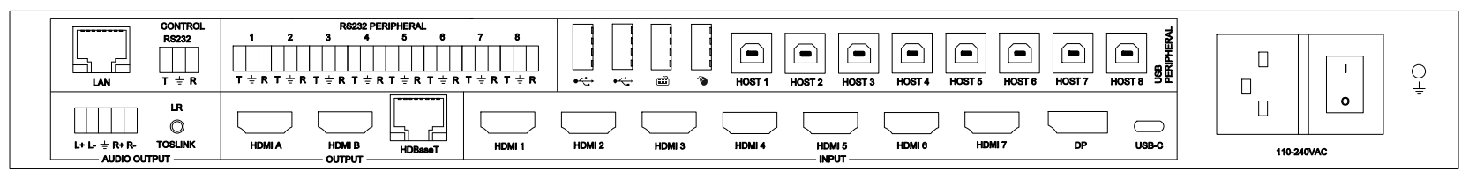

|  |  |
| --- | --- |
| **Name** | **Description** |
| **Audio outputs** | Balanced L+R output,  3.5mm L+R output,  Toslink-optical output |
| **Outputs** | HDMI A, HDMI B, HDBaseT |
| **INPUT**s | HDMI 1, …, HDMI 7, DP, USB-C |
| **LAN** | TCP/IP control. Default parameters as following  IP address: 192.168.0.247; Sub Mask: 255.255.255.0  GATEWAY: 192.168.0.1; NETPORT: 2000  All the parameters can be changed by RS232 command |
| **RS232** control | Default baud rate 9600, 8 data bits, 1 stop bit, no parity  T, Switcher → PC  R, Switcher **←**PC  G, Ground  Baud rate options as following, can be selected by front panel  9600,19200,38400,57600,115200 |
| **RS232-peripheral,**  **8 ports** | Connect to 9 input devices, DP and USB-C input share RS232-8 peripheral port |
|  | Connect to USB 2.0 device |
|  | Connect to Keyboard and Mouse |
| **8 USB-Host** | Connect to 9 input devices,DP and USB-C inputs share HOST-8 port |

# EDID and HDCP handle

User can select following EDID modes by RS232 command or front panel

|  |  |  |  |
| --- | --- | --- | --- |
| **Number** | **EDID mode** | **Number** | **EDID mode** |
| **1** | 4K60-2.0CH | 10 | 1600x1200 |
| **2** | 4K60-5.1CH | 11 | 1440x900 |
| **3** | 4K30-2.0CH | 12 | 1360x768 |
| **4** | 4K30-5.1CH | 13 | 1280x1024 |
| **5** | 1080P-2.0CH | 14 | 1024x768 |
| **6** | 1080P-5.1CH | 15 | AUTO |
| **7** | 720P | 16 | 4K60-7.1CH |
| **8** | 1920x1200 | 17 | 4K30-7.1CH |
| **9** | 1680x1050 | 18 | 1080P-7.1CH |
|  |  | 19 | USER |

The HDMI output support 3 HDCP options: FORCE-1.4, FORCE-2.2, FORCE-OFF

User can select it by RS232 command

# Video and Audio

The switcher support multiple resolution video input up to 3840x2160@60, and support multiple audio format such as LPCM,AC3,DD+,DTS pass through from input ports HDMI 1,2 or 3.

Audio output selection can be independent of video output selection

There are following choice for audio selection:

WIN1, WIN-KVM, HDMI1, HDMI2, …,HDMI7, DP, USB-C.

WIN1 means that the sound is always taken from the first display window.

WIN-KVM means that the sound is always taken from the selected KVM display window.

Volume control (only LPCM format) can be done by RS232 command. The switcher support following video output resolution:

|  |  |  |  |
| --- | --- | --- | --- |
| **Number** | **Output Resolution** | **Number** | **Output Resolution** |
| **1** | 4096x2160p 60Hz | 8 | 1920x1080p 60Hz |
| **2** | 4096x2160p 50Hz | 9 | 1920x1080p 50Hz |
| **3** | 3840x2160p 60Hz | 10 | 1360x768p 60Hz |
| **4** | 3840x2160p 50Hz | 11 | 1280x800p 60Hz |
| **5** | 3840x2160p 30Hz | 12 | 1280x720p 60Hz |
| **6** | 3840x2160p 25Hz | 13 | 1280x720p 50Hz |
| **7** | 1920x1200p60Hz RB | 14 | 1024x768 60Hz |

# Multiview

The Switcher support 5 categories of multiview display modes

SINGLE, PIP, PBP, 3xWIN, 4xWIN

Users can select different operations for different multiview modes as following:

SINGLE, PIP, PBP, 3xWIN, 4xWIN

Multiview window distribution as following

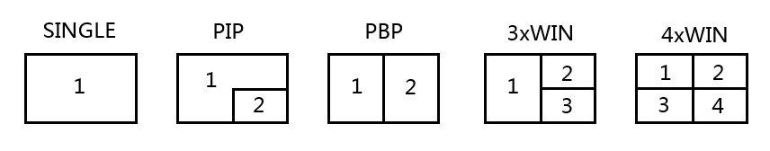

User can do more layouts via RS232 commands and provide user define multiview up to 20 scenes. The scene includes following points

SINGLE: Inputs selection

PIP: Inputs selection, Sub window size and position selection

PBP, 3xWIN, 4xWIN: Inputs selection, Layout Mode, Display aspect

# USB Roaming and hotkey control

The KVM button on front panel can direct select KVM window

USB Roaming can be enabled when works on PBP, 3xWIN or 4xWIN mode

The following sketch map shows USB Roaming when moving mouse cursor from left (WIN1) to right for 4xWIN display mode

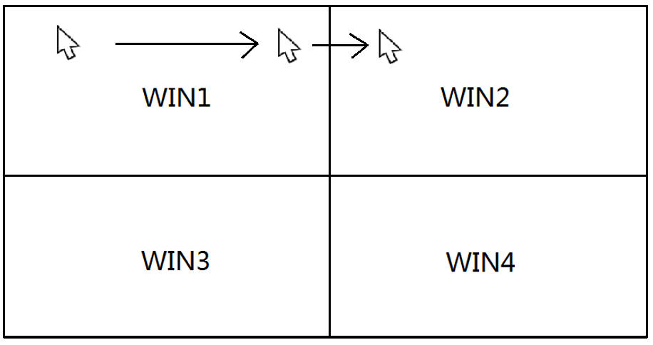

There are some hotkeys of keyboard for KVM control:

1. Ctrl + Ctrl + 1,2,3 or 4, select keyboard/mouse window
2. Ctrl + Ctrl + Q

If current display mode is PIP, PBP, 3xWIN, or 4xWIN mode, these hotkeys switching the display mode to the selected WIN-KVM source single display mode

If current display mode is single mode, these hotkeys switching the display mode to the last multiview mode (PIP, PBP, 3xWIN, or 4xWIN), include the selected WIN-KVM information.

1. Ctrl + Ctrl + R + N, disable USB Roaming
2. Ctrl + Ctrl + R + Y, Enable USB Roaming
3. Ctrl + Ctrl + M + 1,2,3,4 or 5 switching multiview mode to SINGLE, PIP, PBP, 3xWIN, or 4xWIN mode
4. Ctrl + Ctrl + W + m + S + n, display source n on window m. m means window number, n is input port number ( 1 means HDMI 1 input,…, 8 means DP input, 9 means USB-C input).

For example: When Multiview mode is SINGLE and user want to HDMI 2 to display, then can press Ctrl + Ctrl + W +1 + S + 2

1. Ctrl + Ctrl + C + 1, 2, 3…9,0, load one of the pre-saved scene to display,

0 means scene 10

1. Ctrl + Ctrl + S + 1, 2, 3…9,0, save the current display layout to one scene,

0 means scene 10

1. Ctrl + Ctrl + A + n, n is 0,1, 2, 3…8, 9 or A, switch audio source,

0 means WIN-KVM (the source of selected KVM window), 1 means HDMI 1,

8 means DP, 9 means USB-C, A means WIN 1 (the source of window 1)

1. Ctrl + Ctrl + A + N, audio mute

Ctrl + Ctrl + A + Y, audio unmute

Please note:

1. The “+” here represents a sequence, not an actual symbol or letter
2. After press Ctrl + Ctrl, system will enter Hotkey waiting, if the left

Keys pressing not finished in 5 seconds， hotkeys will be time out

1. After press Ctrl + Ctrl, system will enter Hotkey waiting, if then press

Ctrl or ESC,hotkeys operation will be terminated

# Remoter

|  |  |
| --- | --- |
| **Number** | **Description** |
| **1** | Return/Exit |
| **2** | Video input selection |
| **3** | OSD menu navigation  Menu (Enter),UP, DOWN,  LEFT,RIGHT  Press Left or Right key alone can decrease or increase audio volume |
| **4** | Multiview mode selection |
| **5** | Audio input selection |
| **6** | USB-KVM selection |

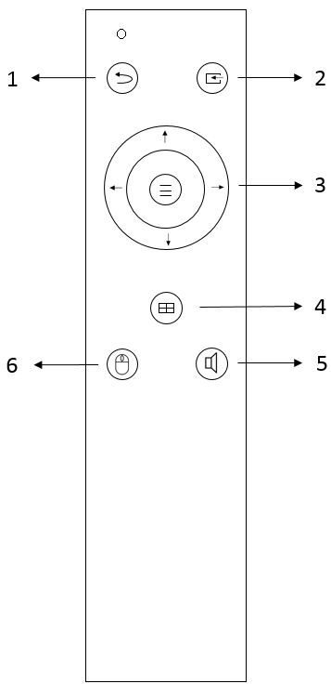

# OSD Menu

Total 4 categories of OSD content: Output Config, Multiview, Audio, System

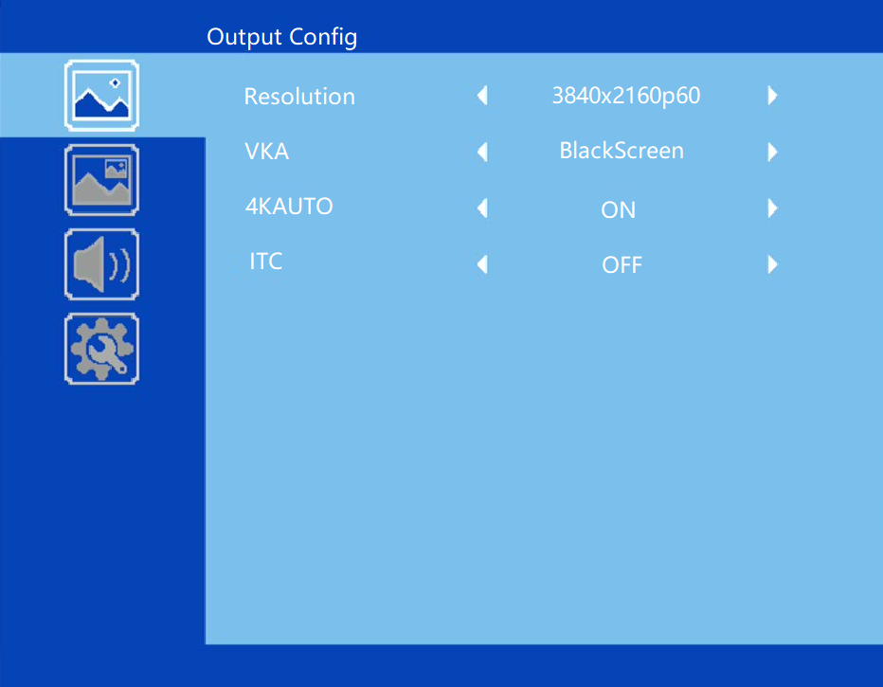

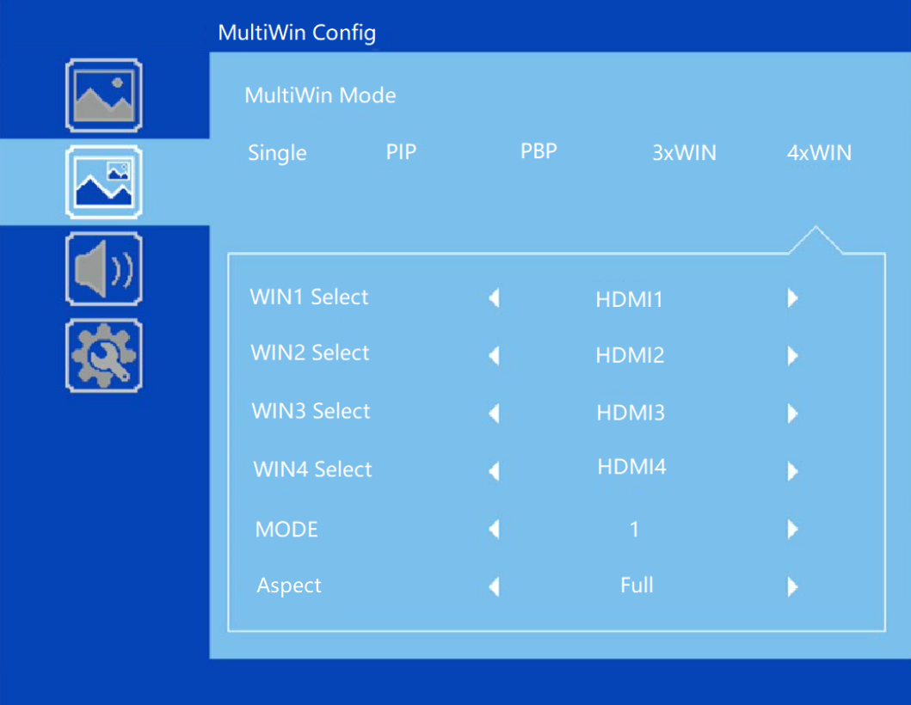

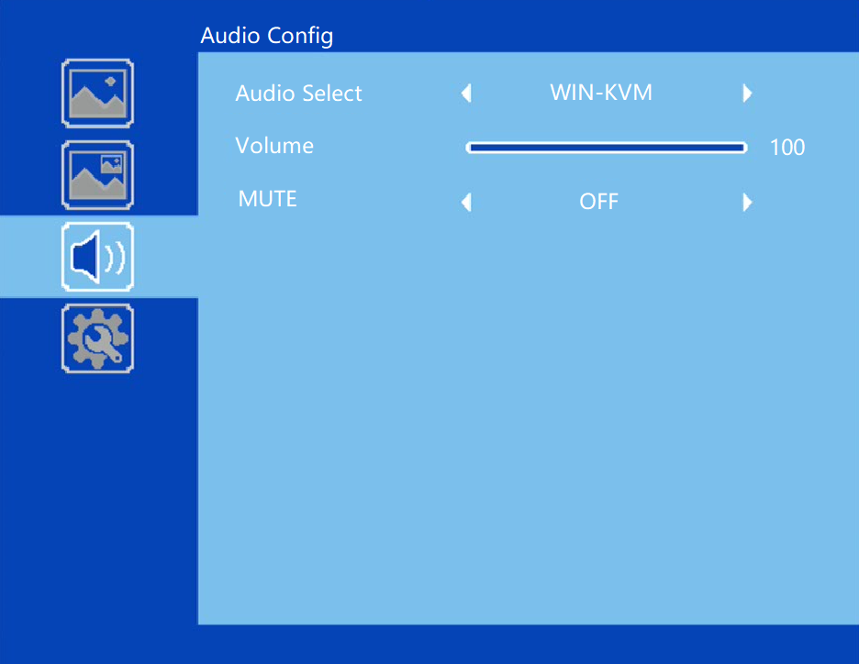

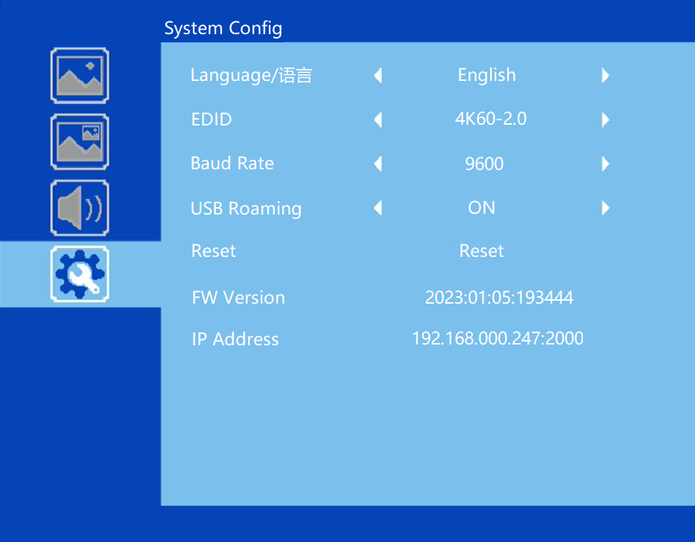

# Specification

|  |  |
| --- | --- |
| Band Width | 594MHz (18Gbps), HDMI 2.0, HDCP2,2 |
| Audio Format | LPCM, AC3, DD+, Up to 7.1 channel |
| Input ports | 7 HDMI, 1 DP, 1 USB-C |
| Output ports | 2 HDMI, 1 HDBaseT  1 5-way captive female screw connector  1 Mini Toslink |
| Power Supply | 110-220VAC |
| Operating Temperature | 0 to +40°C (+32 to +104 °F) |
| Operating Humidity | 10 to 70 % RH (non-condensing) |
| ESD | Air: ± 8KV, Contact: ± 4KV, |
| Dimensions | L430 x W220 x H44 mm |
| Mass (Main Unit) | 5kg |

# Package Contents

|  |  |
| --- | --- |
| **Item** | **Quantity** |
| Switcher Unit | 1 |
| Remoter | 1 |
| AC Power Cord | 1 |
| User Manual | 1 |
| 3 way male captive screw connector | 9 |
| 5 way male captive screw connector | 1 |

# RS232 command

**Note:** All the commands begin with SET or GET, end with Carriage Return (CR).

⮠ Represents Carriage Return (CR).

All return messages are always end with CR.

## System command

|  |  |
| --- | --- |
| Command | Details |
| GET HELP⮠ | Get the Commands list |
| SET RESET⮠ | Recover to default setting |
| GET VERSION⮠ | Get main firmware version  Return: VERSION w (w is version number) |
| GET SUB-VERSION⮠ | Get ARM firmware version  Return: SUB-VERSION w (w is version number) |
| GET EXPAND-VERSION⮠ | Get USB-SOC firmware version  Return: EXPAND-VERSION w (w is version number) |
| GET KEYBOARD-VERSION⮠ | Get front panel keyboard firmware version  Return: KEYBOARD-VERSION w (w is version number) |
| SET BAUDRATE w⮠ | w is 9600, 19200, 38400,57600 or 115200  Return: BAUDRATE w |
| GET BAUDRATE⮠ | Return: BAUDRATE w |
| SET IP ADDRESS w⮠ | For example: SET IP ADDRESS 192.168.0.247  Return: IP ADDRESS w |
| GET IP ADDRESS⮠ | Return: IP ADDRESS w |
| SET SUBMASK w⮠ | For example: SET SUBMASK 255.255.255.0  Return: SUBMASK w |
| GET SUBMASK⮠ | Return: SUBMASK w |
| SET GATEWAY w⮠ | For example: SET GATEWAY 192.168.0.1  Return: GATEWAY w |
| GET GATEWAY⮠ | Return: GATEWAY w |
| SET NETPORT w⮠ | For example: SET NETPORT 2000  Return: NETPORT w |
| GET NETPORT⮠ | Return: NETPORT w |
| SET NETWORK-INFO IP PORT SUBMASK GATEWAY⮠ | For Example:  SET NETWORK-INFO 192.168.0.247 2000 255.255.255.0 192.168.0.1  Return: NETWORK-INFO 192.168.0.247 2000 255.255.255.0 192.168.0.1 |
| GET NETWORK-INFO⮠ | Return: NETWORK-INFO IP PORT SUBMASK GATEWAY |
| SET LONG-REACH w⮠ | w is ON or OFF |
| GET LONG-REACH⮠ | Return: LONG-REACH w |
| SET FREEZE-WINx w | Freeze the display window,x is one of 1, 2, 3 ,4 or ALL, w is ON or OFF  Return: FREEZE-WINx w |
| GETFREEZE-WINx | x is one of 1, 2, 3 ,4.  Return: FREEZE-WINx w (w is ON or OFF) |

## Switching command, only available on SINGLE mode

|  |  |
| --- | --- |
| Commands | Details |
| SET AUTO SWITCH w⮠ | w is ON or OFF, default OFF  Return: AUTO SWITCH w |
| GET AUTO SWITCH⮠ | Return: AUTO SWITCH w |
| SET IN SOURCE w⮠ | w is one of the following:  HDMI1, HDMI2,…HDMI7,DP,USB-C  Return: IN SOURCE w |
| GET IN SOURCE⮠ | Get current input channel selection information  Return: IN SOURCE w |
| GET IN RESOLUTION⮠ | Get current input resolution  Return: IN RESOLUTION w (w is input resolution) |
| GET IN STATUS⮠ | Get status of all input ports  x is HDMI1…..HMDI7,DP,USB-C  Return: IN STATUS x VALID(or INVALID)  If input port is vaild,  Return: IN STATUS x InputRes ColorSpace ColorDepth |

## Output command

|  |  |
| --- | --- |
| Commands | Details |
| SET OUT RESOLUTION w⮠ | w is one of the following, default: 3840x2160p60  4096x2160p60, 4096x2160p50,  3840x2160p60, 3840x2160p50,  3840x2160p30, 3840x2160p25,  1920x1200p60RB, 1920x1080p60,  1920x1080p50, 1360x768p60,  1280x800p60, 1280x720p60,  1280x720p50, 1024x768p60，  AUTO, USER  Return: OUT RESOLUTION w |
| GET OUT RESOLUTION⮠ | Get current output resolution setting  Return: OUT RESOLUTION w |
| SET RESO-USER Width Height⮠ | Set user define output resolution,  Width is horizontal active pixels  Height is vertical active lines  For user define output resolution,the frame rate is always 60Hz  Return: RESO-USER Width Height⮠ |
| GET RESO-USER⮠ | Return: RESO-USER Width Height⮠ |
| SET OUT HDCP w⮠ | w is one of following, default FORCE-OFF  FORCE-1.4,FORCE-2.2,FORCE-OFF  Return: OUT HDCP w |
| SET OUT COMP w⮠ | w is CSC or DSC, default CSC  Compression mode when HDBT output resolution is 4K60  Return: OUT COMP w |
| GET OUT COMP⮠ | Return: OUT COMP w |
| GET OUT HDCP⮠ | Return: OUT HDCP w |
| SET OUT VKA w⮠ | Set video keep alive mode  w is BLUESCREEN or BLACKSCREEN.  Default BLACKSCREEN. It is for no signal display  Return: OUT VKA w |
| GET OUT VKA⮠ | Return: OUT VKA w |
| SET OUT 4K-AUTO w⮠ | w is ON or OFF, default ON  If we set 4K output to a displayer which can’t support 4K, then the **ON** setting can change the resolution to 1080p or 4K-4:2:0  Return: OUT 4K-AUTO w |
| GET OUT 4K-AUTO⮠ | Get current OUT 4K-AUTO mode  Return: OUT 4K-AUTO w |
| SET OUT ITC w⮠ | w is ON or OFF, default OFF  Return: OUT ITC w  Suggest **OFF** for video display and **ON** for PC especially desktop display, default **OFF** |
| GET OUT ITC⮠ | Return: OUT ITC w |
| SET OUT TSP w⮠ | Set Test Pattern on or off, w is ON or OFF  Return: OUT TSP w |
| GET OUT TSP⮠ | Return: OUT TSP w |
| SET OUT TSP-COLOR w⮠ | Set Test Pattern Colour , w is one of the following:  BLACK, BLUE, GREEN, RED, WHITE, PRBS,RAMP, CHECKER_BOARD, STRIPE, RED_RAMP, GREEN_RAMP, BLUE_RAMP  Default: CHECKER_BOARD  Return: OUT TSP-COLOR w |
| SET OUT TSP-TIMING w⮠ | Set output timing for Test Pattern display  w is one of the following:  4K30,1080p60, 720p60  default 1080p60  Return: OUT TSP-TIMING w |
| GET OUT TSP-TIMING⮠ | Return: OUT TSP-TIMING w |

## Multiview command

|  |  |
| --- | --- |
| Commands | Details |
| SET MULTIVIEW w⮠ | Select one Multiview mode for current display  w is one of the following, default SINGLE  SINGLE C:\Users\windows7\AppData\Local\Temp\1629080528(1).png, PIP , PBPC:\Users\windows7\AppData\Local\Temp\1629081546(1).png, 3xWIN C:\Users\windows7\AppData\Local\Temp\1629082712(1).png, 4xWIN C:\Users\windows7\AppData\Local\Temp\1629082974(1).png  Return: MULTIVIEW w |
| GET MULTIVIEW⮠ | Get the current Multiview mode  Return: MULTIVIEW w |
| SET SAVE SCENE w⮠ | Save current display scene  w is 1, 2,…20  Return: SAVE SCENE w |
| SET LOAD SCENE w⮠ | Load display scene  w is 1, 2,…20  Return: LOAD SCENE w |
| SET WINDOWx IN y⮠ | Select one input for one display window for the current Multiview mode. x is one of 1, 2, 3 or 4  y is one of HDMI1, HDMI2, …, HDMI7, DP,USB-C  Return: WINDOWx IN y |
| GET WINDOWx IN⮠ | This command to get which is the input source for one display window for the current Multiview mode  Return: WINDOWx IN y |
| SET PIP POS w⮠ | This command to select the PIP sub window position.  w is one of the following, default RightBottom  LeftTop, LeftBottom, RightTop, RightBottom,USER  Return: PIP POS w |
| GET PIP POS⮠ | This command to get the PIP sub window position  Return: PIP POS w |
| SET PIP SIZE w⮠ | This command to select the PIP sub window size.  w is one of the following, default LARGE  SMALL,MIDDLE, LARGE,USER  Return: PIP SIZE w |
| GET PIP SIZE⮠ | Return: PIP SIZE w |
| SET PIP USER HStart VStart HSize VSize⮠ | Return: PIP USER HStart VStart HSize VSize  This command allows users to customize a PIP layout include sub window position and size.  This customized PIP layout will replace other pre-defined PIP modes (such as LeftTop,LARGE) and display on the screen  After the user enters SET PIP POS or SET PIP SIZE command,the PIP USER will become invalid    Please note  HStart plus HSize less than or equal to 101  VStart plus VSize less than or equal to 101 |
| GET PIP USER⮠ | Return: PIP USER HStart VStart HSize VSize |
| SET PBP MODE w⮠ | Set the PBP display mode  w is one of 1,2 or 3, default 1    Return: PBP MODE w  Please note for PBP mode 3, window 2 can capture part of the input image area. It is main used for presenter show when work with conference camera situations  The capture area can be defined by SET PBP-PRESENTER command |
| GET PBP MODE⮠ | Return: PBP MODE w |
| SET PBP ASPECT w⮠ | Set the PBP window display aspect  w is FULL or 16:9, default FULL    Return: PBP ASPECT w |
| GET PBP ASPECT⮠ | Return: PBP ASPECT w |
| SET PBP-PRESENTER HStart VStart HSize VSize⮠ | Set window 1 capture area for PBP mode 3  This command only valid when the switcher already work on PBP mode 3  Return: PBP-PRESENTER HStart VStart HSize VSize    Default HStart 38, VStart 13, HSize 25, VSize 75  Please note  HStart plus HSize less than or equal to 101  VStart plus VSize less than or equal to 101 |
| GET PBP-PRESENTER⮠ | Return: PBP-PRESENTER HStart VStart HSize VSize |
| SET 3xWIN MODE w⮠ | Set the 3xWIN display mode  w is one of 1,2,3 or 4; default 1  C:\Users\windows7\AppData\Local\Temp\1658982390(1).png  Return: 3xWIN MODE w |
| GET 3xWIN MODE⮠ | Return: 3xWIN MODE w |
| SET 3xWIN ASPECT w⮠ | Set the 3xWIN window display aspect  w is FULL or 16:9, default FULL  C:\Users\windows7\AppData\Local\Temp\1658982480(1).png  Return: 3xWIN ASPECT w |
| GET 3xWIN ASPECT⮠ | Return: 3xWIN ASPECT w |
| SET 4xWIN MODE w⮠ | Set the 4xWIN display mode  w is 1 or 2 ,default 1    Return: 4xWIN MODE w |
| GET 4xWIN MODE⮠ | Return: 4xWIN MODE w |
| SET 4xWIN ASPECT w⮠ | Set the 4xWIN window display aspect  w is FULL or 16:9, default FULL  C:\Users\windows7\AppData\Local\Temp\1637116792(1).png  Return: 4xWIN ASPECT w |
| GET 4xWIN ASPECT⮠ | Return: 4xWIN ASPECT w |
| GET MULTIVIEW-SYNC⮠ | Return Multiview layout information |

## Audio command

|  |  |
| --- | --- |
| Commands | Details |
| SET AUDIO SOURCEw⮠ | w is one of the following, default: WIN-KVM:  WIN-KVM,WIN1,HDMI1, … HDMI7,DP,USB-C  Return: AUDIO SOURCE w |
| GET AUDIO SOURCE⮠ | Return: AUDIO SOURCE w |
| SET AUDIO VOL+⮠ | Increase audio out volume  Return: AUDIO VOL w (w is the volume value) |
| SET AUDIO VOL-⮠ | Decrease audio out volume  Return: AUDIO VOL w (w is the volume value) |
| SET AUDIO VOL w⮠ | Set audio volume value  w is 0,1…,or 100, default 100  Return: AUDIO VOL w |
| GET AUDIO VOL⮠ | Return: AUDIO VOL w |
| SET AUDIO-MUTE w⮠ | Mute or unmute audio output  Here w is ON or OFF, default OFF  Return: AUDIO-MUTE w |
| GET AUDIO-MUTE⮠ | Return: AUDIO-MUTE w |

## KVM command

|  |  |
| --- | --- |
| Commands | Details |
| SET KVMw⮠ | w is one of WIN1, WIN2, WIN3, WIN4  Return: KVM w |
| SET USB ROAMINGw⮠ | w is ON or OFF, default OFF  Return: USB ROAMING w |
| GET USB ROAMING ⮠ | Return: USB ROAMING w |
| SET KVM-BORDER w⮠ | w is ON or OFF, default ON  Return: KVM-BORDER w |
| GET KVM-BORDER⮠ | Return: KVM-BORDER w |
| SET KVM-BORDER-COLOR w⮠ | w is BLACK, RED, GREEN, BLUE, YELLOW, MEGENTA, CYNA, WHITE, GRAY  Default RED  Return KVM-BORDER-COLOR w |
| GET KVM-BORDER-COLOR w⮠ | Return KVM-BORDER-COLOR w |

## 

## EDID command

The following commands are used to set EDID mode for the inputs

|  |  |
| --- | --- |
| Commands | Details |
| SET IN EDIDMODE w⮠ | w is one of the following:  4K60-2.0, 4K60-5.1, 4K60-7.1, 4K30-2.0,  4K30-5.1, 4K30-7.1, 1080p60-2.0,1080p60-5.1,  1080p60-7.1,1920x1200, 1680x1050, 1600x1200, 1440x900, 1360x768, 1280x1024, 1024x768, 720p, AUTO,USER  Default: 4K60-2.0  Return: IN EDIDMODE w |
| SET EDID-USER w⮠ | Switcher can only support 256 bytes EDID-USER data.  w is 256 bytes EDID data.  Return: EDID-USER OK |
| GET IN EDIDMODE⮠ | Return: IN EDIDMODE w |

## RS232-peripheral command

The following commands are used to enable or disable one or all RS232-peripheral ports

|  |  |
| --- | --- |
| Commands | Details |
| SET RS232-PER x⮠ | w is 1,2,3…8 or KVM,ALL,NONE  Default: KVM  KVM means RS232-peripheral port follow selected KVM source |
| GET RS232-PER⮠ | Return: RS232-PER w |