**8x8 Seamless Matrix Video Switcher**

**Seamless Matrix Switcher**

**4 Window Multiviewer**

**LCD and LED Video Wall Controller**

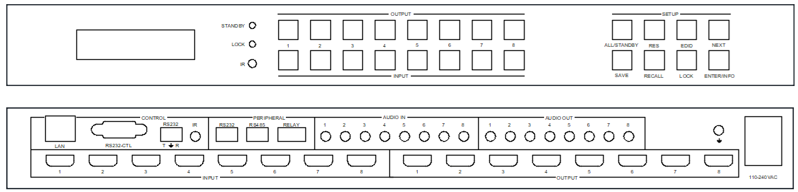

**warningWarning**

* Do not expose this device to Rain, Moisture, and Dripping
* Only use accessories specified by the manufacture
* Unplug this device during Lightning Storms
* The manual is for reference only, maybe updated without further notice

**Content**

1. System description 2

1.1. Introduction 2

1.2. Features 2

1.3. Specification 2

1.4. Output resolution index（Hex） 2

2. Panel Layout 3

2.1 Front view 3

2.2 Rear view 3

3. Package Contents 4

4. PC Tool user guide 4

4.1 Connect tab 4

4.2 Matrix switch tab 5

4.3 Signal config tab 6

4.4 TV wall tab 6

4.5 Multiview tab 7

4.6 System tab 7

4.7 Peripheral tab 7

5. How to set pixel to pixel display with LED panel/sender card 8

6. How to fit with a LED wall with different physical size panel units -MultiPanel 8

# System description

## Introduction

HDMI 8x8 seamless matrix switcher is a high-performance HDMI 2.0 video signal switching device that supports 4K@60Hz processing of input, output, switching, splicing, and multiview.

## Features

1. Support seamless switching between different input source
2. Comprehensive splicing display function with bezel compensation
3. Support two synchronization mode for all output ports: General synchronization mode and Sync delay mode
4. Supports 180° rotation
5. Free multiview up to 4 windows with all outputs
6. 8 Inputs and 8 Outputs：HDMI 2.0, up to 3840x2160/4096x2160@60Hz resolution
7. Support Auto and User Define output resolution, can be flexibly applied to the display of LED wall
8. Support analog audio insert on input side and audio extractor on output side
9. Provide multiple control ports: front panel buttons, remote control, RS232, network and WebGui control

## Specification

|  |  |
| --- | --- |
| **Item** | **Description** |
| Bandwidth | 597MHz, HDMI 2.0 |
| Audio Format | LPCM 2.0 |
| Inputs | 8x HDMI， 8x 3.5mm audio interface |
| Outputs | 8x HDMI， 8x 3.5mm audio interface |
| Power | 110-240VAC，75W Max |
| Operating Humidity | 10 to 70 % RH (non-condensing) |
| Operating Temperature | 0 to +40°C (+32 to +104 °F) |
| ESD | Air: ± 8KV, Contact: ± 4KV |
| Dimensions | L430 x W220 x H44 mm |
| Mass | 5kg |

## Output resolution index（Hex）

|  |  |  |  |
| --- | --- | --- | --- |
| **Index** | **Output resolution** | **Index** | **Output Resolution** |
| 00 | 4096x2160p 60Hz | 0C | 1920x1080p30 Hz |
| 01 | 4096x2160p 50Hz | 0D | 1680x1050p60 Hz |
| 02 | 3840x2160p 60Hz | 0E | 1600x1200p60 Hz |
| 03 | 3840x2160p 50Hz | 0F | 1360x768p60 Hz |
| 04 | 3840x2160p 30Hz | 10 | 1280x1024p60 Hz |
| 05 | 3840x2160p 25Hz | 11 | 1280x768p60 Hz |
| 06 | 3440x1440p 60Hz | 12 | 1280x720p60 Hz |
| 07 | 2560x1600p 60Hz | 13 | 1280x720p50 Hz |
| 08 | 2560x1440p 60Hz | 14 | 1024x768p60 Hz |
| 09 | 1920x1200p 60Hz | 15 | USER |
| 0A | 1920x1080p 60Hz | 16 | AUTO |
| 0B | 1920x1080p 50Hz |  |  |

# Panel Layout

## 2.1 Front view

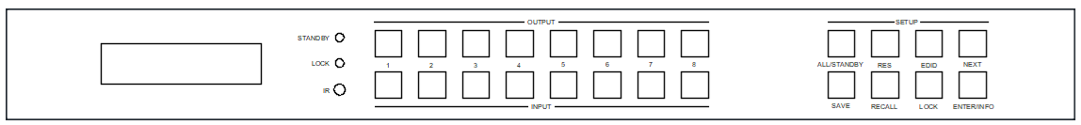

1. LCM display screen: displays the routing status of each channel. Used together with front buttons, it can set and view some parameters
2. OUT SELECT：1, 2, ...,8, ALL
3. IN SELECT： 1, 2, ...,8

Press OUTPUT m +INPUT n +ENTER, switch input n to output m

1. ALL button: Press ALL + INPUT n +ENTER, switch input n to all output ports

Long hold ALL button more than 3 seconds, the device will enter or exit standby mode

1. LOCK button : Hold this button more than 3 seconds, all the fronts buttons will be locked and will not work.

Hold it more than 3 seconds again, unlock

1. Press buttons RES + OUTPUT m + NEXT + ENTER with guide of front LCM screen display, to change output resolution of OUTPUT m
2. Press buttons EDID + INPUT n + NEXT + ENTER with guide of front LCM screen display, to change the EDID mode of INPUT n
3. SAVE button : Press SAVE+ OUTPUT m +ENTER, save current routing and screen layout to scene m
4. RECALL button: Press RECALL+ OUTPUT m +ENTER, load scene m for current displaying
5. ENTER/INFO button: Long hold and continuously press this button, front LCD panel will loop display IR ON/OFF,RS232 Baud Rate and IP parameters etc,.
6. IR: IR receiver, can be disabled by RS232 command

## 2.2 Rear view

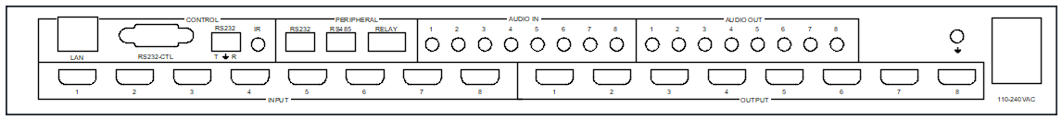

**Control ports**:

1. LAN control（TCP/IP or Web Control）

IP address: 192.168.0.247, Submask: 255.255.255.0, Gateway: 192.168.0.1, Baud Rate: 9600, NetPort: 23

Web login account : admin，password : admin

1. RS232-CTL

Baud Rate: 9600

1. RS232-Phoenix:

Baud Rate: 9600

T: Main Unit -> PC, G: Ground, R: Main Unit <- PC

1. IR: IR receiver extender interface, just reserved.

**Peripheral control ports**:

One RS232-phoenix port，one RS485-phoenix port，two relay controller

For details, please refer to the following PC tool for instructions on using peripheral ports control.

**Input and output ports**

8x HDMI inputs, 8x 3.5mm LR audio inputs

8x HDMI outputs, 8x 3.5mm LR audio outputs

# Package Contents

|  |  |
| --- | --- |
| **Item** | **Quantity** |
| Main Unit | 1 |
| AC Power Cord | 1 |
| USB to RS232 cable | 1 |
| 1 meter RJ45 cable | 1 |
| Remoter | 1 |

# PC Tool user guide

This PC tool is an installation free control software. It is divided into different tabs according to different functions: Connect, Matrix, Signal, TV wall, System, and Multiview

The initial login password is: 111111

## 4.1 Connect tab

Please note：

1. Use serial cable (straight line) or Ethernet cable
2. When using a serial port connection, the network port connection must be disconnected, and vice versa
3. When connecting through the network port, you must first search for and select the device before connecting

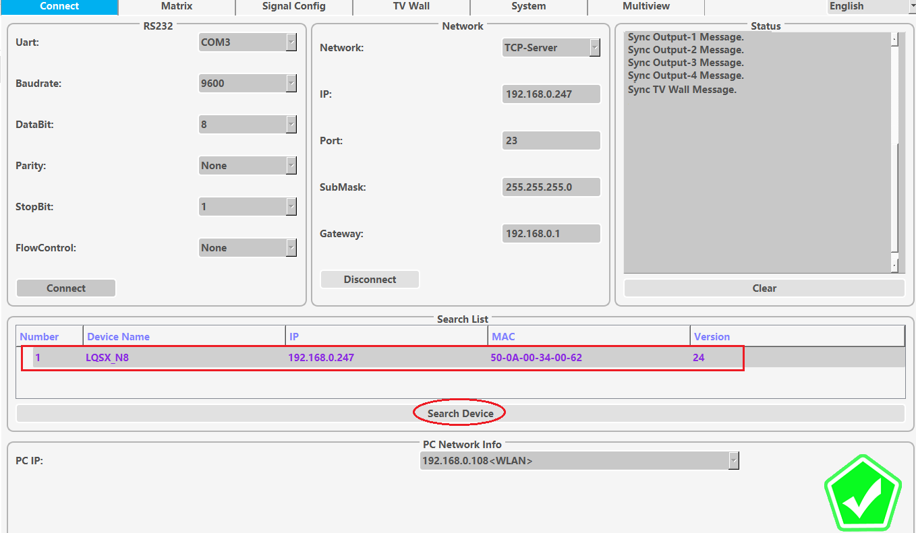

## 4.2 Matrix switch tab

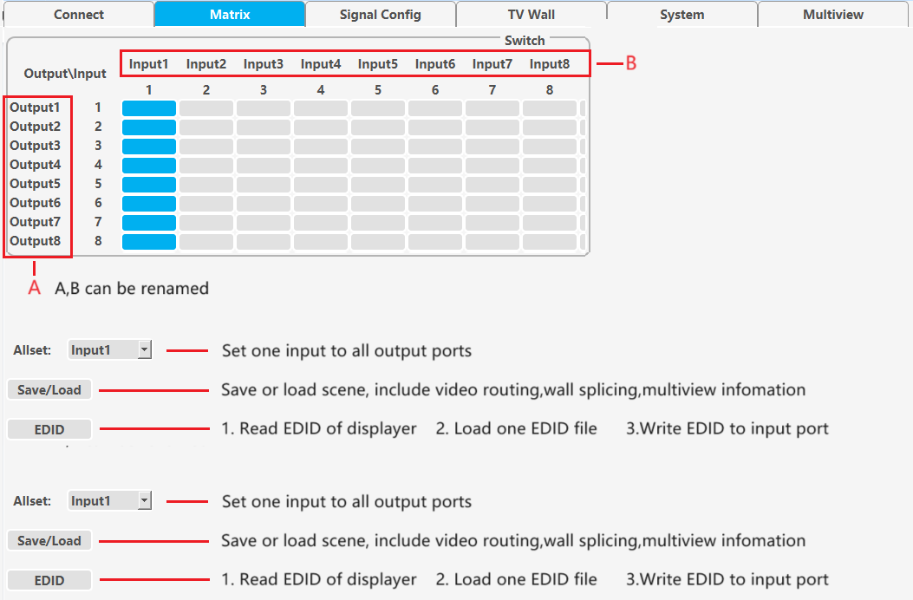

## 4.3 Signal config tab

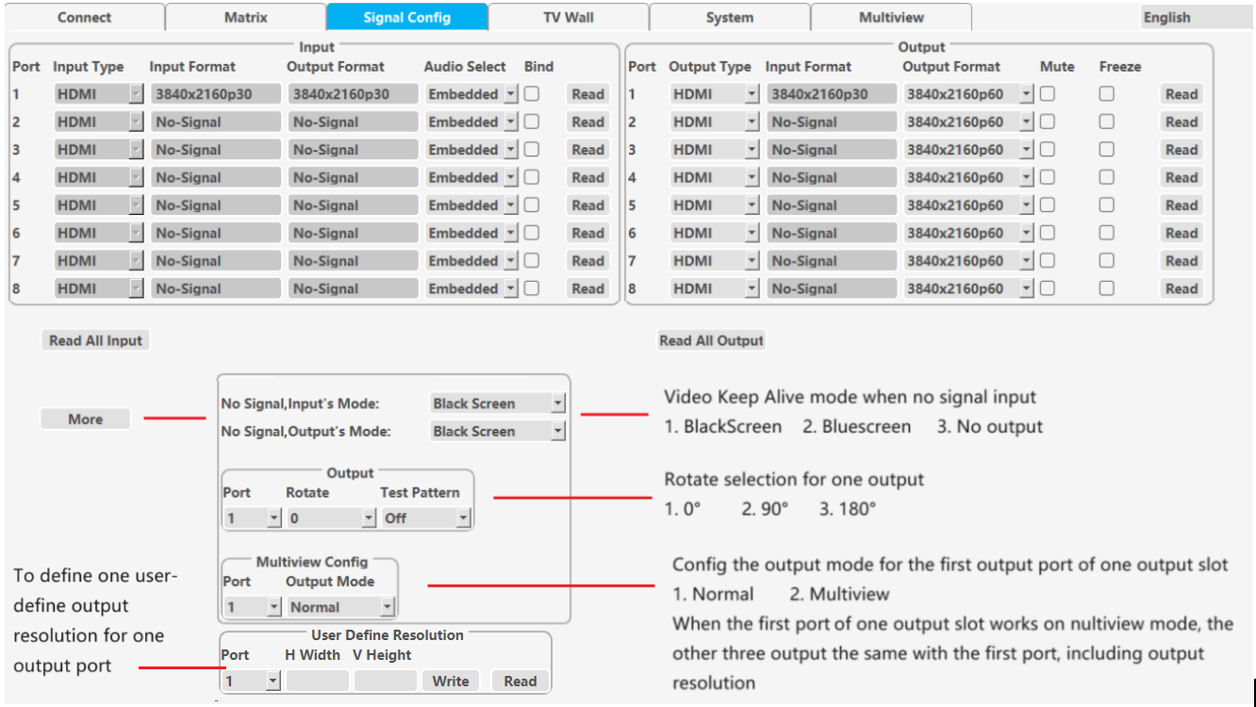

## 4.4 TV wall tab

This tab set the splicing wall parameters: layout, bezel compensation, input/output settings, etc

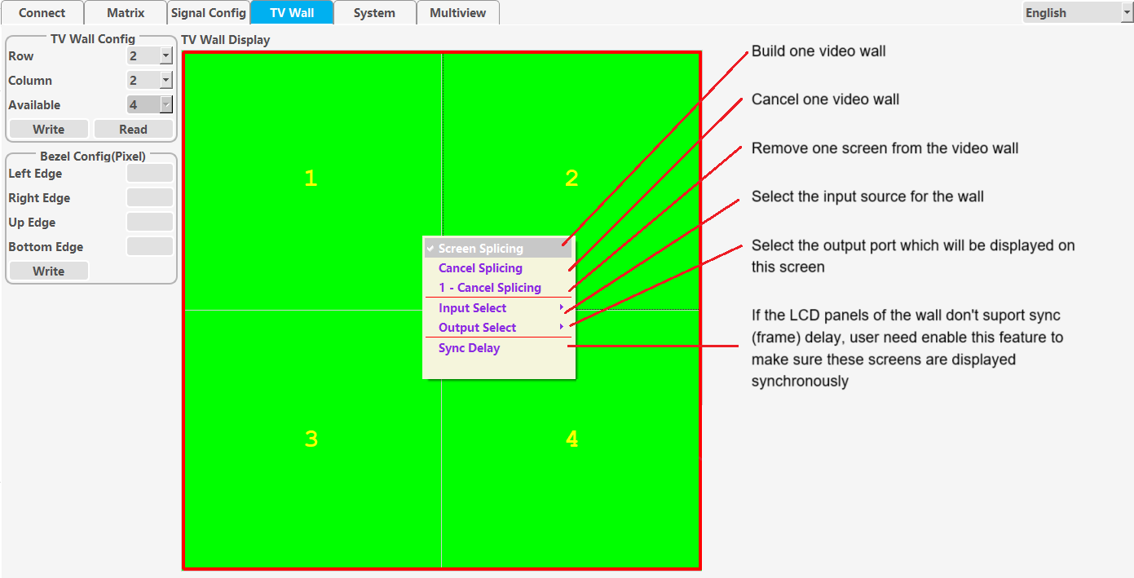

**Please note**: In order to ensure the synchronization of moving video on each screen during splicing output, if the output resolution of one or some splicing output ports is changed, please be sure to restart the device. Similarly, the various splicing operations of LED screens mentioned below also need to be done in this way.

## 4.5 Multiview tab

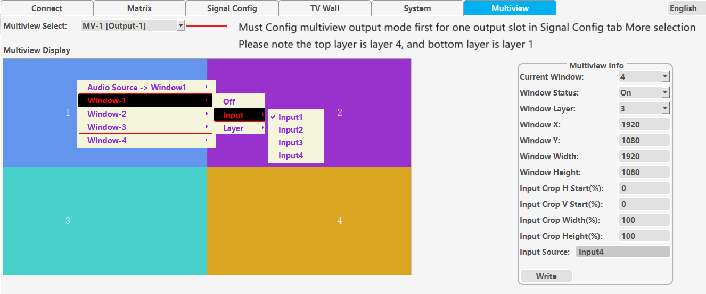

## 4.6 System tab

This tab sets network parameters, resets, reads software versions, etc

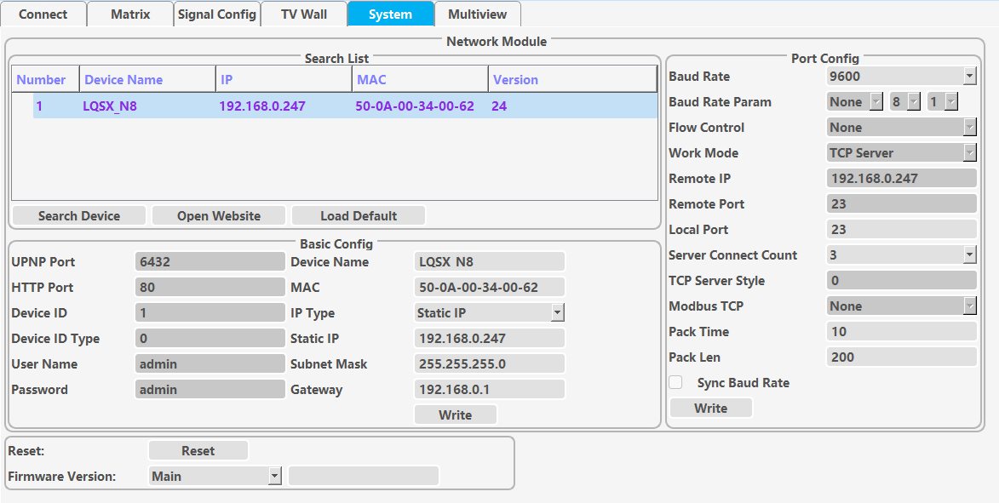

## 4.7 Peripheral tab

User can set the two relays to be on or off to control related peripheral device. And can send RS232 or RS485 commands at a specific baud rate to control other peripheral device.

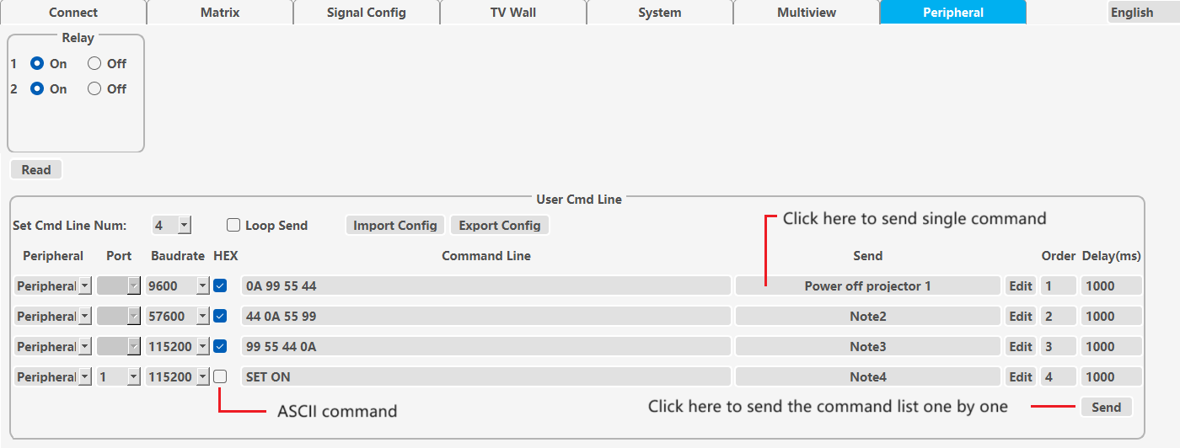

# How to set pixel to pixel display with LED panel/sender card

**Step 1**, connect input cable between source and one input port of the matrix switcher.

**Step 2**, connect output cable between LED panel/sender card and one output port of the matrix switcher.

**Step 3**, read the EDID of LED panel/sender card with PC Tool and download this EDID to the input port of the matrix switcher.

**Step 4**, set the output resolution of this output port as USER or AUTO. When set USER, need configure the user define resolution first, and make the user defined resolution to match the physical resolution of the LED panel unit completely.

# How to fit with a LED wall with different physical size panel units -MultiPanel

Sometimes we may encounter situations where the width or height of the LED splicing panel units are different.

In this case, in addition to setting up the relevant splicing operations normally firstly, then we also need to make the following configurations

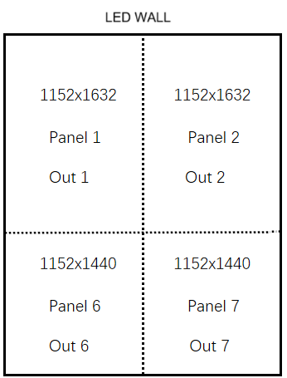

1. Set user define output resolution to the physical display resolution of the corresponding LED panel for **every** output port which displayed on this LED wall

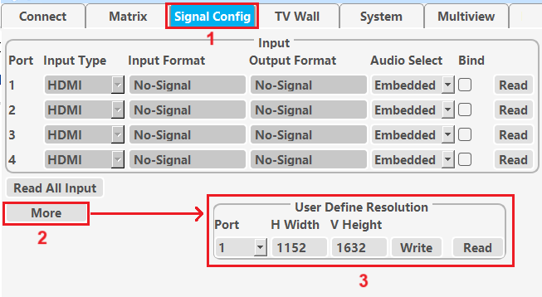

1. Turn to TV Wall Tab and press alt Q on PC keyboard
2. Press right button of the mouse, then appears the interface as below, and click MultiPanel, then system will automatically fit the different panels

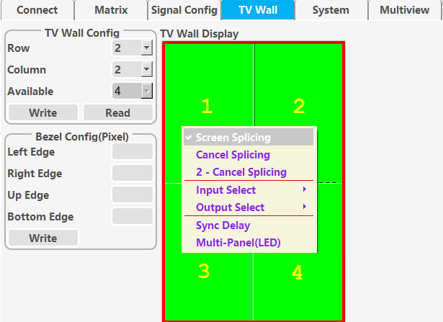

1. If user want to exit MultiPanel function, he need cancel this video wall, then system will automatically exit MultiPanel function
2. Please note MultiPanel function is not included in scene save or recall