4x4 Seamless UHD Matrix

**Model No. VM4K44H**

**Version 2.0**

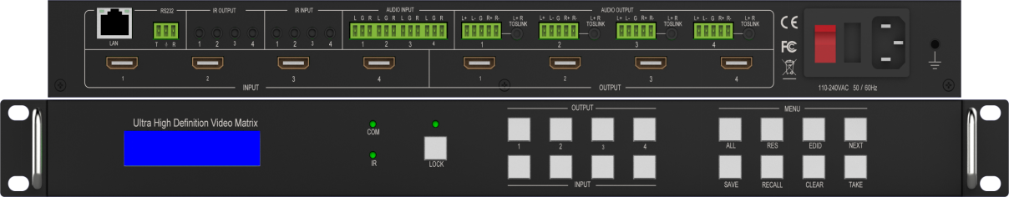

**warning Warning**

* Do not expose this device to Rain, Moisture, and Dripping
* Only use accessories specified by the manufacture
* Unplug this device during Lightning Storms
* Product specifications may be subject to technical upgrades without further notice

Content

1 Introduction 3

2 Front Panel Control 3

3 Rear Panel 5

4 RS232/LAN Control 6

4.1 RS232 connector 6

4.2 Ethernet control and connection 6

5 PC tool user guide 6

5.1 Account’s authentication 6

5.2 Connect with PC tool 6

5.3 Matrix Switch tab 7

5.4 Signal setting tab 8

5.5 Fine Tune tab 8

5.6 Video Wall tab 9

5.6.1 Video Wall Context Menu 10

Bezel Setting 11

Type A Bezel Settings 11

Type B Bezel Settings 11

Bezel Compensation 11

5.6.2 Layout Save/Load 11

5.7 CEC control page 12

6 Control via Web 12

7 Electrical parameters 14

8 Package Contents 14

# Introduction

VM4K44H is a high-performance seamless UHD matrix switcher with 4x HDMI inputs and 4x HDMI outputs. Audio extract or insert can also be enabled on this device. IR matrix routing on this video matrix is followed with video routing. VM4K44H has independent audio matrix, support CEC manager and strong video wall processor

VM4K44H key features:

* Support HDMI 2.0/HDCP 2.2
* Support seamless switching
* Support video wall
* Support CEC manager
* Support Rotation 180 degree
* Support audio matrix
* Support HDMI audio extract
* Support external LR audio insert on HDMI stream
* Support EDID management
* HDMI video output resolution up to 3840x2160@60
* Front panel,RS232,TCP/IP (LAN 10M/100M) control

# Front Panel Control

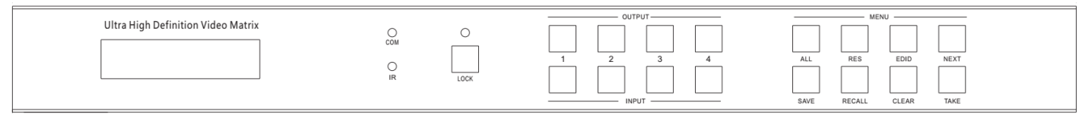

|  |  |
| --- | --- |
| **Item** | **Description** |
| **LCD Panel** | Displays the current video selections |
| **COM** | Power LED (also indicates control commands) |
| **LOCK** | Front panel lock/unlock |
| **OUTPUT** | Output selection buttons 1~4 |
| **INPUT** | Input selection buttons 1~4 |
| **ALL** | Set all outputs to the next input selection |
| **RES** | Set the output scaler resolution |
| **EDID** | Set the EDID options for the next input selection |
| **NEXT** | Select the next available option |
| **SAVE** | Save the current matrix setting as a preset |
| **RECALL** | Set the matrix setting from a saved preset |
| **CLEAR** | Cancel the current command function |
| **ENTER** | Set the displayed option |

* Press buttons ALL + INPUT m + TAKE by sequence, to switch input m to all the outputs
* Press button SAVE + OUTPUT n to save current routing/video wall scene as scene n. The maximum

available scene No. is 8

* Press button RECALL + OUTPUT n to recall routing scene n as current routing
* Press button RES + OUTPUT n + NEXT + TAKE, to change output resolution of OUTPUT n

Resolution options:

|  |  |  |  |
| --- | --- | --- | --- |
| Number | Output Resolution Setting | Number | Output Resolution Setting |
| 1 | 3840x2160p 60Hz | 9 | 1440x1050 60Hz |
| 2 | 3840x2160p 50Hz | 10 | 1366x768 60Hz |
| 3 | 3840x2160p 30Hz | 11 | 1360x768 60Hz |
| 4 | 3840x2160p 25Hz | 12 | 1280x1024 60Hz |
| 5 | 1920x1200 60Hz | 13 | 1280x768 60Hz |
| 6 | 1920x1080p 60Hz | 14 | 1280x720p 60Hz |
| 7 | 1920x1080p 50Hz | 15 | 1280x720p 50Hz |
| 8 | 1600x1200 60Hz | 16 | 1024x768 60Hz |

* Press buttons EDID + INPUT m + NEXT + TAKE, change the EDID mode of port INPUT m

EDID options:

|  |  |  |  |
| --- | --- | --- | --- |
| Number | Output Resolution Setting | Number | Output Resolution Setting |
| 1 | Manual | 5 | 1920x1080 60Hz |
| 2 | 3840x2160 60Hz | 6 | 1280x1024 60Hz |
| 3 | 3840x2160 30Hz | 7 | 1280x720p 60H |
| 4 | 1920x1200 60z | 8 | 1024x768 60Hz |

Manual EDID is loaded by PC Tool

* Front Lock button

The front panel control buttons can be locked to prevent accidental use or operation by unauthorized persons. Press the LOCK button for two seconds to lock or unlock the front panel. When the panel is locked, all buttons except the LOCK button will not function until the front panel is unlocked. The LOCKED/UNLOCKED state is shown on the LCD panel and by the LED above the LOCK button, which is lit when the front panel is fully LOCKED.

When the unit is UNLOCKED, press and hold down the LOCK button for six seconds - The LCD panel will show the following (any exiting numbers indicates that those buttons are already locked):

Output: --------

Input: --------

Pressing any of the numbered Output or Input buttons will toggle the lock status of that button. The button will become locked when the respective button number is shown on the LCD panel. When all selection are done, press the ENTER button to set the new LOCK/UNLOCK states of those buttons.

Whenever a locked Output or Input button is activated, the LCD panel will show that the button is locked. In this mode, the LOCK LED is not lit.

To unlock those buttons, repeat the above steps to remove the button numbers from the LCD panel before pressing ENTER to accept the changes.

# Rear Panel

* LAN(10M/100M), RS232 are for PC control
* Analog Audio IN/OUT ports bind to corresponding HDMI ports.

For example:

If HDMI 1 audio source is selected with External LR, then analog AUDIO IN LR1 (with phoenix connector) will be selected to replace the embedded audio of the HDMI input 1 data stream. If HDMI 1 audio source is selected with AUTO by PC TOOL or command, then will use the original embedded audio of input HDMI 1 as its audio data stream.

If the input is DVI signal, no matter how it is set up, system will get external analog audio input. Analog AUDIO OUT n will always output the same audio content with HDMI OUTPUT n Analog Audio IN/OUT connection

* IR IN and IR OUT

IR IN/OUT routing is follow video matrix routing, no need to separately control IR matrix

IR extender connectors (not as accessories)

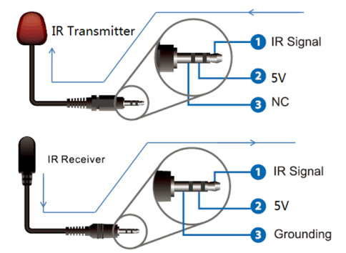

* Audio Input

4 3-way Phoenix connectors to input external analog LR audio, user can select this audio to replace

the corresponding embedded HDMI audio

* Audio Output

4 5-way Phoenix connectors to output balanced LR audio, and 4 mini Toslink jackets to output

analog LR audio and digital S/Pdif audio

The 4 Audio output (LR and Toslink) channels can be independent of video and switched by PC Tool

or commands

# RS232/LAN Control

## RS232 connector

* RS-232 control, baud rate 9600, 3-PIN Phoenix connector

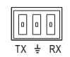

TX Pin, Matrix--->PC

RX Pin, Matrix<---PC

## Ethernet control and connection

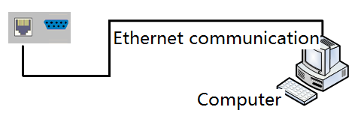**Note：Factory default network setting：**

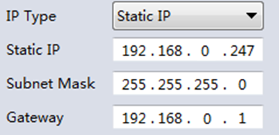

# PC tool user guide

## Account’s authentication

When you run the PC tool, there needs password to authenticate.

Default password of Administrator（access to all features）：111111

Default password of User（access to all features, except OSD function）：000000

## Connect with PC tool

1. The default PC tool’s UI style as bellow

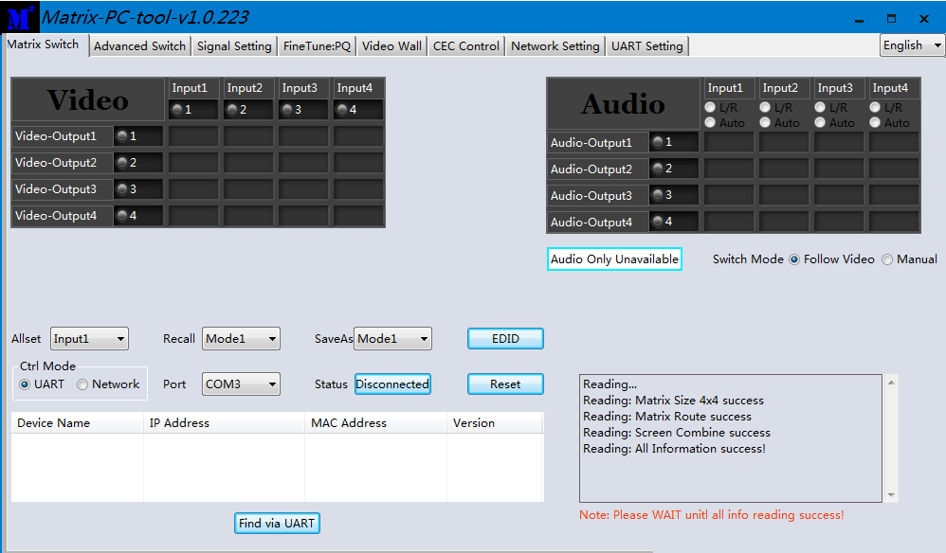

2. User can select **UART** (with RS232 cable) or **Network** to connect, baud rate is 9600 bps

3. **D**efault IP address, 192.168,0.247

## Matrix Switch tab

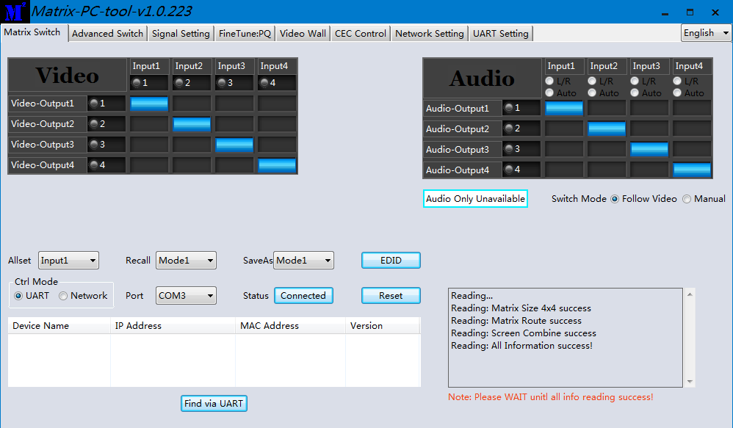

1. There is a shortcut button to switch one input port to all output ports, that is Allset,

For example, switch input 1 to all outputs, user can select

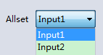

1. Recall mode：Recall an inputs/outputs routing scene which already be saved before.

The device supports maximum 8 scenes.

1. Save mode：Save current inputs /outputs routing in one index. Maximum 8 modes supported.

Note: Save/Recall button here works the same with front panel save/recall control and also the same with Save/Load function on video wall page

1. System reset: The PC tool support reset system to recover to factory configuration.
2. Audio Switch mode: Follow Video mode or Manual mode

When select Manual mode, user can separately switch L/R (Phoenix interface) and Toslink output

User also can select to use HDMI embedded or corresponding external LR audio

1. EDID Control: Click the ‘EDID’ button on Matrix Switch page, then opens a EDID control window, then user can do follow activity
   1. Read EDID of one output port
   2. Open one existing EDID file
   3. Write EDID to one input port

## Signal setting tab

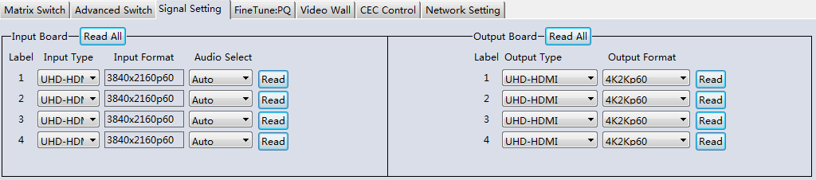

1. Audio Select

There are two options for input Audio Select

* 1. Auto: If the input source is HDMI signal, system will get the embedded audio, and if the input source is DVI signal, the system will get the corresponding analog audio
  2. External: System will get the corresponding analog audio

2. Output type

There are four options for input Output Type:

1. UHD-HDMI (HDCP OFF): HDCP Off
2. UHD-DVI
3. UHD-HDCP-1.4,
4. UHD-HDCP-2.2

3. Output Resolution: Same to the description on Front Panel page

## Fine Tune tab

User can read and set the brightness/contrast/saturation/sharpness of each output.

If none special occasions, do not change the default settings

## Video Wall tab

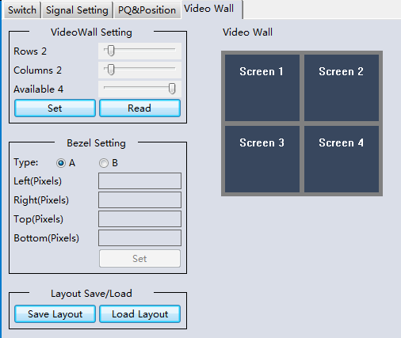

1. Use the Video Wall Setting controls to change how the displays are arranged on the Video Wall tab:
   1. Adjust the Rows and Columns sliders to change the displayed screen arrangement to permit proper Drag-and-Select of the desired screens for the video wall.
   2. Change the Available slider to set how many outputs will be used for the Video Wall.
   3. Click the Set button to change the Screen configuration on the Video Wall tab.
2. Use the left mouse button to drag-select the screens that will be set for video wall mode. The selected screens will be shown as bright blue.
3. Use the right mouse button to open a menu.
4. Select Screen Stitching from the menu to program the video wall mode. The selected screens will now be shown as bright green.
5. To change the displayed image: either use the methods detailed in the section Controlling the Matrix Switcher starting on page 10, or right-click to open the pop-up menu and select the desired input from the Input Select menu option.
6. Repeating steps 2 to 5 above with a different set of outputs allows the creation of a second video wall. However, changing the Rows, Columns and Available sliders will automatically delete the current video wall set up when the Set button is clicked. The following example shows a more unusual video wall set-up of two video walls with two 2x1 configurations:

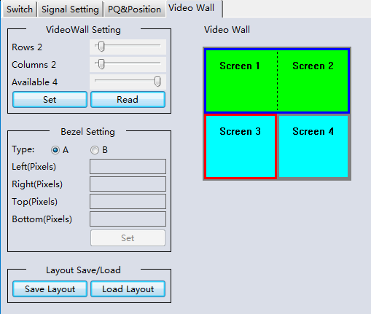

### Video Wall Context Menu

Right clicking on any of the screen icons will display the following context menu:

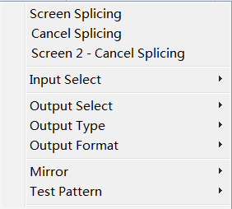

|  |  |
| --- | --- |
| **Screen Stitching** | This option connects the selected screens into a video wall configuration. |
| **Cancel Stitching** | Return the Video Wall configuration to normal outputs. |
| **Screen x – Cancel Stitching** | Removes the single screen x from the video wall to allow the displaying another full frame image within the video wall configuration, as shown in this example: |
| **Input Select** | Use the sub-menu to select the input to display on the video wall or the secondary input image shown in the above example. |
| **Output Select** | This option is only available for any screen that is not assigned to a video wall mode. |
| **Output Type** | This option is only available for any screen that is not assigned to a video wall mode. It allows setting of the selected screen output mode as described in the Output Board section on page 14. |
| **Output Format** | This option is only available for any screen that is not assigned to a video wall mode. It allows setting of the output resolution for the selected screen output. |
| **Mirror** | Two sub options : OFF ( default ), ON ( H+V Mirror)  When select **ON**, you can make 180º rotation with the selected screen |
| **Test Pattern** | When enable Test Pattern, the output will display Color Bar pattern |

### Bezel Setting

The Bezel Setting section allows the entry of values to compensate for the display bezel thickness. These values may be entered either as pixels (Type A) or as milli meter (Type B).

### Type A Bezel Settings

The image size will be adjusted to allow for the number of pixels entered in each of the entry boxes. Click the **Set** button view the effect of the new values.

### Type B Bezel Settings

The image size will be adjusted to allow for the Inner and Outer display dimensions as entered in each of the entry boxes. Click the **Set** button view the effect of the new values.

### Bezel Compensation

The following images demonstrate the effect of not having bezel compensation and what a correctly configured bezel compensation settings should produce:

|  |  |
| --- | --- |
| No Bezel Compensation | Correct Bezel Compensation |

### Layout Save/Load

The Save Scene/Layout and Load Scene/Layout buttons allow a video wall configuration to be saved or recalled at any time. Up to 8 configurations, each with their own name can be saved or recalled. When saving, each Scene can optionally be given a name to identify that video wall scene setup.

## CEC control page

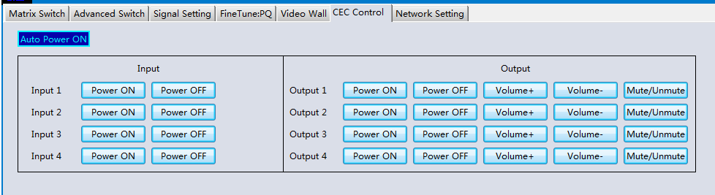

When **Auto Power On** is enabled, every time when VM4K44H turned on, it will turn on all the sources

and displayers which connected to it and support CEC function

VM4K44H CEC function include Power on/off, Volume+/-,Mute/Unmute

# Control via Web

The built-in WebGUI interface provides only basic control of the matrix switcher and access to the network settings. The following will be displayed when the web interface is access each time:

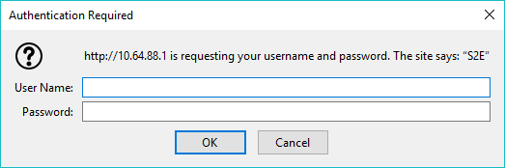

The default User Name is: **admin**

The default Password is: **admin**

After entering the **User Name** and **Password** a screen similar to the following will be displayed:

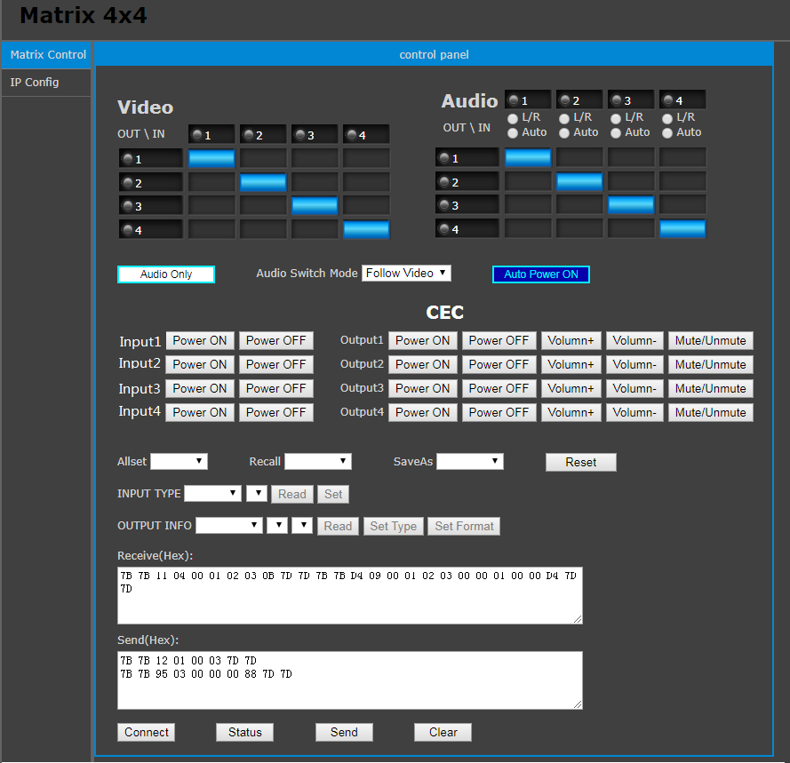

IP Config

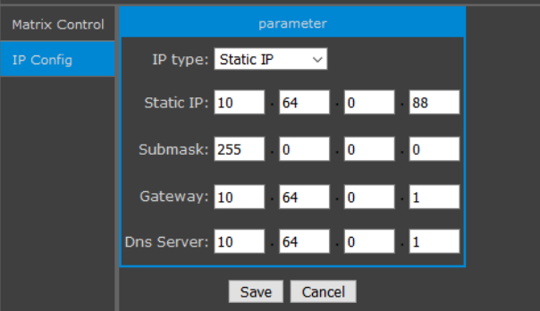

The IP Config tab is used to change the IP settings of the matrix switcher. Enter any necessary changes and click **Save** to program the switcher to the new settings, or **Cancel** to reject the changes.

# Electrical parameters

|  |  |
| --- | --- |
| Electrical parameter | |
| Interface | HDMI-A |
| HDMI Version | HDMI2.0,HDCP2.2 |
| Bandwidth | 18Gbps |
| HDMI Amplitude | T.M.D.S +/- 0.4Vpp |
| Differential impedance | 100±15ohm |
| RS232/Ethernet control | |
| Baud rate and protocol | Baud rate：9600, data bit：8， |
| stop bit：1,no parity checking |
| Ethernet | IE10.0+,HTML5 |
| Power | |
| Max Consumption | 60W, 110-240VAC |
| Matrix Mechanical dimensions | |
| Size(mm) | 430(L)X220(W)X44 (H) |
| Weight | 5Kg |
| Operating temperature | 0 to 40°C |
| Storage temperature | -20 to 70°C |
| Permissible humidity | 10%-50% |

# Package Contents

|  |  |
| --- | --- |
| Item | Quantity |
| VM4K44H unit | 1 |
| VM4K44H User Manual | 1 |
| AC Power Cord | 1 |