**HDMI and HDBaseT Extender**

**User Manual**

70 meters version: 70m @1080p or 40m @4K

100 meters version: 100m @1080p or 70m @4K

The extender supports:

HDMI 2.0, Test Pattern, Down-Scaler, EDID & HDCP control,

Audio embedding, CEC & Temperature control, diagnostics, POC

**Contents**

1. Features 3

2. Front 4

3. Rear 4

4. Using the Extenders 5

5. RJ45 cable 6

6. Test Pattern and Keep-Alive Features 6

7. Down-Scaling 7

8. Connecting to the IR Ports 7

9. RS232 Commands 7

10. Parameters 13

11. Video and Audio 13

12. Regarding the installation of hanging ears 14

13. Packaging size and environmental parameters 14

14. Package Contents 15

**Thank you for purchasing the HDMI/HDBaseT Extender Set.**

This HDBaseT extender is designed with the professional AV installers in mind. The many extensive features assist in system integration, validation and maintenance.

**Installation precautions**

This product has special circuitry to protect it against moderate surges and static discharges. However, to ensure reliable operation and long service life, it is important to take the necessary precautions against any spikes, surges and static discharges.

Place the units away from heat sources and allow adequate ventilation.

Shielded cable and in particular cat6, cat6a or cat7 is highly recommended. As much as possible cables should be routed away from any noisy sources and avoiding long runs in close proximity to mains cables.

The HDBaseT Extender set supports all input resolutions to 4K60 4:4:4, with bi-directional IR, and two independent pass-through RS232 ports. The main RS232 channel (Tx/Rx) is also used for controlling the many features. The second RS232 channel (T2, R2) can also be used for RTS/CTS handshaking.

The transmitter unit also supports external L/R audio embedding and HDMI local loop output, as well as many useful features such as: HDCP management, EDID settings, video Down-Scale, Test Patterns, Video Keep Alive, Temperature & CEC control, diagnostics.

# Features

* HDMI input supports up to 18G HDMI 2.0 (4K60 4:4:4)
* Transmission length

70 meters version: up to 70m @1080p, or 40m @4K

100 meters version: up to 100m @1080p, or 70m @4K

* Many features: Test Patterns, 4K down-scale, Video Keep Alive, CEC control, etc.
* Extensive EDID and HDCP control
* Over-temperature control and protection
* External audio embedding and HDMI loop output (Transmitter unit)
* Bidirectional IR and two independent RS232 ports
* PCTool: For easy control and diagnostics of enhanced features
* POC safely provides power to both units using a single 24V PSU

# Front

**Transmitter**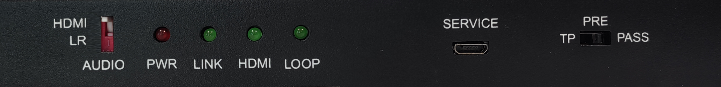

**Receiver**

| **Name** | **Description** |
| --- | --- |
| **EDID Switch**  (Transmitter) | * **TP:** Generate a Test Pattern (RS232 command configurable).   Default Test Pattern is Chequerboard at 1080p   * **PRE:** Pre-defined HDMI input EDID.   There are 22 EDID options selectable from RS232 commands.  Default pre-define EDID is 4K60 (4:4:4) 2.0CH   * **Pass:** Use the EDID data from the display device |
| **Power LED** | Lit when the unit is powered |
| **LINK LED** | Lit when the HDBaseT Transmitter and Receiver are linked together |
| **HDMI LED** | Lit when there is video signal transmission through HDMI cable |
| **Service port** | Used for firmware updating (do not use as a USB port) |
| **LOOP LED**  (Transmitter) | When the loop out port connected to a displayer, the LED will be lit |
| **AUDIO Switch**  (Transmitter) | To select external LR audio or original HDMI embedded audio |

# Rear

**Transmitter**

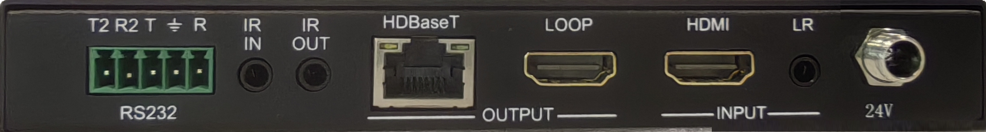

**Receiver**

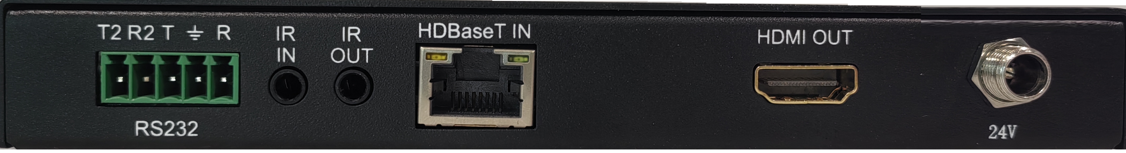

|  |  |
| --- | --- |
| **Name** | **Description** |
| **24V** | 24V DC input |
| **IR OUT** | IR output |
| **IR IN** | IR input |
| **HDMI IN** (Transmitter) | HDMI input |
| **HDMI OUT** (Receiver) | HDMI output |
| **HDBaseT** | HDBaseT RJ45 connection - (with PoC) |
| **RS232** | * **Tx, Rx and GND** connections   A general-purpose pass-through RS232 port.  This port is also used to control the Transmitter/Receiver units – see **RS232 Control Commands**.   * **T2, R2 and GND connections**   Independent second RS232 (pass-through) data port for any baud rate up to 57600. These can also be used as RTS/CTS handshaking lines, see **Figure 1**. |
| **LR IN –** (Transmitter) | External L/R audio input |
| **LOOP–** (Transmitter) | HDMI loo out |

# Using the Extenders

* Connect a video source to the Transmitter HDMI input connector and the remote display device to the Receiver HDMI output connector.
* Ensure the catx cable is wired correctly – see **RJ-45 Wiring** for connection details.
* Plug the cat5e/6/6a cable into the RJ45 jacks of Transmitter and Receiver units.
* If needed, connect any optional inputs and outputs such as audio, IR, HDMI loop out cable or RS232.
* Power up the extender by connecting the 24V DC power adaptor to either Transmitter or Receiver unit – Only one PSU required with PoC function.
* For simple RS232 pass-through communication use Tx Rx lines. These lines are also used for controlling the extender units (see **RS232 Control Commands**).
* When RTS/CTS handshaking is also required, connect R2 to RTS and T2 to CTS of the control device, as shown in the following wiring diagram:

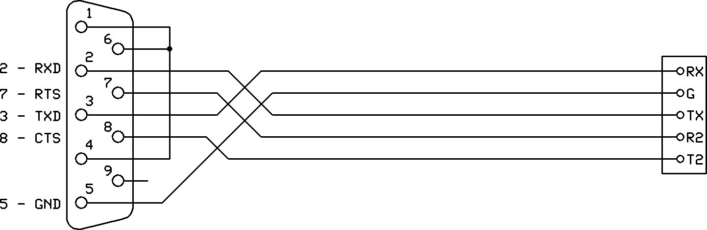

Figure 1 - RS232 Wiring with optional RTS/CTS Handshakes

* The extender can support two independent RS232 channels. T2/R2 can be used as a second independent pass-through RS232 channel, as per below diagram:

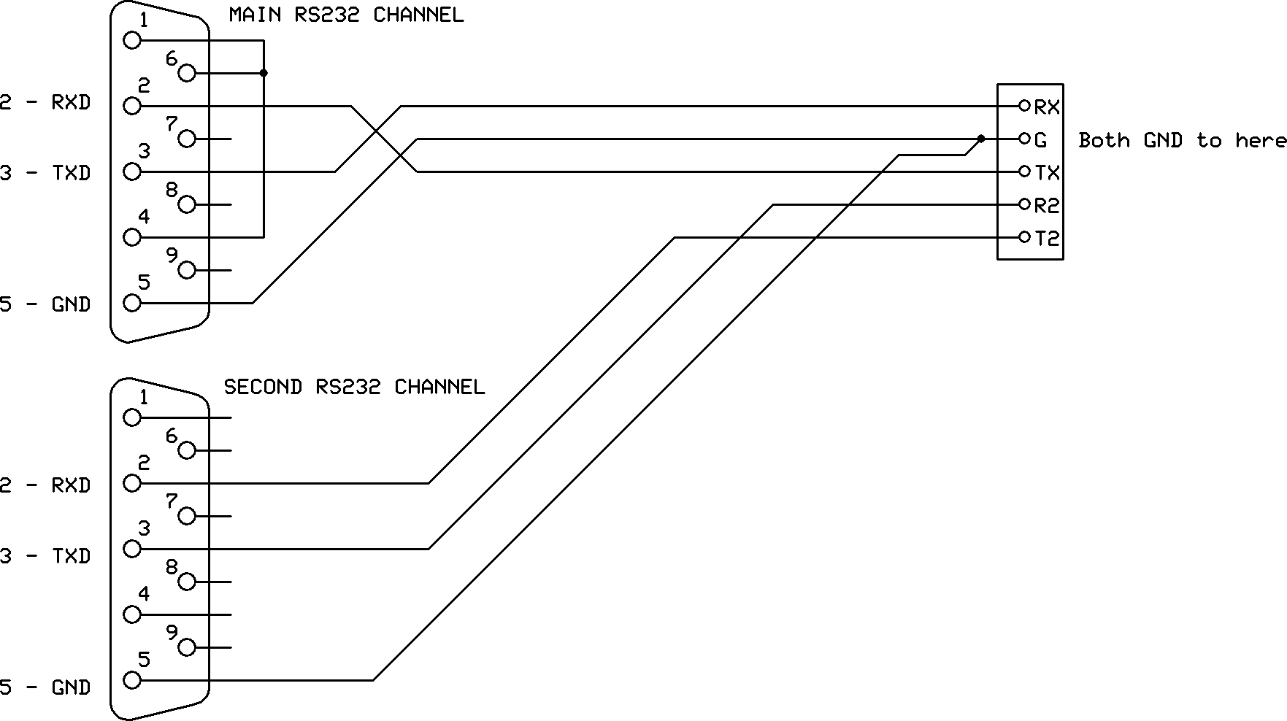

Figure 2 - Dual Independent RS232 Wiring

If the R2/T2 terminals are not required, they can be left as not connected.

# RJ45 cable

Both connectors must be wired identically.

|  |  |
| --- | --- |
| Rj45plug-8p8c.png | rj45wiring.gif |

HDBaseT signals will NOT pass through any Ethernet device, the HDBaseT port on the Transmitter must be connected directly to the HDBaseT port on the Receiver.

Please do make sure that the Cat6 cable uses 4 pairs of 23AWG solid copper wires. Do not use inferior copper clad cables as these exhibit much higher resistances.

# Test Pattern and Keep-Alive Features

The extenders provide a built-in Test Pattern generator for verifying the integrity of connections from the transmitter through to the display device. Several test patterns at different resolutions are provided. See **Test Pattern** in the **RS232 Control Commands** section. Test pattern is enabled when the front panel switch on the transmitter is set to TP.

The **Video Keep-Alive** feature also uses the saved test pattern setting, ensuring a video signal is always present at the receiver HDMI output in the event of input video loss. This mode can also have a timeout value to disable the test pattern after a programmable of time up to 4 hours.

See Video Keep-Alive in the RS232 Control Commands section.

# Down-Scaling

The Transmitter can accept 4K50/4K60 4:4:4 (18G) HDMI 2.0 signals. The built-in down-scaler ensures appropriate scaling to maximum HDBaseT bandwidth of 10.2G, whilst providing compatibility with of the display unit. Three scale options are available as per below:

1. Down-Scale any 4K resolution to 1080p
2. Convert 4K60 4:4:4 signals to 4K60 4:2:0 (colour-space conversion)
3. Auto: Provides optimal resolution / colour-space option, based on cable length and display capability.

See **4K Down-Scaling** in the **RS232 Control Commands** section.

# Connecting to the IR Ports

The IR IN and IR OUT ports on the rear of the Transmitter/Receiver units may be used to send IR remote control data between the two units. The following table details the wiring connections for the IR input and output ports:

|  |  |  |
| --- | --- | --- |
| **3.5mm Jack Terminal** | **IR Eye (Receiver)** | **IR Bud (Emitter)** |
| **Tip** | 5V | 5V |
| **Ring** | IR Signal | Not applicable |
| **Sleeve** | Ground | IR Signal |

# RS232 Commands

The many features of transmitter/receiver units can be managed using RS232 commands (Tx, Rx port). The ASCII commands given in this section use the following port settings:

Baud Rate: 57600

Data Bits: 8

Parity: None

Stop Bits: 1

**Notes:**

1. All commands in this section must be sent in uppercase and are always terminated with the ASCII carriage-return character, 0x0d (represented by the ⮠ symbol).
2. All responses are terminated with the ASCII carriage-return character, 0x0d.
3. All spaces shown in the commands are required. Lowercase letters are used as value placement indicators, the required value or identifier is given in the **Details** panel for the respective command.
4. The RS232 commands can be sent to either the Transmitter or Receiver without regard for the actual unit being controlled. Any command containing **TX** is always routed to the Transmitter and all **RX** commands routed to Receiver.
5. All RS232 communications are passed through regardless of baud rate or other settings.

This allows the use of third-party RS232 communication without having to set the protocol specifics – Just pass-through.

**PC Tool**

The PCTool is a PC software package that allows the user to interface/control the product. Please interface with RS232 (Tx, Rx) port via a com-port (or USB to RS232 dongle). The control panel provides a very simple and easy interface for managing /monitoring the extenders set. This is highly recommended for installation as well as possible maintenance requirements.

All the following commands, except for the HELP command are included in the PCTool software.

**HELP command**

This command returns the complete list of supported control commands, with examples.

|  |  |
| --- | --- |
| **Commands** | **Command Receive** |
| **GET TX HELP⮠** | Get the current Transmitter Commands list |
| **GET RX HELP⮠** | Get the current Receiver Commands list |

**Input HDCP command**

The following commands are used to select the HDMI Input HDCP modes

|  |  |
| --- | --- |
| **Commands** | **Details** |
| **SET TX INPUT-HDCP-CONFIG w⮠** | **w** is one of following:  **1.4** – Accepts HDCP 1.4 and No HDCP  **2.2** – (default) Accepts HDCP 2.2, HDCP 1.4 and No HDCP  **OFF** – Only accepts signals with No HDCP |
| **GET TX INPUT-HDCP-CONFIG⮠** | Get the current input HDCP mode |

**Output HDCP command**

|  |  |
| --- | --- |
| **Commands** | **Details** |
| **SET TX HDCP-OPTION w⮠** | **w** is one of following:  FORCE-1.4  FORCE-2.2  FORCE-OFF (cascade mode)  FOLLOW-INPUT (default) |
| **GET TX HDCP-OPTION⮠** | Get the output current HDCP mode |

**EDID command**

Any of the following pre-defined EDID settings can be selected as the active EDID when the front EDID switch on the Transmitter is set to the **PRE** position. The selection for **PRE** is done using the RS232 command given in the following table:

|  |  |  |
| --- | --- | --- |
| * 4K60-2.0 (default) * 4K60-5.1 * 4K60-7.1 * 4K30-2.0 * 4K30-5.1 * 4K30-7.1 * 1080P60-2.0 * 1080P60-5.1 | * 1080P60-7.1 * 1080P60-3D-7.1 * 1080P60-DVI * 1920x1200 * 1680x1050 * 1600x1200 * 1440x900 * 1400x1050 | * 1360x768 * 1280x1024 * 1024x768P60 * 720P60-2.0 * MANUAL * PASS |

|  |  |
| --- | --- |
| **Commands** | **Details** |
| **SET TX PREDEFINE-EDID w⮠**  (default: 4K60-2.0) | **w** is one of the 22 EDID options as given above.  See below for use of the MANUAL and PASS options. |
| **GET TX PREDEFINE-EDID⮠** | Get the current EDID setting |
| **SET TX COPY-DISP-EDID⮠** | Copy Display EDID to the MANUAL EDID memory. |

When a specific EDID is required, it is recommended to use PCTool to load and save the EDID file and then select the MANUAL EDID option by sending the **SET TX PREDEFINED-EDID MANUAL⮠** command to enable it.

To use the display EDID directly, set the switch on the transmitter to the **Pass** position, or send the **SET TX PREDEFINED-EDID PASS⮠** command.

**4K Down-Scaling**

Compatibility with 1080p display units is assured by down-scaling any 4K signal to 1080p. All 1080p or less signals are simply passed through.

For 4K display requirements, 4K60 4:4:4 input signals can be down-scaled to 4K60 4:2:0, ensuring the 10.2Gbps maximum output bandwidth is not exceeded (Max. 40m). All lower bandwidth signals such as 4K30 4:4:4, 1080p are just passed through.

There are three options available:

* **1080p:** Down-Scale any 4K signal to 1080p
* **4K60-420:** Convert 4K50/60 4:4:4 to 4K50/60 4:2:0 - (colour space conversion)
* **Auto:** cat5e/6/6a cable and the display capabilities are analysed for optimal resolution / colour space (4K 4:2:0 or 1080p) for 4K50/60 4:4:4 input.

**Note:** The frame rate is not altered – only the resolution or colour space is changed.

The following command selects the 4K handling mode:

|  |  |
| --- | --- |
| **Commands** | **Details** |
| **SET TX 4K-HANDLE w⮠**  (default: Auto) | **w** is one of following options:  **1080P**  **4K60-420**  **AUTO** (default) |
| **GET TX 4K-HANDLE⮠** | Get the current 4K handling mode |

## 

**Video Keep Alive (No Signal Handling) (Timed)**

When there is no signal present at the Transmitter, the following options are available:

* Output current Test Pattern – Maintain output video stream (Video Keep-Alive)
* No timing output (default) – (VKA off) No output video; hence video drop-out
* The Test Pattern can be displayed for a programmable time interval
* The following commands select the VKA modes:

|  |  |
| --- | --- |
| **Commands** | **Details** |
| **SET TX NO-SIGNAL-HANDLE TEST-PATTERN⮠** | Output Test Pattern when no input signal |
| **SET TX NO-SIGNAL-HANDLE NO-TIMING⮠** | No output when no signal – VKA off (default) |
| **GET TX NO-SIGNAL-HANDLE⮠** | Get the current No Signal Handling mode |
| **SET TX VKA-TIMEOUT x**  (default: 0 – always on) | **x** = 0 to 240 minutes (VKA time out)  0 disables the timer and the Video Keep Alive is always on, until an input signal is detected.  Timeout values 1 to 240, will turn off the VKA at the end of period. Values above 240 are ignored (current setting maintained). |
| **GET TX VKA-TIMEOUT** | Get the current VKA timeout value. |

## 

**Test Pattern**

The transmitter has 12 test patterns and 5 resolution settings available. The selected Test Pattern can be activated using the TP switch setting on the transmitter

|  |  |
| --- | --- |
| **Commands** | **Details** |
| **SET TX TEST-PATTERN x y⮠**  (default: 1080p Checkerboard) | **x** is Pattern - select one of following options:  BLACK, RED, GREEN, BLUE, WHITE,  RED_RAMP, GREEN_RAMP, BLUE_RAMP,  PRBS, RAMP, STRIPE, CHECKER-BOARD (default)  **y** is Resolution - select one of following options:  4K30, 4K25, 4K24, 1080P60, 720P60 |
| **GET TX TEST-PATTERN⮠** | Get the current Test Pattern mode |

**Safety Temperature**

The following commands can set the Power Off, Warning, and Re-Power temperatures:

|  |  |
| --- | --- |
| **Commands** | **Details** |
| **SET TX SAFE-TEMP-ONOFF ON⮠**  **SET RX SAFE-TEMP-ONOFF ON⮠** | Enable Transmitter safety temperature handling  Enable Receiver safety temperature handling |
| **SET TX SAFE-TEMP-ONOFF OFF⮠**  **SET RX SAFE-TEMP-ONOFF OFF⮠** | Disable Transmitter safety temperature handling  Disable Receiver safety temperature handling |
| **SET TX SAFE-TEMP-VALUE x y z⮠**  **SET RX SAFE-TEMP-VALUE x y z⮠** | Set warning temperature **x**  Set shutdown temperature **y**  Set re-power temperature **z**  Default TX settings: x=70, y=75, z=65, the unit is °C  Default RX settings: x=75, y=80, z=70, the unit is °C |
| **GET TX SAFE-TEMP-VALUE⮠**  **GET RX SAFE-TEMP-VALUE⮠** | Get the current Transmitter safety temperature values  Get the current Receiver safety temperature values |

**Notes:**

1. For the **SAFE-TEMP-VALUE** commands, the following rule must be followed:

**55 < Re-Power (z) < Warning (x) < Shutdown (y)**.

1. When the device enters the Temperature Warning condition, the red PWR LED will slow flash once every two seconds. When the device enters the power off condition due to excessive overheating, the red PWR LED will fast flash three times a second.
2. An automatic GET TX/RX SAFE_TEMP_VALUE RS232 response is reported (sent), in case of Temperature Warning / Power Off condition.

**Diagnostic Commands**

User can read the catx cable length, HDBaseT link status, signal status:

|  |  |
| --- | --- |
| **Diagnostic Commands** | **Details** |
| **Cable Length** | |
| **GET TX CABLE-LENGTH⮠** | **GET TX CABLE-LENGTH wM**, w=20,30…70 |
| **GET RX CABLE-LENGTH⮠** | **GET RX CABLE-LENGTH wM,** w=20,30…70 |
| **Link/Signal Status** | |
| **GET TX LINK-STATUS⮠** | Returns Transmitter link **on** or link **off** status |
| **GET RX LINK-STATUS⮠** | Returns Receiver link **on** or link **off** status |
| **GET TX SIGNAL-STATUS⮠** | Returns Transmitter signal **on** or signal **off** status |
| **GET RX SIGNAL-STATUS⮠** | Returns Receiver signal **on** or signal **off** status |
| **Input HDMI Signal Detail** | |
| **GET TX INPUT-HDMISIGNALS⮠** | Get the current input HDMI signals information |
| **Signal Error** | |
| **GET TX SIGNAL-ERROR⮠** | GET TX SIGNAL-ERROR w, w=1, 2, 3… |
| **GET RX SIGNAL-ERROR⮠** | GET RX SIGNAL-ERROR w, w=1, 2, 3… |
| **Pulse HPD** | |
| **SET TX PULL-HPD⮠** | Forces HDMI HPD low for 200ms on HDBaseT Transmitter |
| **SET RX PULL-HPD⮠** | Forces HDMI HPD low for 200ms on HDBaseT Receiver |
| **Temperature Read** | |
| **GET TX CPU-TEMP⮠** | **GET TX CPU-TEMP wC**, where w is the temperature (number)  For example, **GET TX CPU-TEMP 48C** means 48℃ |
| **GET RX CPU-TEMP⮠** | **GET RX CPU-TEMP wC** |

## 

**CEC command**

|  |  |
| --- | --- |
| **CEC Commands** | **Details** |
| **Display On** | |
| **SET TX DISPLAY-ON⮠** | Set Display to the ON state |
| **Display Off** | |
| **SET TX DISPLAY-OFF⮠** | Set Display into the standby state |
| **Volume Increase** | |
| **SET TX CEC-VOLADD⮠** | Increase sound volume |
| **Volume Decrease** | |
| **SET TX CEC-VOLDEC⮠** | Decrease sound volume |
| **Volume Mute** | |
| **SET TX CEC-MUTE⮠** | Mute/Unmute sound volume (Toggle) |
| **Display Connection Status** | |
| **GET TX READ-DISPLAY⮠** | Get the current Connected/Disconnected info |
| **Display Power Status** | |
| **GET TX DISPLAY-POWER⮠** | Get the current display device power on/off info |

**Automatic CEC Display Control**

The following commands set the operating mode for automatic CEC control of the display “power on” and “power off”. The CEC “power off” command can be sent after a specified time delay. The CEC “power on” command will be sent immediately when a new input HDMI signal is detected. To use this feature, the CEC Auto ONOFF must be enabled (ON) (default: OFF)

|  |  |
| --- | --- |
| **Commands** | **Details** |
| **SET TX AUTO-ONOFF-CONFIG ON⮠** | Enable automatic CEC power on and power off control. |
| **SET TX AUTO-ONOFF-CONFIG OFF⮠** | Disable automatic CEC power on and power off control. (default) |
| **SET TX AUTO-OFF-TIMER x⮠**  (default: 30 minutes) | **x** = 1 to 240 minutes.  Values above 240 are ignored (current setting maintained).  Set the time in minutes before sending the CEC power off message, if enabled. |

# Parameters

|  |  |
| --- | --- |
| **HDMI version** | Input: HDMI 2.0 -支持HDR/HBR |
| **Bandwidth** | Input: 18 Gbps (4K60 4:4:4) Output: 10.2 Gbps (4K60 4:2:0) |
| **HDCP** | Input HDCP: 1.4 and 2.2  Output HDCP: Pass, 1.4, 2.2, Cascade mode |
| **RS232** | 57600 baudrate, 8 data bits, 1 stop bit, no parity |
| **RS232** (Pass-Through – Tx, Rx) | Maximum baud rate 115200. |
| **RS232** (Pass-Through – T2, R2) | Maximum baud rate 57600 (or used as CTS, RTS) |
| **IR IN, IR OUT** | 25-60 KHz |

# Video and Audio

|  |  |
| --- | --- |
| **Input format** | All VESA resolutions to 4096x2160p (18G), and all 3D formats – Examples:  4096x2160p 24/25/30/50/60Hz  3840x2160p 24/25/30/50/60Hz  2560x1440 50/60Hz  2048x1152 50/60Hz  1920x1080p 24/25/30/50/60Hz  1920x1080i 50/60Hz  1280x720p 50/60Hz  All PC resolution including 1920x1200 – Examples:  1920x1200 60/75Hz 1360x768 60/75Hz  1680x1050 60/75Hz 1280x1024 60/75Hz  1600x1200 60/75Hz 1280x960 60/75Hz  1440x900 60/75Hz 1280x800 60/75Hz  1400x1050 60/75Hz 1024x768 60/75Hz  1366x768 60/75Hz 1152x864 60/75Hz |
| **Color space** | RGB, 4:4:4, 4:2:2, 4:2:0 |
| **Color depth** | 8, 10, 12 bits |
| **Down scale** | 1080p: All 4K inputs scaled down to 1080p  4K60-420: Convert 4K50/60 4:4:4 inputs to 4K50/60 4:2:0  Pass-through ：All others as Pass-through video |
| **Audio format** | 2.0 / 2.1 / 5.1 / 7.1 channel LPCM, Dolby, AC3, DTS |

## 

|  |  |
| --- | --- |
| Power **consumption** (Tx + Rx) | 9W max. (Tx: 3.5W, Rx: 5.5W) |
| **Adapter** | 24V /1A |

# Regarding the installation of hanging ears

This product is equipped with desktop mounting ears by default, and can also be optionally equipped with cabinet mounted mounting ears (special requirements are required). The installation dimensions are as follows:：

**Desktop hanging ear and installation dimensions (top view):**

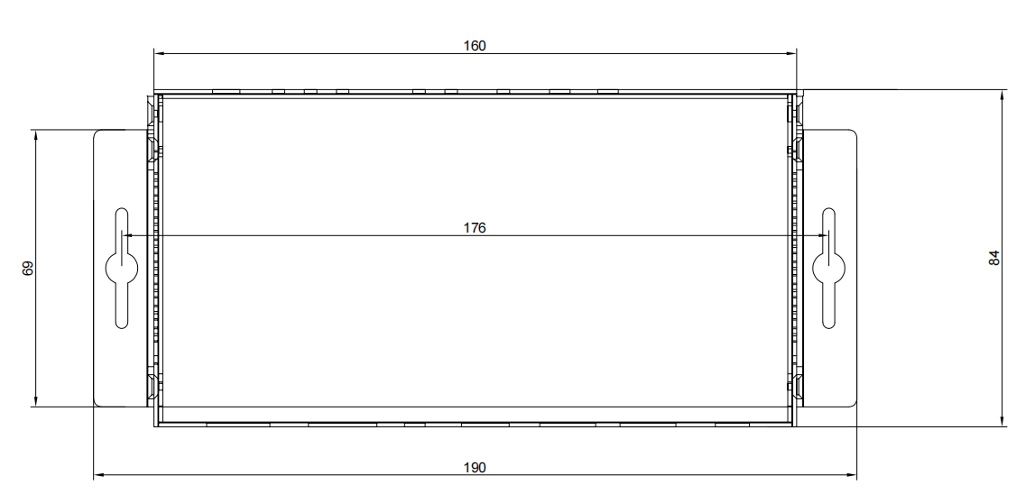

**Cabinet hanging ear and installation dimensions (front panel, needs to be installed vertically):**

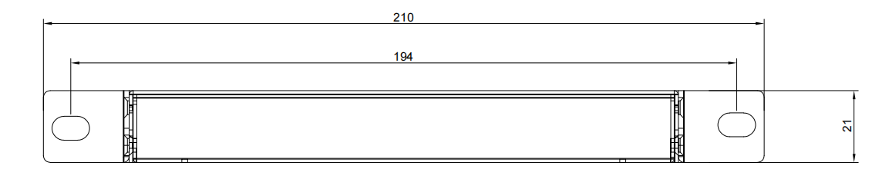

# Packaging size and environmental parameters

|  |  |
| --- | --- |
| Operating Temperature | 0 to +40°C (+32 to +104°F) |
| Operating Humidity | 10 to 90 % RH (non-condensing) |
| Dimensions(L x W x H) | 160mm x 84mm x 21mm |
| Weight(Unit only) | Transmitter: 400g  Receiver: 400g |

# Package Contents

|  |  |
| --- | --- |
| **Name** | **Quantity** |
| **Transmitter** | 1 |
| **Receiver** | 1 |
| **Desktop hanging ear** | 4 |
| **5 pin female phoenix connector** | 2 |
| **IR transmitter/Receiver cable（one pair）** | 1 |
| **Power adapter 24V/1A** | 1 |