**HDM-Fiber Extender**

**User Manual**

**HDMI to Fiber, Transmitter**

**Fiber to HDMI, Receiver**

**warningWarning**

* Do not expose this device to Rain, Moisture, and Dripping
* Only use accessories specified by the manufacture
* Unplug this device during Lightning Storms
* The manual is for reference only, maybe updated without further notice

**Contents**

1. Feature 3

2. Panel 3

3. Regarding the installation of hanging ears 5

4. Packaging size and environmental parameters 5

5. Package Contents 6

**Thank you for purchasing the HDMI fiber extender kit**

This HDMI-Fiber extender includes a fiber optic transmitter and a fiber optic receiver. Video transmission supports HDMI 2.0, with input and output resolutions up to 3840x2160p60.

Supports single-mode single cable, with a transmission distance of 10Km.

Support audio embedding and extracting, IR bidirectional transparent transmission, RS232 transparent transmission, keyboard and mouse transparent transmission.

# Feature

* Support HDMI 2.0,HDCP1.4/2.2
* Single-mode single cable, with a transmission distance of 10Km, LC interface
* 4 EDID options
* Support audio embedding and HDMI loop out on transmitter side
* Support audio extracting on receiver side
* Transparent transmission：IR, RS232, Keyboard/Mouse

# Panel

**Front Panel**

Transmitter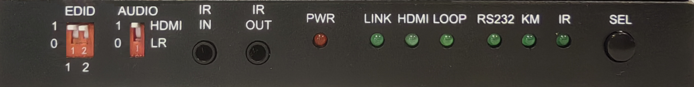

Receiver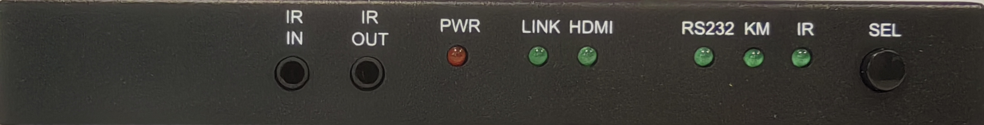

| **Name** | **Description** |
| --- | --- |
| **EDID Switch**  (Transmitter) | Total two Pins，PIN1/PIN2， 4 options   * 11: EDID pass * 01: 3840x2160p60 * 10: 3840x2160p30 * 00: 1920x1080p60 |
| **AUDIO Switch**  (Transmitter) | * 1: HDMI internal audio * 0: external 3.5mm L/R audio |
| **IR IN** | IR In |
| **IR OUT** | IR Out |
| **PWR Led** | Power Led |
| **LINK Led** | Optical Link Led |
| **HDMI Led** | HDMI signal Led |
| **LOOP Led**  **（Transmitter）** | When the loop out interface connected to a display, the light is on |
| **Transparent transmission function selection**  **And related indicator Led** | * SEL: The transparent transmission function selection button allows for the selection of three functional options:：   RS232，KM（Keyboard and Mouse），IR   * RS232 Led, KM Led, IR Led |

**Rear Panel**

Transmitter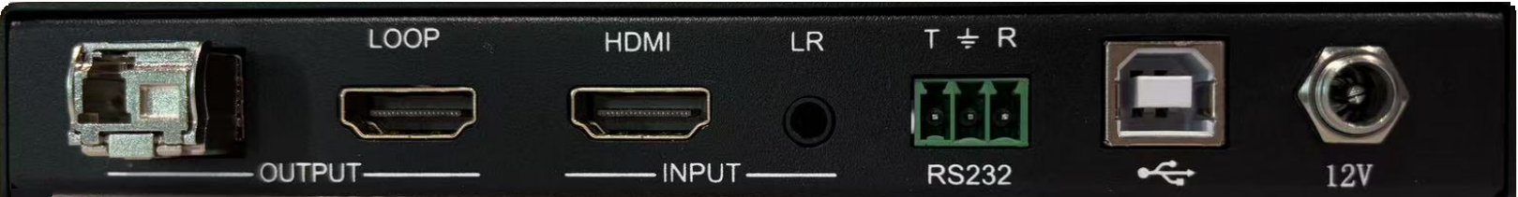

Receiver

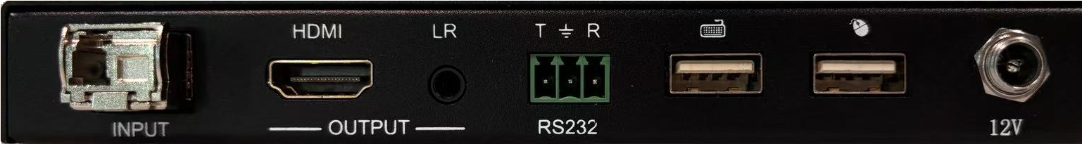

|  |  |
| --- | --- |
| **Name** | **Description** |
| **12V** | 12V power input |
| **HDMI IN****（Transmitter）** | HDMI input |
| **LR IN** **（Transmitter）** | External 3.5 L/R audio input |
| **LOOP OUT****（Transmitter）** | HDMI loop out |
| **Fiber OUT****（Transmitter）** | Fiber output， LC |
| **（Transmitter）** | Connect to PC by USB-B cable |
| **RS232** | RS232 transparent transmission  T: TX，Extender PC  G: GND  R: RX，Extender PC |
| **Fiber IN** **(Receiver）** | Fiber input， LC |
| **HDMI OUT (Receiver）** | HDMI output |
| **(Receiver）** | For keyboard and mouse connection |
| **LR OUT (Receiver）** | Audio extracting output, 3.5mm L/R interface |

## 

# Regarding the installation of hanging ears

This product is equipped with desktop mounting ears by default, and can also be optionally equipped with cabinet mounted mounting ears (special requirements are required). The installation dimensions are as follows:：

**Desktop hanging ear and installation dimensions (top view):**

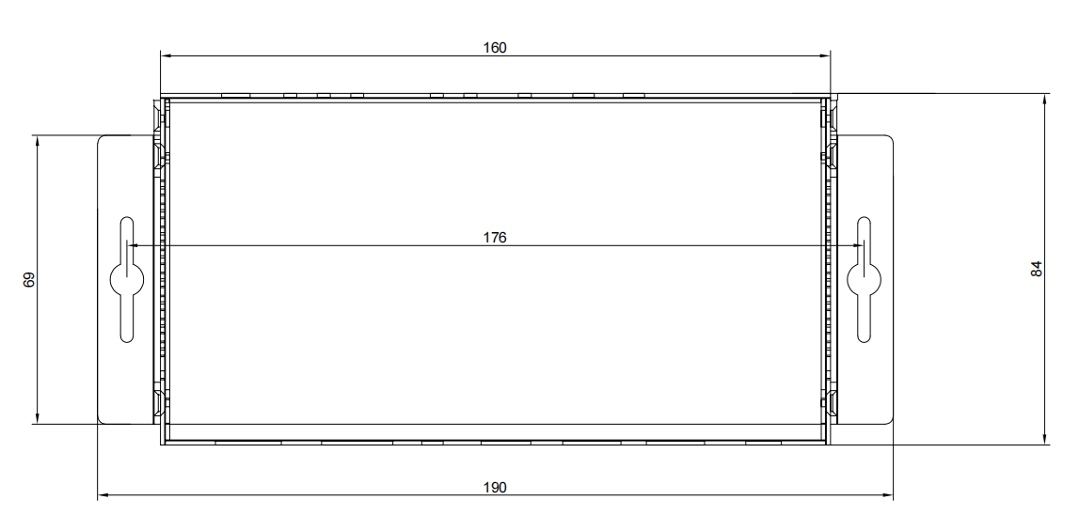

**Cabinet hanging ear and installation dimensions (front panel, needs to be installed vertically):**

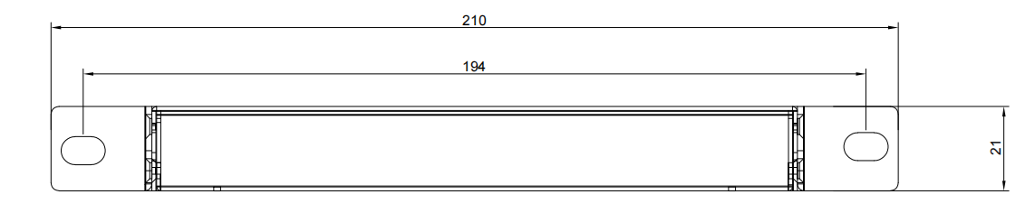

# Packaging size and environmental parameters

|  |  |
| --- | --- |
| Operating Temperature | 0 to +40°C (+32 to +104°F) |
| Operating Humidity | 10 to 90 % RH (non-condensing) |
| Dimensions(L x W x H) | 160mm x 84mm x 21mm |
| Weight(Unit only) | Transmitter: 400g  Receiver: 400g |

# Package Contents

|  |  |
| --- | --- |
| **Name** | **Quantity** |
| **Transmitter** | 1 |
| **Receiver** | 1 |
| **Desktop hanging ear** | 4 |
| **3 pin female phoenix connector** | 2 |
| **IR transmitter/Receiver cable（one pair）** | 1 |
| **Power adapter 12V/1A** | 2 |