About PoC of HDbaseT cards of Matrix and SSH70
Dear customer:

- About PoE and PoC/PoH
  - PoE = Power Over Ethernet. PoE was defined by IEEE 802.3af. Link: https://baike.baidu.com/item/IEEE%20802.3af/1243295?fr=aladdin
    - PoE: 40~57V with handshaking protocol
    - There is no Non-standard PoE.
    - In HDbaseT product, PoE adds too much cost.
    - So usually we use PoC/PoH instead of PoE
  - PoC = Power Over Cable, PoH = Power Over HDbaseT. PoC == PoH.
  - PoC/PoH：usually there are 3 versions：+12V, +24V, +48V.
    - Many extenders come with +12V / 2~3A adapter. HDbaseT extender is not stable with +12V if you have a long RJ45 cable.
    - +48V is the most stable, compare to +12V or +24V with long RJ45 cable.
    - VTRIX suggests +24V
  - PoC/PoH：there is no standard to define PoC/PoH. Before plug in DC connector, you MUST confirm it’s compatible.

- PoC circuit in HDbaseT cards of Matrix
  - CN15 is the DC socket with “24V” silkscreen.
  - Inside the cards, the “24V” is directly connected to LAN transformer and isolated to internal circuit.
  - Although the silkscreen is “24V”, actually you may use any voltage such as +12V or any other to match with TX or RX.

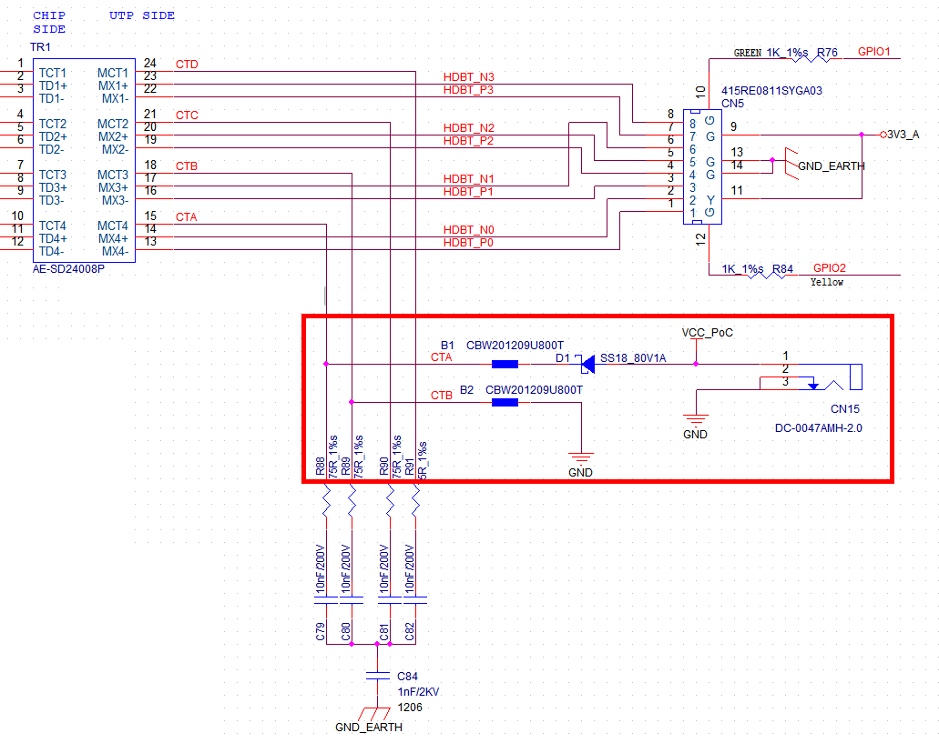
- SSH70/SSH100, super slim HDbaseT extender
  - To achieve most slim, we use phoenix socket with +24V~48V.
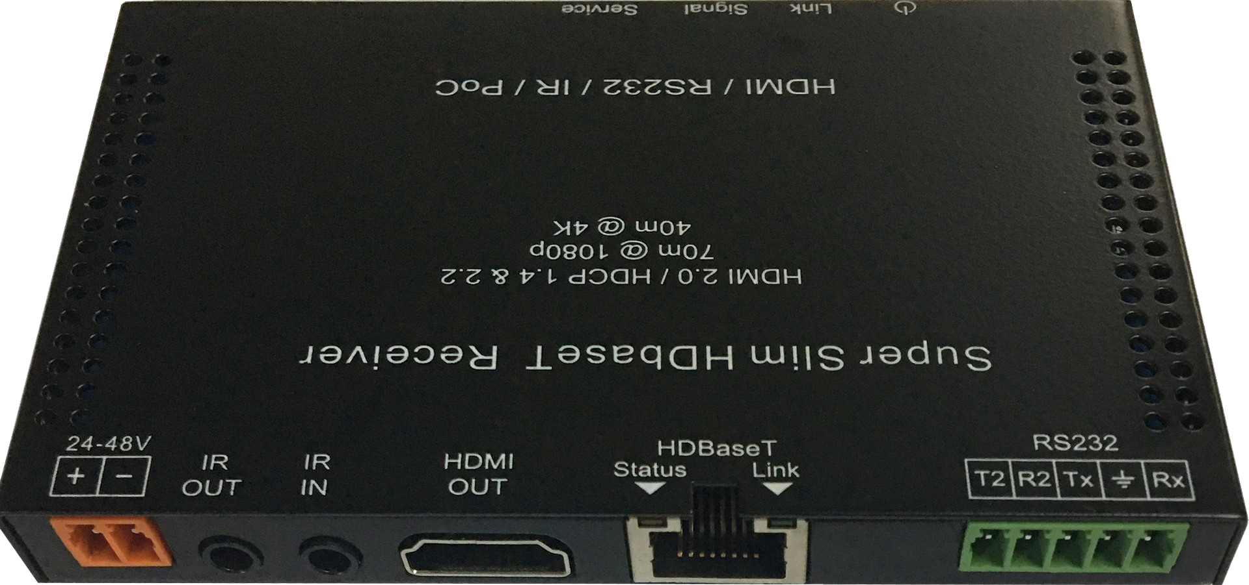

- HDbaseT card and SSH70 extender with PoC
  - To support PoC, there is a 24V DC socket on input/output card to power SSH70-TX/SSH70-RX.

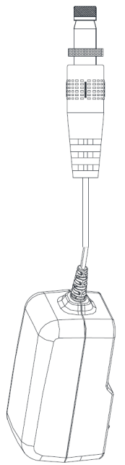
PoC in RJ45
PoC in RJ45

- HDbaseT card and SSH70 extender without PoC
  - Do NOT insert any AC-DC adapter to “24V”.

Video/Audio, No POC

Video/Audio, No POC

Powered with +48V Powered with +48V

- Danger: DO NOT use both +24V and +48V adapter, it may destroy products.

Nov, 21, 2022

