Fiber products
Dear customer:

Fiber Products for QVM Quad-Ch modular matrix
Model | Resolution | Transmitter/Receiver | Distance
Cards for modular matrix:  PCBA_Q**-IN-FIBER  PCBA_Q**-OUT-FIBER  ** stands for Q4K/Q18G  Same cards for Q4K/Q18G  Single-Mode Single Cable | 4K444@60Hz | F02P-HDMI2Fiber-SingleMode  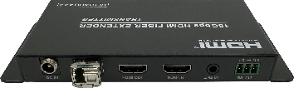  F02P-Fiber2HDMI-SingleMode  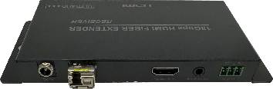 | >10Km with Single-Mode Fiber cable  >300m with Multi-Mode Fiber cable
F02P-HDMI2Fiber-SingleMode  F02P-Fiber2HDMI-SingleMode | 4K444@60Hz | Standalone Fiber Extender | >10Km with Single-Mode Fiber cable  >300m with Multi-Mode Fiber cable

May 11, 2024

