Fiber products
Dear customer:

- About Fiber products:
  - Generally only single Fiber cable, no more dual Fiber cable.
  - Almost all Fiber products using Private protocol.
  - Multi-Mode: low cost, can’t works on Single-Mode Fiber cable.
  - Single-Mode: 1.4Km with Single-Mode Fiber cable, 300m with Multi-Mode Fiber cable

- Our Fiber Products
Model | Resolution | Transmitter/Receiver | Distance
Cards for modular matrix  Single-Mode Single Cable  PCBA_9VMC-IN-FIBER  PCBA_9VMC-OUT-FIBER | 1080p | F02P-HDMI2Fiber-SingleMode  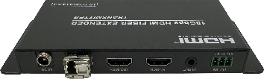  F02P-Fiber2HDMI-SingleMode  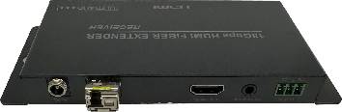 | 1.4Km with Single-Mode Fiber cable, 300m with Multi-Mode Fiber cable  Option: 10Km with Single-Mode Fiber cable
Cards for modular matrix  Multi-Mode Single Cable  PCBA_BVMC-IN-FIBER  PCBA_BVMC-OUT-FIBER | 4K 420@60Hz  4K 444@30Hz | F88-HDMI2Fiber-MulitiMode  F88-Fiber2HDMI-MulitiMode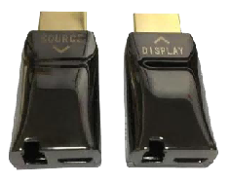 | 300m with Multi-Mode Fiber cable
F88-HDMI2Fiber-MulitiMode  F88-Fiber2HDMI-MulitiMode | 4K 420@60Hz  4K 444@30Hz | N/A | 300m with Multi-Mode Fiber cable
F02P-HDMI2Fiber-SingleMode  F02P-Fiber2HDMI-SingleMode | 4K 444@60Hz | N/A | 1.4Km with Single-Mode Fiber cable, 300m with Multi-Mode Fiber cable  Option: 10Km with Single-Mode Fiber cable

2022年7月22日

