Mixed Seamless Switching Matrix (8x8~140x140 Series)

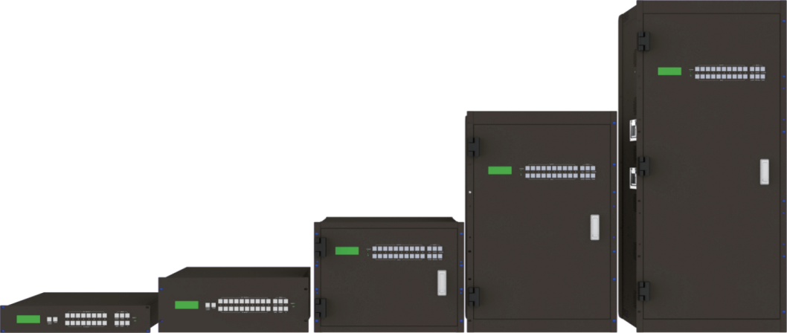



**VER 1.1**

# Thank you for purchasing this product

For optimum performance and safety, please read these instructions carefully before connecting, operating or adjusting this product. Please keep this manual for future reference.

# Surge protection device recommended

This product contains sensitive electrical components that may be damaged by electrical spikes, surges, electric shock, lighting strikes, etc. Use of surge protection systems is highly recommended in order to protect and extend the life of your equipment.

# Table of Contents

1. Introduction. 1
2. Features. 3
3. Package Contents. 3
4. Specifications. 3
   1. Specifications-Matrix (Take the DVI-U card as an example). 3
   2. Specifications-2K Series Card. 4
   3. Specifications-4K Series Card. 4
5. Operation Controls and Functions. 5
6. Connection with External Device 6

6.1 Input & Output Ports.................................................................................................6..

6.2 Communication Ports & Connection Methods. 6

1. PC Tool User Guide. 8
   1. UART Control. 8
   2. Network Control. 9
   3. Matrix Switch Page. 14
   4. Signal Setting Page. 15
   5. FineTune: PQ&Position Page 16
   6. OSD CTRL Page. 16
   7. TV Wall Page. 18
   8. EDID Control. 20
2. Control via Web. 21
3. Precautions for Use. 21
4. Card Picture. 22
5. Card Picture-1080i Output Card. 25
6. DVIU Universal Port: Adaptor. 25

# Introduction

This mixed seamless switching matrix is a high performance HD video signal switching equipment, which supports up to 8~140 signal inputs and 8~140 signal outputs. This product supports multiple video format signal input and output. It can be used for the input and output exchange of multiple HD digital video signals and analog video signals. The high-fidelity image output of any channel signal can be selected from any channel signal source without interfering with other outputs.

The matrix adopts card inserting structure, which is flexible and convenient for installation. It supports optical fiber, HDbaseT, HDMI, DVI, 3G/HD/SD-SDI, VGA, YPbPr, CVBS and other signal input and output. With the Ethernet and RS-232 communication interfaces, the matrix can be controlled and monitored through the special control software.

### Function 1, seamless switching function:

Instantaneously switch any input signal source.

|  |  |
| --- | --- |
| **Normal Switching** | **Seamless Switching** |
| The current image | The current image |
| The image appears 3~10 seconds later after switching. | The image appears immediately later after switching. |
| The new image | The new image |

### Function 2, Gen-Lock video wall splicing function:

Based on Gen-Lock technology, the image delay between any output channel is less than 0.1ms, and the spliced images are strictly synchronized without tearing. It can realize any splicing mode in the allowed range of 8x8~140x140 matrix, especially suitable for LCD video wall, LED video wall, LED lattice wall.

|  |  |
| --- | --- |
| **Picture Tearing (2x2 video wall)**  With the common splicing technology, the delay between the four images may be 100ms~200ms, resulting in the four images being out of sync and torn.   1. Right-click the desktop and select "Properties". 2. Use the left mouse button to quickly drag   the Properties window. | **Normal Picture (2x2 video wall)** With Gen-Lock splicing technology, the delay between four images is less than 0.1ms, and the four spliced images are strictly synchronized without tearing.   1. Right-click the desktop and select "Properties". 2. Use the left mouse button to quickly drag   the Properties window. |
|  |  |



### Function 3, character overlay function:

Overlay any Chinese or English characters on the image with variable font/color/size/position.

|  |  |
| --- | --- |
| **Beijing**  **Conference Room 1** | **Shanghai Conference Room 2** |
| **Shenzhen Conference Room 3** | **Guangzhou Conference Room 4** |

# Features

☆ Support video resolution up to 1920×1200@60hz (2K series card), 3840x2160 444@ 60Hz (4K series card)

☆ Support 8~140 video signal input and output switching

☆ Support fiber, HDbaseT, HDMI/DVI, 3G/HD/SD-SDI, VGA, YPbPr, CVBS signal input

and output

☆ With seamless switching, character overlay and video wall function

☆ A variety of control ports: RS-232, Network control port (controlled through smartphone,

PAD and PC, and no need to install APP/APK)

☆ With special control software, convenient for remote control, real-time display of input and output status

☆ Signal input supports resolution amplify function, output resolution can be configured

through the control software

☆ Signal output supports resolution independent selection function

☆ With power-down memory function

☆ Dual power redundancy design

☆ Aluminum electrolytic capacitors are forbidden, long-life PC motherboard solid state

capacitors and tantalum capacitors are adopted

# Package Contents

① 1 x Mixed Seamless Switching Matrix

② 2 x 110~240V AC 50/60Hz Power Cord

③ 1 x RS-232 Serial Cable (1.5 meters, male to female connector)

④ 1 x User Manual

# Specifications

## Specifications-Matrix (Take the DVI card as an example)

|  |  |  |  |  |  |
| --- | --- | --- | --- | --- | --- |
|  | 8x8, 2U | 16x16, 4U | 36x36, 8U | 80x80, 16U | 140x140, 29U |
| **Dimensions W*D*H** | 483x365x89mm | 483x365x178mm | 483x365x365mm | 483x365x712mm | 483x365x1290mm |
| **Weight** | 9kg | 13kg | 23kg | 44kg | 88kg |
| **Power Module** | 100W * 2  (Redundancy) | 200W * 2  (Redundancy) | 350W * 2  (Redundancy) | 350W * 4  (Redundancy) | 500W * 4 |

|  |  |  |  |
| --- | --- | --- | --- |
| **Control - RS-232** | RS-232 pass-through | D-sub 9 | Baud rate：9600 |
| **Control - LAN** | Static IP, Automatic IP | | |
| **Power Supply** | AC100 - 240V 50/60Hz | | |
| **Operation Temperature** | 32 - 104°F / 0 - 40°C | | |
| **Storage Temperature** | -4 - 140°F / -20 - 60°C | | |
| **Storage Temperature** | 20 - 90% RH (no condensation) | | |

## Specifications-Daughter Cards

|  |  |  |  |
| --- | --- | --- | --- |
| Input | Interface  Type | Signal | Format |
| DVI-U | HDMI DVI VGA  YPbPr CVBS | HDMI / DVI / VGA:  800x600, 1024x768, 1280x768, 1280x800, 1280x1024, 1360x768,  1400x1050, 1600x1200, 1920x1080  YPbPr: 480i, 576i, 720p50, 720p60, 1080i50, 1080i60, 1080p50, 1080p60  CVBS: PAL, NTSC |
| DVI-D | HDMI/DVI | 800x600, 1024x768, 1280x768, 1280x800, 1280x1024, 1360x768,  1400x1050, 1600x1200, 1920x1080 |
| HDMI | HDMI | Up to HDMI 2.0 4K 444@60Hz |
| VGA | VGA | Same as VGA input of DVI-U universal card |
| BNC | SDI | 480i60, 576i50, 1080i50/60, 720p50/60, 1080p24/25/29/30/50/60 |
| RJ45 | HDBaseT | Up to HDMI 2.0 4K 420@60Hz |
| LC | Optical | Up to 1080p60, single mode single cable,10 kilometers |
| **Output** | **Interface Type** | **Signal** | **Format** |
| HDMI | HDMI-2K | 800x600, 1024x768, 1280x768, 1280x800, 1280x1024, 1360x768,  1400x1050, 1600x1200, 1920x1080 |
| DVI-D | HDMI/DVI | Same as HDMI-2K output card |
| DVI-U | HDMI/DVI VGA  YPbPr CVBS | HDMI / DVI / VGA:  800x600, 1024x768, 1280x768, 1280x800, 1280x1024, 1360x768,  1400x1050, 1600x1200, 1920x1080  YPbPr: 720p50, 720p60, 1080i50, 1080i60, 1080p50, 1080p60  CVBS: PAL, NTSC |
| VGA | VGA | Same as HDMI-2K output card |
| BNC | SDI | 720p50, 720p60, 1080i50, 1080i60,1080p30/50/60 |
| RJ45 | HDBaseT-2K | Same as HDMI-2K output card |
| HDMI | HDMI-4K | Up to HDMI 2.0 4K 444@60Hz |
| RJ45 | HDBaseT-4K | Up to HDMI 2.0 4K 420@60Hz |
| LC | Optical | Up to 1080p60, single mode single cable,10 kilometers |

# Operation Controls and Functions

**(Take the DVI card, 8x8 as an example)**

### Front Panel

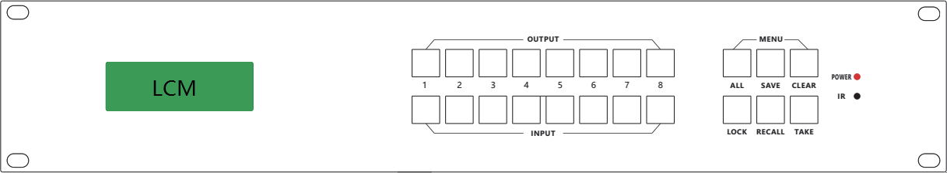

**1**

**2**

**3**

**4**

**5**

|  |  |  |
| --- | --- | --- |
| **No.** | **Name** | **Function Description** |
| 1 | LCM screen | Display the output status of the matrix. |
| 2 | INPUT/OUTPUT  buttons | Used to select the corresponding input and output channels. You need to press the output button (1~8, including “ALL”) firstly, then press the input button (1~8) , finally press  “TAKE” button to complete switching. |
| 3 | MENU buttons | **All:** It represents all the output channels.  e.g. Press “ALL→INPUT n (n=1,2,...8)→TAKE” to switch input source n to all output channels.  **SAVE:** Used to save the current display scene.  e.g. Press “SAVE→OUTPUT n (n=1,2,...8)→TAKE” to save the current display scene as Scene n.  **CLEAR:** Press “CLEAR” button to cancel the front panel button operation that has not been performed.  **LOCK:** Used to lock the panel buttons. When you press this button, the button will light on, and the panel buttons (except for OUTPUT 1~8) will be locked. Press this button again to unlock, the button light will be off, and all panel buttons can be used normally.  **RECALL:** Used to recall the saved scene as the current display scene.  e.g. Press “RECALL→OUTPUT n→TAKE” to recall the saved Scene n as the current display scene.  **TAKE:** Used to confirm and execute the operation. |
| 4 | POWER LED | When the product is powered on, the red LED will be on. |
| 5 | IR Window | IR receiver window, it only receives the IR remote signal from this product. |

**Rear Panel**

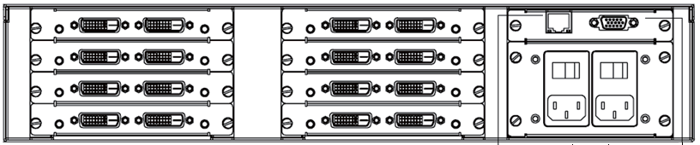

**1**

**2**

**3 4**

**5**

|  |  |  |
| --- | --- | --- |
| **No.** | **Name** | **Function Description** |
| 1 | IN 1-8 | Input ports , connected to source device such as DVD or set-top box. |
| 2 | OUT 1-8 | Output ports, connected to display device such as TV or monitor. |
| 3 | LAN port | TCP/IP control port, connected to PC or router with an  RJ45 cable. |
| 4 | RS-232 port | Connect to a PC or control system by D-Sub 9-pin cable to  transmit RS-232 command. |
| 5 | Power switch & port | Power switch: Used to turn on/off the power.  Power port: Connect with 110-220V AC power cord. |

# Connection with External Device

**(Take the DVI card, 8x8 as an example)**

## Input & Output Ports

The 8x8 matrix can be configured up to 4 input cards and 4 output cards, each card supports 2 channel video signals, a total of 8 inputs and 8 outputs. The input channel is marked as IN01 ~ IN08, and the output channel is marked as OUT01 ~ OUT08.

The input and output cards are fixed in the 2U case according to the categories.

You can select the input and output cards according to the actual needs of the project. Input/output card: DVI/VGA/HDMI/SDI/HDbaseT

## Communication Ports & Connection Methods

The matrix is communicated using a direct-attach RS-232 serial cable. You can use the control computer with proprietary control software to achieve matrix switching, query and other operations. The RS-232 port is a 9-pin female connector and the Pin description is as below.

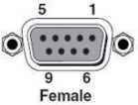

|  |  |
| --- | --- |
| **Index** | **Pin** |
| 1 | N/u |
| 2 | Tx (Matrix→PC) |
| 3 | Rx ( Matrix ←PC) |
| 4 | N/u |
| 5 | Gnd |
| 6 | N/u |
| 7 | N/u |
| 8 | N/u |
| 9 | N/u |

## RS-232 Control and Connection

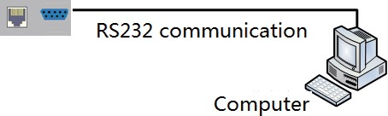

* + 1. **Ethernet Control and Connection**

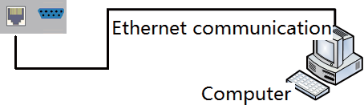

**Note**：**Factory default network setting**：

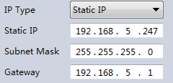

# PC Tool User Guide

**(Take the DVI card, 8x8 as an example)**

The PC tool is an installation-free control software that supports both UART and network control. It consists of six parts: Matrix Switch, Signal Setting, Fine Tune: PQ &Position, OSD CTRL, TV Wall, Network Setting.

The UI is as follows (Matrix Switch is the default page):

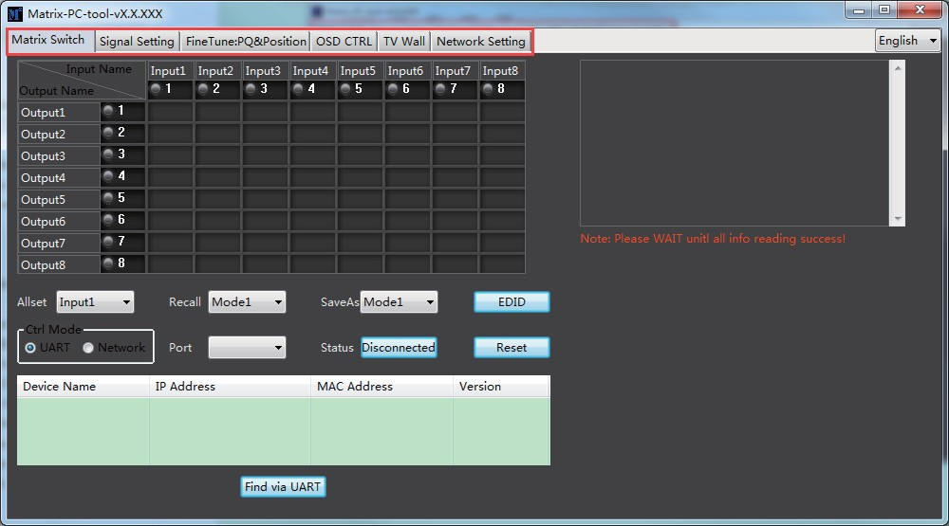

### Note:

1. The initial login password is 111111.
2. After the PC tool is lauched, press “Ctrl+Shirft+Fn+F2” to enter the engineer mode of the PC tool, in which you can check the sending/receiving serial port commands, software version and so on.

## UART Control

The operation steps are as follows:

**Step 1.** Connect the matrix and PC via the included RS-232 serial cable.

**Step 2.** Launch the PC tool software (If it is already launched, click the “Matrix Switch” tab).

**Step 3.** Click to switch “Ctrl Mode” to “UART”.

**Step 4.** Click the drop-down box which is right to “Port”, then select the correct COM port. (There may be multiple COM ports connected to the PC).

**Step 5.** Click the “Disconnected” button (which is right to “Status”) to connect the device. **Step 6.** After successful connection, the button right to “Status” will turn to “Connected”. (If you click it now, it will disconnect.)

The UI after successful connection will be as follows:

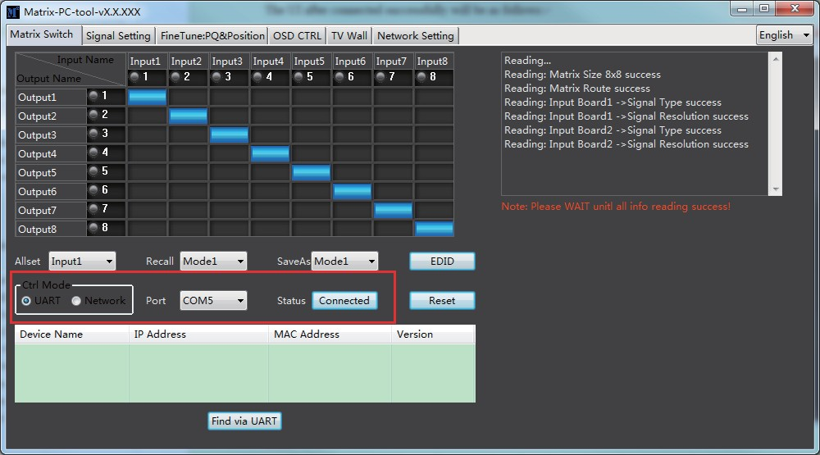

### Note:

1. The baud rate is 9600bps (no manual setting is required).
2. Click the drop-down box of “Port” after the serial port is connected to the PC, then the COM ports in the current system will be refreshed automatically. If no COM port is detected, please make sure the serial port driver is installed correctly or reboot the system and try again.
3. If the button which is right to “Status” shows “Connected”, but the software displays a prompt “Device response timeout, please check the connection parameters or hardware connection!”, please check whether the COM port is correct, the serial cable is loosen or the device is powered on, and then disconnect and try again.

## Network Control

* + 1. **Direct Connection via Network Cable**

The operation steps are as follows:

**Step 1.** Connect the matrix and PC via network cable.

**Step 2.** Manually set the IP address of PC to be in the same network segment with the matrix (The default IP address of the matrix is 192.168.0.247, and the default network mask is 255.255.255.0). The specific operation is as follows:

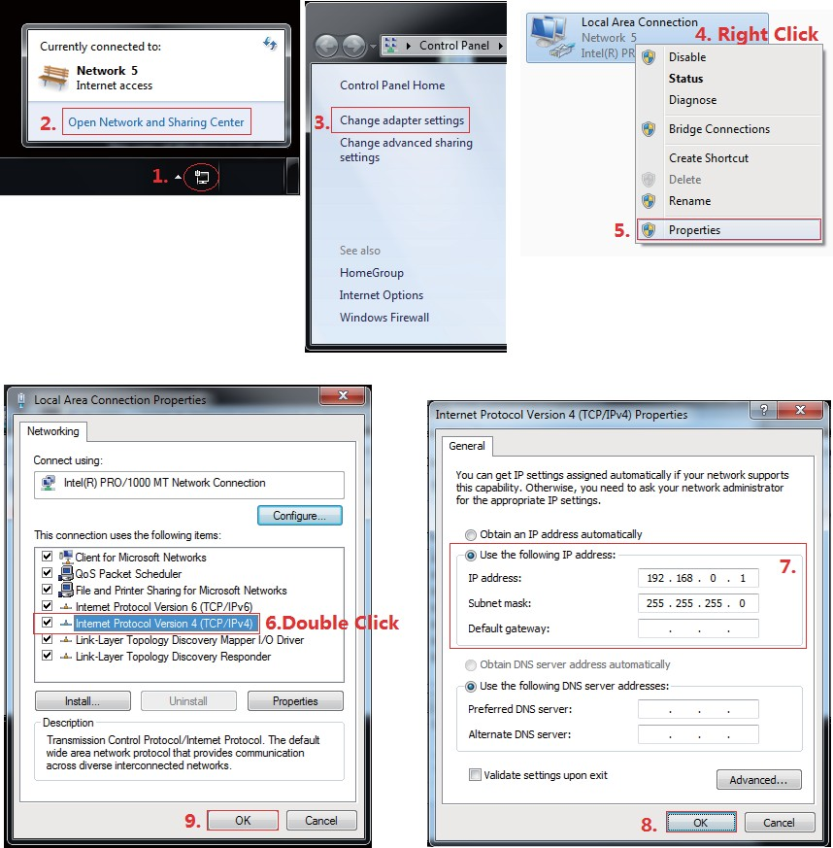

Manually setting up the IP address of the PC

**Step 3.** Launch the PC tool software. (If the IP address of the PC is changed after launching the PC tool, you should close the PC tool and open it again.)

**Step 4.** Click to switch “Ctrl Mode” to “Network”.

**Step 5.** Click the “Search Device” button.

**Step 6.** Click the device you want to control in the result list. (After the device is selected, the software will automatically read its network configuration, such as network port and so on.) **Step 7.** Click the “Disconnected” button (which is right to “Status”) to connect the device.

**Step 8.** After successful connection, the button right to “Status” will turn to “Connected”. (If you click the button now, it will disconnect.)

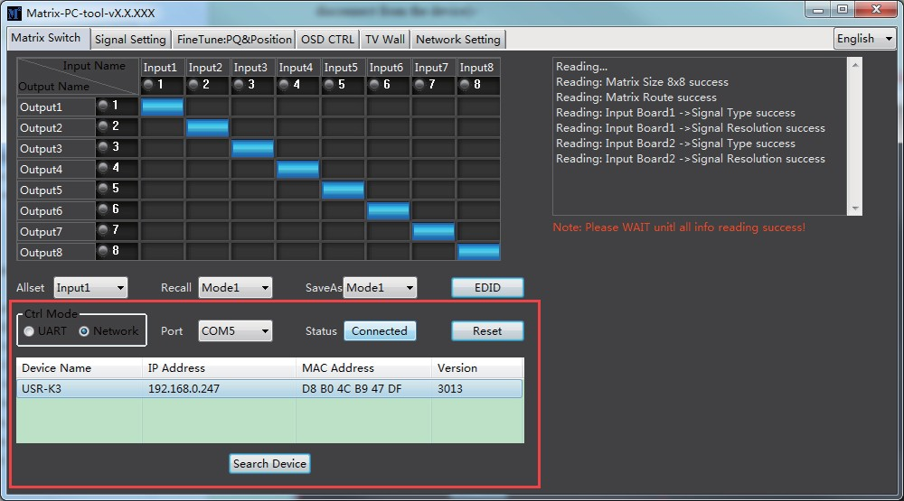The UI after successful connection will be as follows:

## Control via LAN

The operation steps are as follows:

**Step 1.** Connect the matrix and the PC to a same network router.

**Step 2.** Set the IP address of PC to be in the same network segment with the device. (if the router can assign IP address, the device and the PC can automatically obtain IP addresses that are in the same network segment.)

**Step 3.** Launch the PC tool software. (If the IP address of the PC is changed after launching the PC tool, you should close the PC tool and open it again.)

**Step 4.** Click to switch “Ctrl Mode” to “Network”.

**Step 5.** Click the “Search Device” button.

**Step 6.** Click the device you want to control in the result list (After the device is selected, the software will automatically read its network configuration, such as network port and so on.) **Step 7.** Click the “Disconnected” button (which is right to “Status”) to connect to the device. **Step 8.** After successful connection, the button right to “Status” will turn to “Connected”. (If you click the button now, it will disconnect.)

## Configure the Network Module of the Device

### Configuration via UART

**Step 1.** Connect to the device via the included RS-232 serial cable on “Matrix Switch” page.



**Step 2.** Switch to “Network Setting” page.

**Step 3.** Click the “Find via UART” button to read the configuration of the device.

**Step 4.** Modify the IP address or the IP address type.

**Step 5.** Click the “Save Config” button to save the setting.

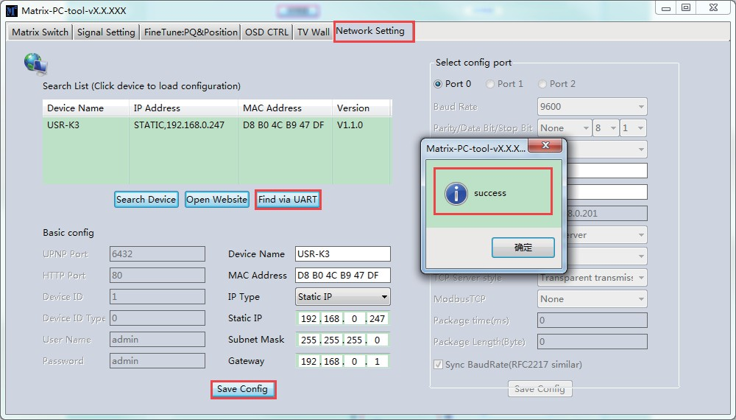**Step 6.** After a message of “success” pops up, click the “Find Via UART” to load configuration again to make sure your modification is completed successfully.

### Configuration via Network

**Step 1.** Switch to “Network Setting” page.

**Step 2.** Click the “Search Device” button to search devices.

**Step 3.** Click the device you want to configure in the result list. (When you click it, the software will read the network configuration of the device automatically.)

**Step 4.** Modify the IP address or the IP address type or other configuration.

**Step 5.** Click the “Save Config” button to save the setting.

**Step 6.** After a message of “Save Config: success!” pops up, click the “Search Device” to read the Network configuration again to make sure your modification is completed successfully.

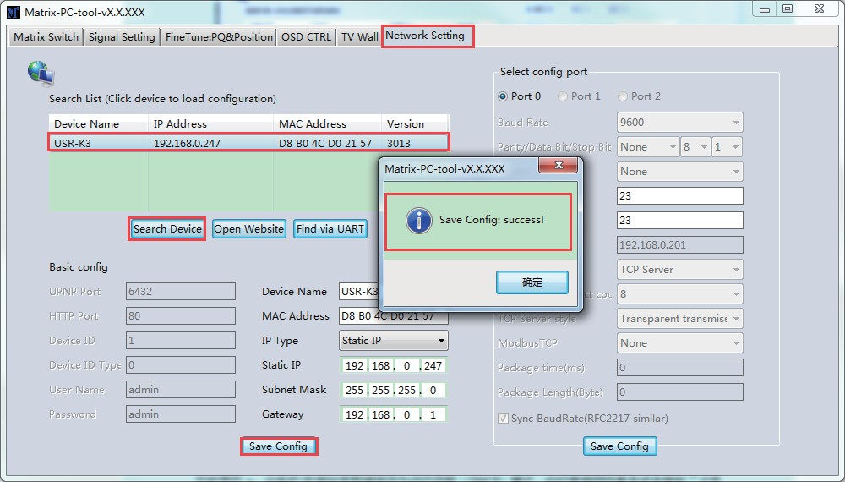

### Note:

1. Click to select the device, then the device’s information will display. User can edit the “Device Name” for better identification. User can set Dynamic IP (DHCP) / Static IP, Subnet Mask, Gateway and other network information. At the same time, user can also set the device port. Serial port baud rate is 9600. (The baud rate is not allowed to be changed, otherwise

it will cause network control failure.)

1. Configuration via UART only supports modifying IP address and IP address type. If you want to modify other configuration, please configure it via Network.

## Troubleshoot

### Failed to search devices

**Cause A**: The IP address type of the device is modified to be Dynamic IP (DHCP) mode, but currently the device is connected via network cable or connected to a router/switch which does not support DHCP function (automatically assigning IP addresses).

**Solution A**: Modify the IP address type of the device to static IP address, or connect the device to a router which supports DHCP function.

**Cause B**: The device is not powered on.

**Solution B**: Please power on the device.

**Cause C**: The network cable is not properly connected.

**Solution C**: Check the network cable connection.

**Cause D**: The IP address type of the PC is modified to be Dynamic IP (DHCP) mode, but currently the PC is connected via network cable or connected to a router/switch which does not support DHCP function (automatically assigning IP addresses).

**Solution D**: Modify the IP address type of the PC to static IP address, or connect the PC to a router which supports DHCP function.

**Cause E**: Unknown

**Solution E**: When using direct connection via network cable, please set the IP address

type of both the PC and the device to static mode, and make sure the IP addresses of both are in the same network segment. When using connection via LAN, connect the PC and the device to a same network router which supports DHCP function.

### The software shows a message of “Device response timeout” after connecting to the device.

**Cause**: The IP addresses of the device and the PC are not in the same network segment.

**Solution**: Set the IP addresses of the device and the PC to be in the same network segment.

### The software shows a message of “TCP connection failed” after connecting to the device.

**Cause**: The TCP connection between the PC and the device is failed.

**Solution**: Set the IP addresses of the device and the PC to be in the same network segment.

**Note:** If the device’s IP address type is Dynamic IP (DHCP) mode, we can connect to the device via UART firstly, then click the “Find Via UART” button to read the device’s IP address. If the IP address of the device is 255.255.255.255, it means that the router, which the device is connected to, does not support DHCP function.

## Matrix Switch Page

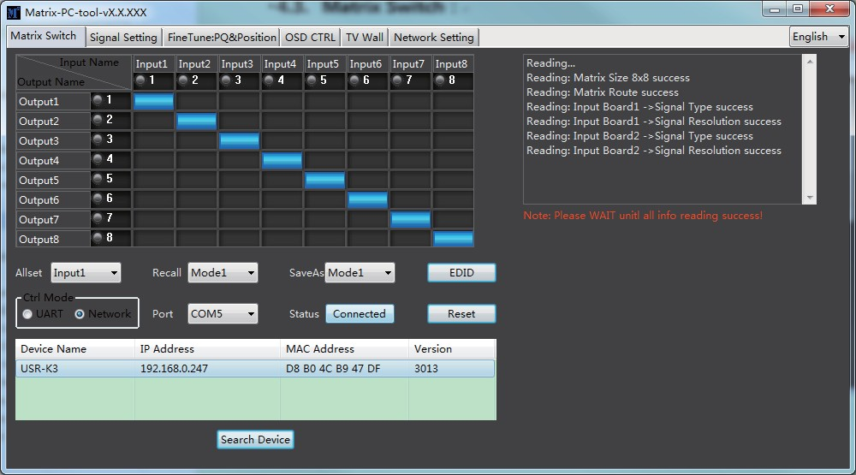After the PC tool is connected to the matrix via UART or Network, it will display the matrix’s input and output switching status.

1. User can switch the input by clicking the corresponding box, edit the input source name or the output device name (for example, the user can name input 1 to “set-top box” or name output 1 to “TV”).
2. Support scene saving. (User can click the drop-down list of “SaveAs” to save the current input and output switching status to mode X. 8 different modes are supported.)
3. Support scene recalling. (User can click the drop-down list of “Recall” to to recall the mode X’s input and output switching status to the matrix).
4. Support the setting of “one-to-many”. (User can click the drop-down list of "Allset" to switch the input X signal to all the output channels).
5. Support system resetting: Click “Reset” button, after confirming, the matrix will be reset to factory default settings.

## Signal Setting Page

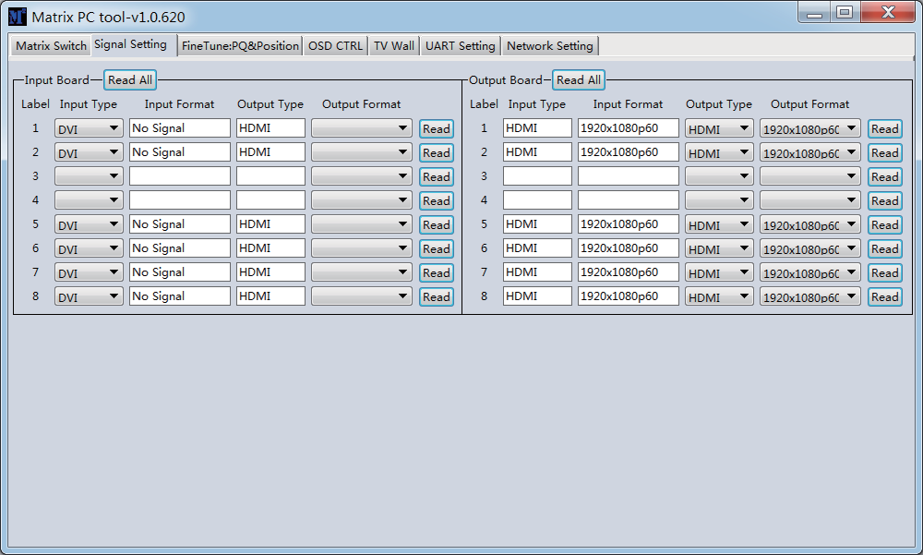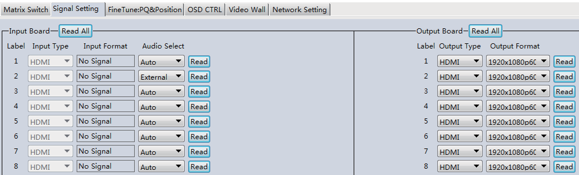

1. Read the type (HDMI/DVI/VGA/YPbPr/CVBS) of all input ports.
2. User can read the signal resolution (Input Format) of all input ports. The output resolution

is fixed at 1080P60Hz to ensure the effect of seamless switching.

1. Read and set the “Output Type”ut card.
2. Read and set output channel’s output resolution.

## FineTune: PQ&Position Page

User can read and set the brightness/contrast/saturation/sharpness/video display position of the input port & output port.

**Note:** If there is no special need, do not change the default settings; if there is a problem after changing, click “Reset” to return to the factory settings.

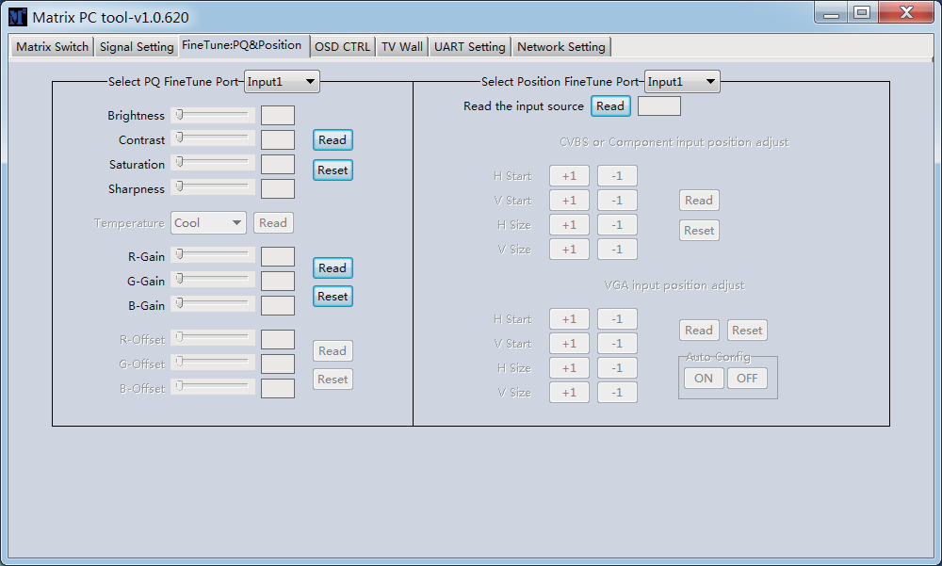

## TV Wall Page

Set the TV wall by setting the rows, columns and quantity of layout.

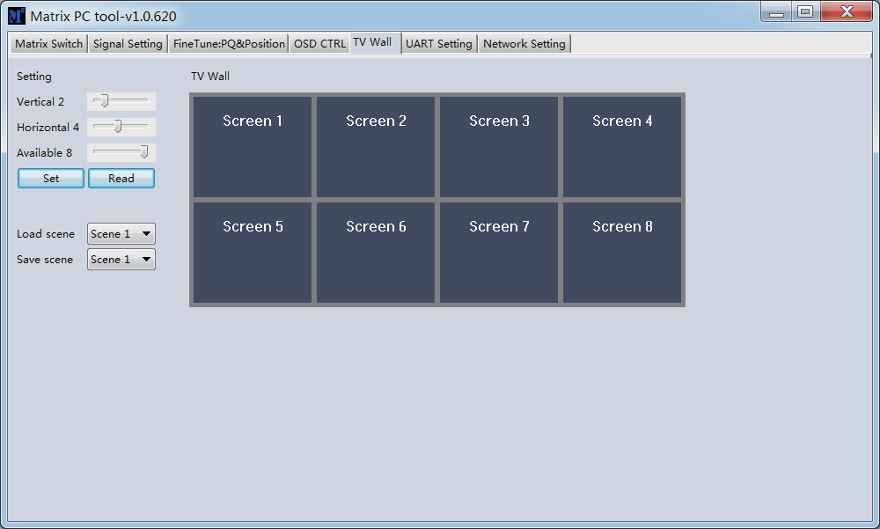

### Build a Wall

Select one screen, right click, there will be a sub menu as the following picture shows:

**Input Select:** Select the input port (Input 1 ~ Input 8) for the screen to display. **Output Select:** Set the output port (Output 1 ~ Output 8) that connects to the display according to the TV wall connect status.

**Output Type:** Set the output port type according to the TV wall system setup status. (In splicing mode, only HDMI or DVI can be selected.)

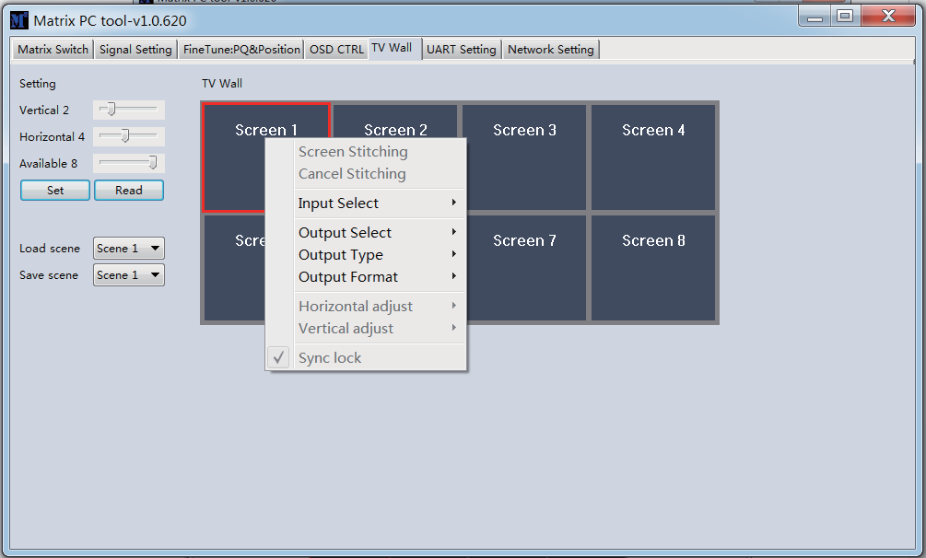**Output Format:** Set the the resolution of output port. (In splicing mode, only 1080P 60HZ can be selected.)

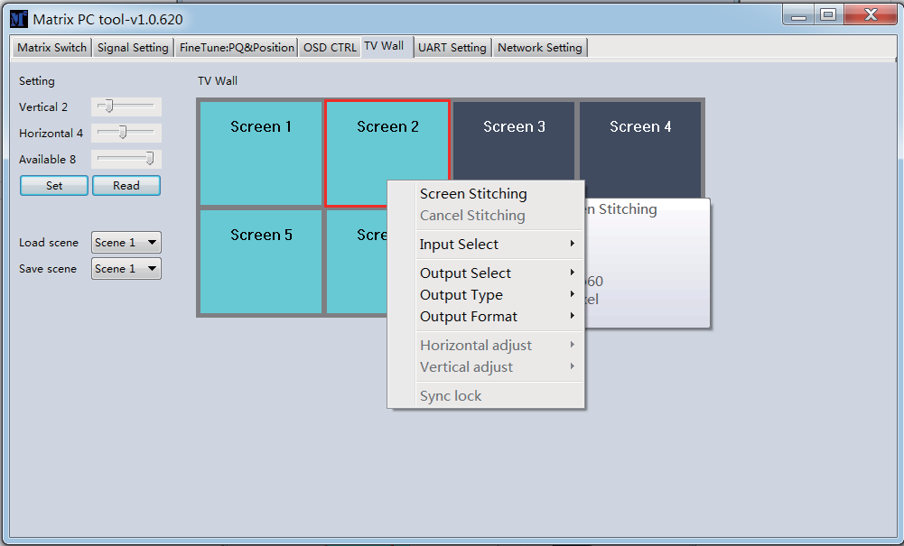Click to select one screen, then drag the mouse to select all the screens to be spliced, right click, and select “Screen Stitching” to splice.

Select the screen, which is splicing, right click, then the menu appears as follows:

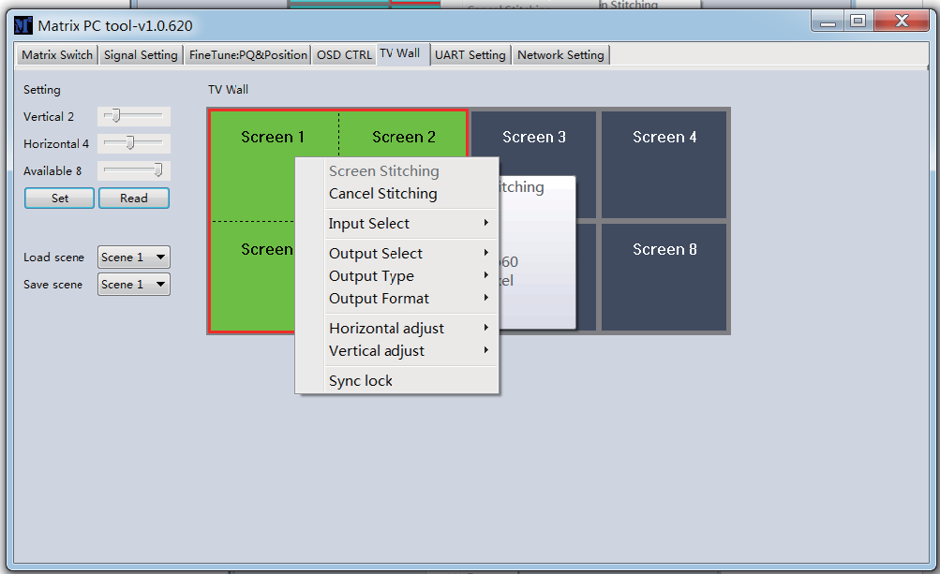

**Cancel Stitching**: Click to cancel TV wall splicing.

**Horizontal adjust:** Set the horizontal frame width for each screen of the TV wall.

**Vertical adjust:** Set the vertical frame width for each screen of the TV wall.

**Sync lock:** To make sure that all the screens that in splicing are sync lock all the time, user can click to switch on “sync lock”.

**Save Scene/ Load Scene:** User can save or load one splicing wall scene, including input/ output routing and wall layout.

## EDID Control

Click the “EDID” button on “Matrix Switch” page to open the EDID setup interface.

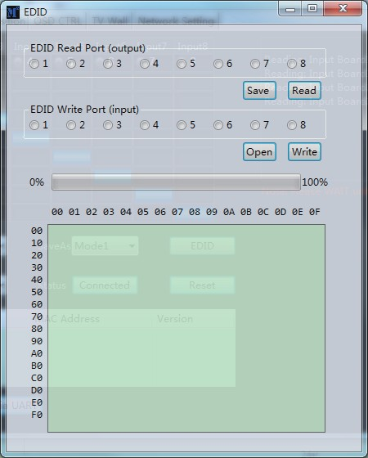

1. Read EDID: Select the output port, then click the “Read” button to read EDID. When the progress bar reaches 100%, it will prompt that the reading is successful.
2. Write EDID: First read an EDID from output port, or open an EDID file saved before, then select the input port, finally click the “Write” button to write EDID. When the progress bar reaches 100%, it will prompt that the write operation is successful.
3. Save EDID: After reading EDID successfully, click “Save” button, then choose the save path and file name for EDID saving.

# Control via Web

The matrix can be controlled via Web. You can enter the Web GUI through two methods:

### Method 1: Through PC Tool

**Step 1.** Open the PC Tool, switch to “Network Settings” page and click “Search Device”.

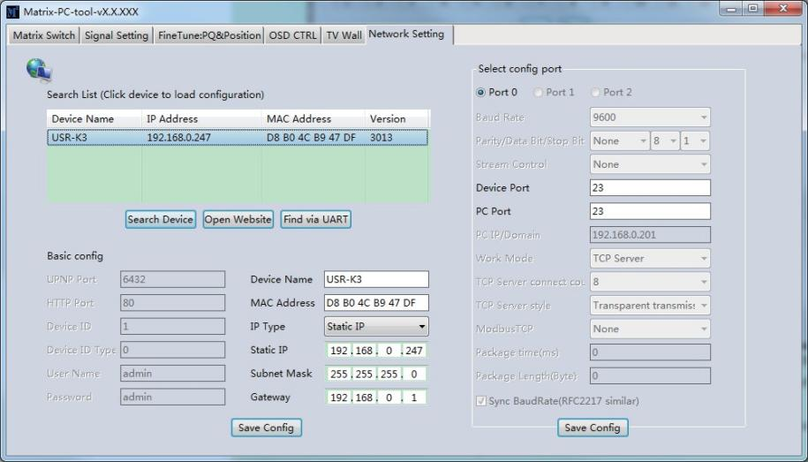**Step 2.** Select the detected device, and click “Open Website” to open the Web GUI login page.

**Step 3.** Input the username (admin) and password (admin) to login.

### Method 2: Through PC Browser

**Step 1.** Connect the LAN port of the matrix to PC with an network cable, and set the IP address of the PC to be in the same network segment with the matrix.

**Step 2.** Input the IP address of matrix in the web browser on the PC to enter Web GUI login page. (You can check the IP address of matrix through PC Tool.)

**Step 3.** Input the username (admin) and password (admin) to login.

**Note**: The PC browser must be IE10 or above, and support HTML5 feature.

# Precautions for Use

1. During installation, make sure that the ground wire in the power cord is well grounded. Do not use a two-core plug. Ensure that the input power of the device is AC110-240V, 50/60Hz.
2. Do not place the device in a place that is too cold or too hot. Turn off the power supply of the device in humid environment or when not in use for a long time.
3. Keep the working environment well ventilated so that the heat generated by the device can be discharged in time.
4. Make sure the signal cable and communication cable are connected well to the matrix before powering on the system; the AC power can’t exceed 220V.
5. When the system changes signal source without powering off the matrix, the output image may not match the display screen; please reboot the system or re-plug the input card.
6. When choosing HDMI or DVI signal input, the cable length should not exceed 20 meters; when choosing HDMI or DVI signal output, the cable length should not exceed 10 meters. (It is recommended to use certified special cables.)
7. If the control via RS-232 failed, please check whether the com port selected is right; check whether the communication port and cable of the computer are in good condition; the RS-232 cable is a straight-through cable, not cross cable.
8. After matrix switching control is executed through the control software, if there is no image output, please check as follows:

**A**: Please check whether the matrix has executed the switching command correctly. The corresponding status of input and output can be inquired through the control software. **B**: Please check whether the input signal source is working properly. The state of the signal source can be tested by directly accessing the display device.

**C**: If the signal source is normal, please check whether the input card of the matrix is working properly. Please refer to the PC Tool’s “Signal Setting” page to check whether the input card has signal input or not. If there is no signal input, then the input card is broken, otherwise the input card is ok.

**D**: If the input card is ok, check whether the output card is ok or not;

**E**: If the fault is still not determined through the above steps, please replace the input or output

card, or ask professional maintenance personnel for help.